# 1. Introduction to Statistics

# Gathering Data

## Sampling and observational studies

### Identifying bias in samples and surveys

* Response bias: During the week when students visited the counselors to schedule classes, they asked every student in person if they smoked cigarettes or not.
* Under coverage: She conducted a poll by calling 100100100 people whose names were randomly sampled from the phone book (note that mobile phones and unlisted numbers aren't in phone books). The senator's office called those numbers until they got a response from all 100100100 people chosen.
* Voluntary response sampling: He asks his listeners to visit his website and participate in the poll.
* Convenience sampling: He decides to poll the next 100100100 listeners who send him fan emails.
* Nonresponse: She conducted a poll by calling people using random digit dialing, where computers randomly generate phone numbers so unlisted and mobile numbers can still be reached. They called over 1000 random phone numbers—most people didn't answer—until they had reached 100100100 respondents.
* Biased wording: Counselors selected a random sample of students to take a survey on drug use. One of the questions reads, "If you are under the age of 181818 years, do you illegally smoke cigarettes?"

## Sampling methods

Cluster sampling vs stratified sampling

In single-stage **cluster sampling**, all the elements from each of the selected **clusters** are sampled. ... In **stratified sampling**, the **sampling** is done on elements within each strata. In **stratified sampling**, a **random sample** is drawn from each of the strata, whereas in **cluster sampling** only the selected **clusters** are sampled.

## Types of studies (experimental vs. observational)

### Statistical studies:

Sample study: estimate a population parameter

Observational study: study correlations, move together, but not causality <== confounding variable, or lurking variable

Experiment: establish causality, control group and treatment group

## Experiments

Explanatory variable and Response variable=> placebo and medicine

* Control group and treatment group

Blind (or double blind) experiment

Random sample: Block design (60 women, 40 men=> 30 and 20 in each group)

The process of replication

Matched pairs experiment design: switched the group and treatment

Note: In the real world, we can't ethically take a random sample of people and make them participate in a study involving drugs, however, there are more advanced methods for controlling for this type of selection bias. When we rely on volunteers for testing new drugs and we see significant results, we need to be willing to assume that the volunteers are representative of the larger population. We can also repeat the study on a different group of volunteers to see if we get the same results.

Key idea: If a sample isn't randomly selected, it may not be representative of the larger population. On the AP test, be ready to apply this concept and some nuance when it comes to discussing if a sample is representative of the larger population.

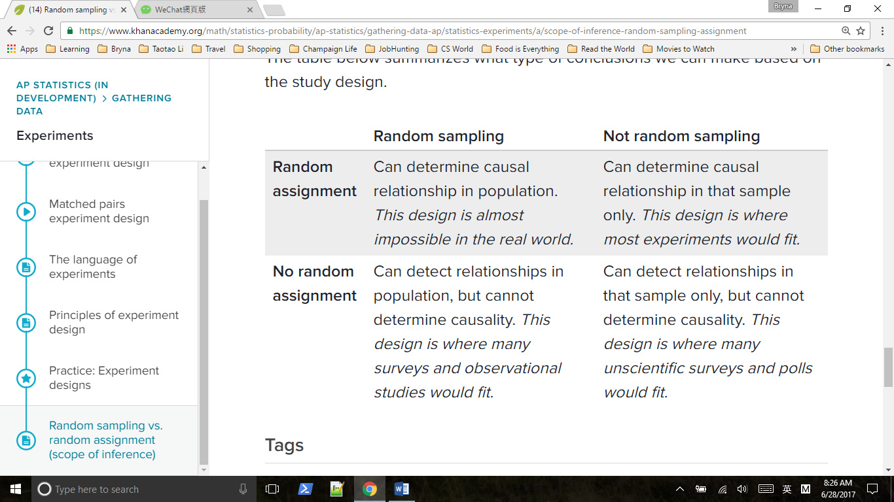

# 2. Analyzing categorical data

## 2.2 Two-way tables

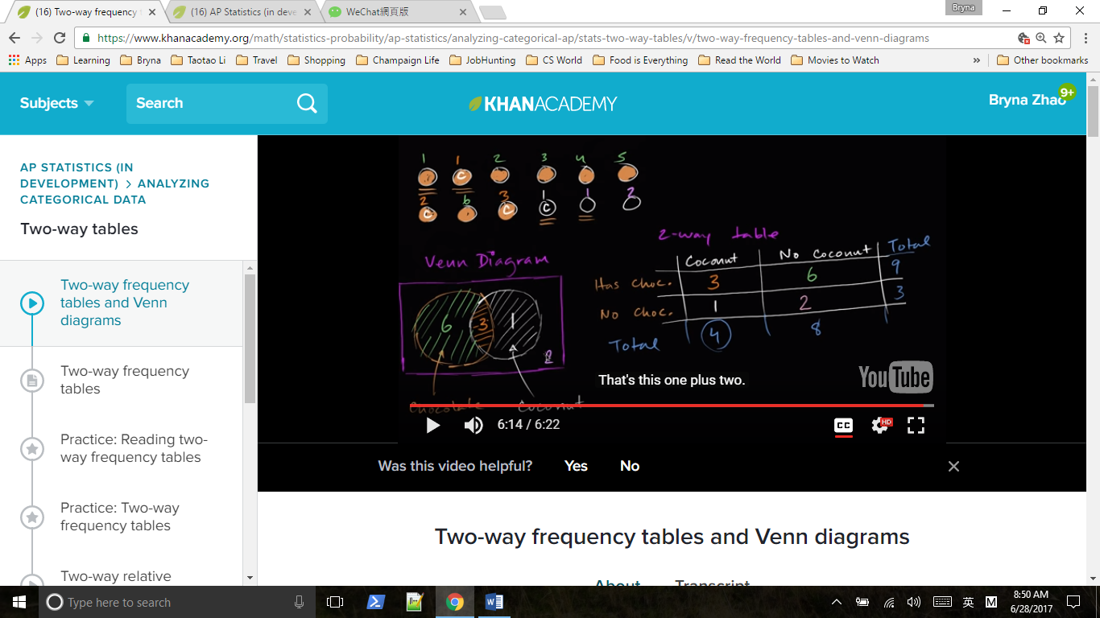

### Analyzing trends in categorical data

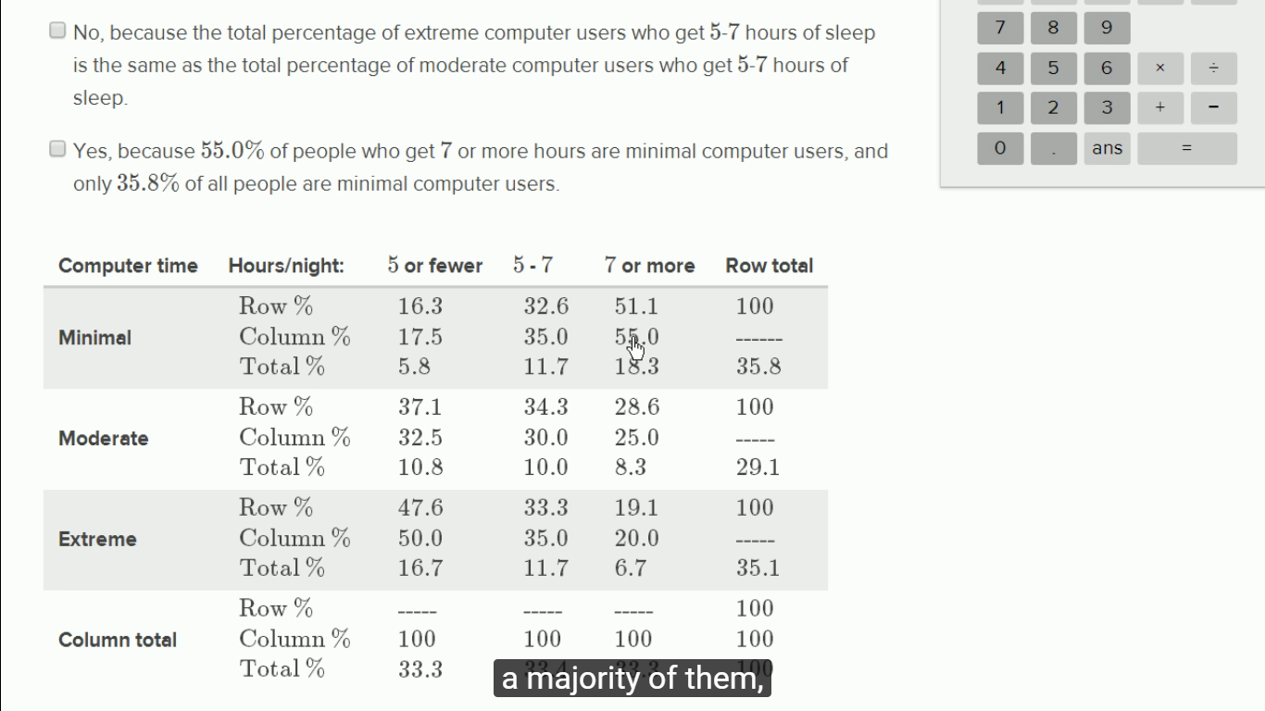

## Marginal distribution and conditional distribution

They are found in the margins (that's why they are called “**marginal**”). The following table shows probabilities for rolling two dice. The total probabilities in the margins are the **marginal distributions**. A **conditional distribution** on this table would be a sub-population

# 3. Displaying and comparing quantitative data

## 3.1 [Displaying quantitative data with graphs](https://www.khanacademy.org/math/statistics-probability/displaying-describing-data/quantitative-data-graphs/v/ways-to-represent-data)

Histograms

A histogram displays numerical data by grouping data into "bins" of equal width. Each bin is plotted as a bar whose height corresponds to how many data points are in that bin.

Bins are also sometimes called "intervals", "classes", or "buckets".

Stem and leaf plots

A stem and leaf plot displays numerical data by splitting each data point into a "leaf" (usually the last digit) and a "stem" (the leading digit or digits).

For example, the buyer for a chain of department stores counted the number of pairs of boots at each of the stores and made a stem and leaf plot for the data. Here is the dataset and the stem and leaf plot:

Dataset: 17, 18, 20, 25, 28, 34, 34, 37, 38, 50

Stem and leaf plot:​

​1 ∣ 7 8

​2 ∣ 0 5 8

​3 ∣ 4 4 7 8

​4 ∣

​5 ∣ 0

​​

## 3.2 Describing and comparing distributions

### Shapes of distributions

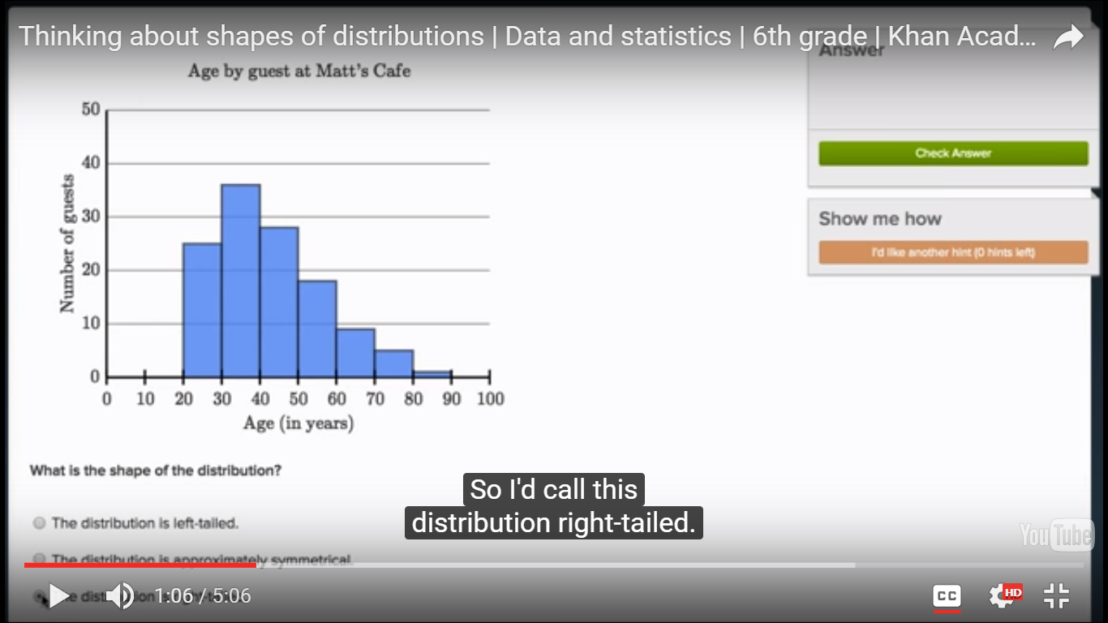

Think of an armadillo, it has body and tail. It’s a right-tailed distribution, and skewed to the right( the mean is to the right of the median and mode.

### Clusters, gaps, peaks & outliers

## A cluster is formed when several data points lie in a small interval. A **gap** is an interval that contains no data. An outlier has a value that is much greater than or much less than other data in the set. An outlier may significantly affect the mean of a data set.

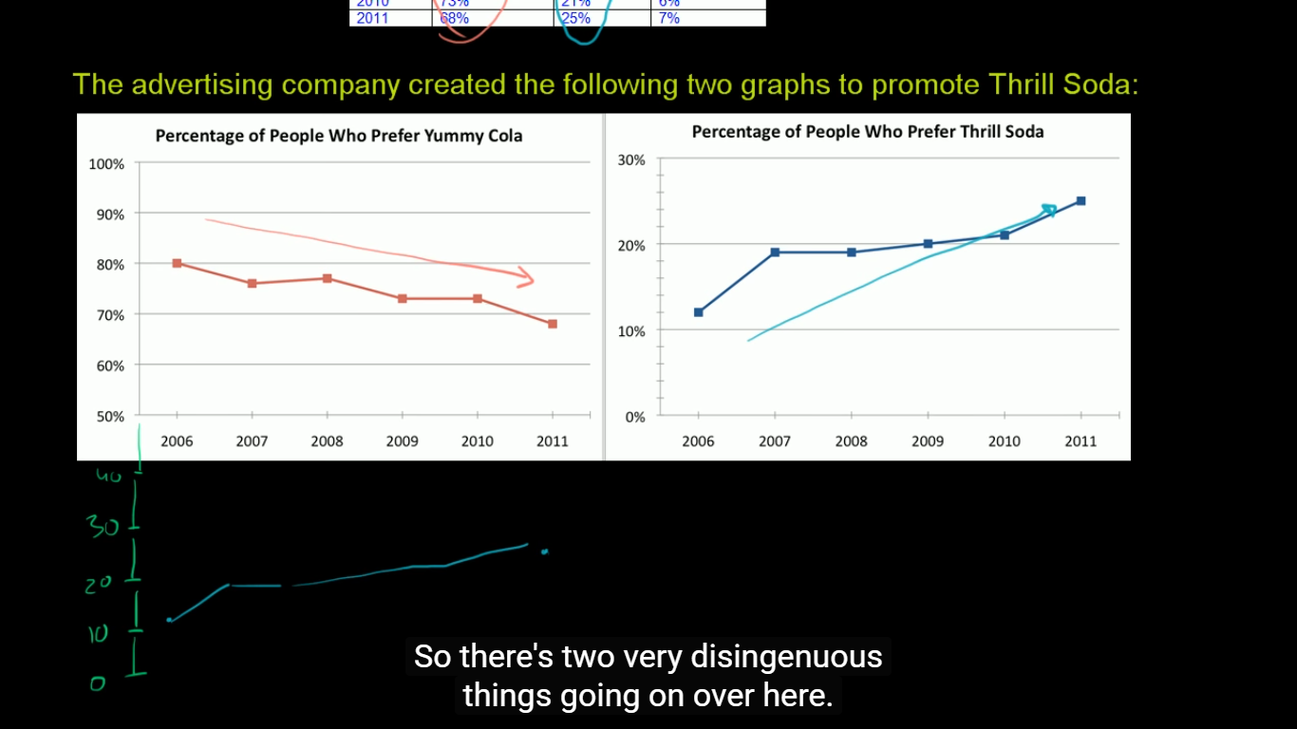

1. scales are different 2. Y-axis are different

# 4. Summarizing quantitative data

## 4.1 Measuring center in quantitative data

Descriptive:

Average, central tendency

Inferential: conclusion

Mean: arithmetic mean, the balancing point

Median: middle number

Mode: most common number

Mean and standard deviation versus median and IQR

* If you have a roughly symmetric dataset, mean and sd can be solid.
* When you have a skewed data set( have a few significant outliers), median is more robust. And since sd is based on the mean, it is not a good measure of central tendency in this case, IQR is better for an indication of the spread. For example, salaries or home prices.

## 4.2 Measuring spread in quantitative data

### Interquartile range (IQR)

The IQR describes the middle 50% of values when ordered from lowest to highest. To find the interquartile range (IQR), ​first find the median (middle value) of the lower and upper half of the data. These values are quartile 1 (Q1) and quartile 3 (Q3). The IQR is the difference between Q3 and Q1.

### Variance of a population(δ2)

Variance as a measure of, on average, how far the data points in a population are from the population mean, how much spread the data points is around the mean

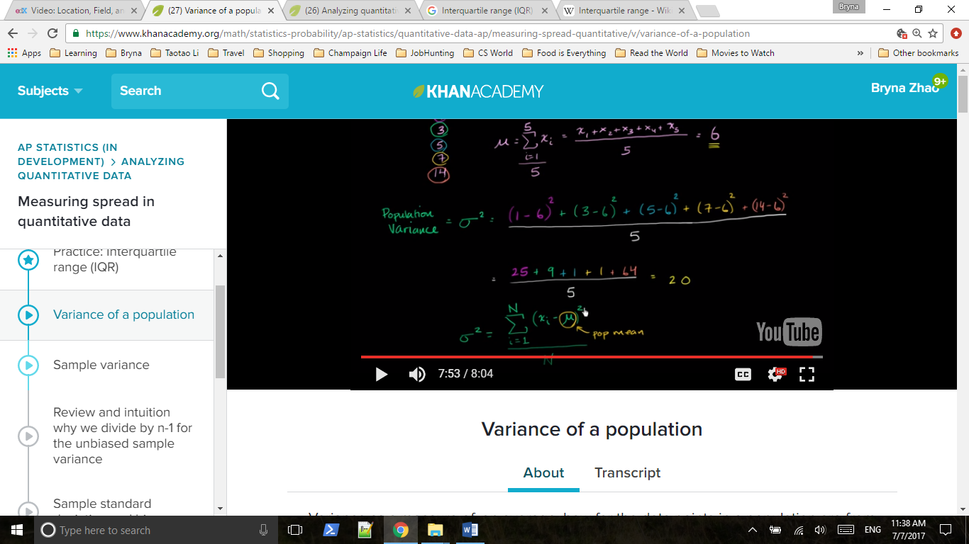

### Statistics: Alternate variance formulas

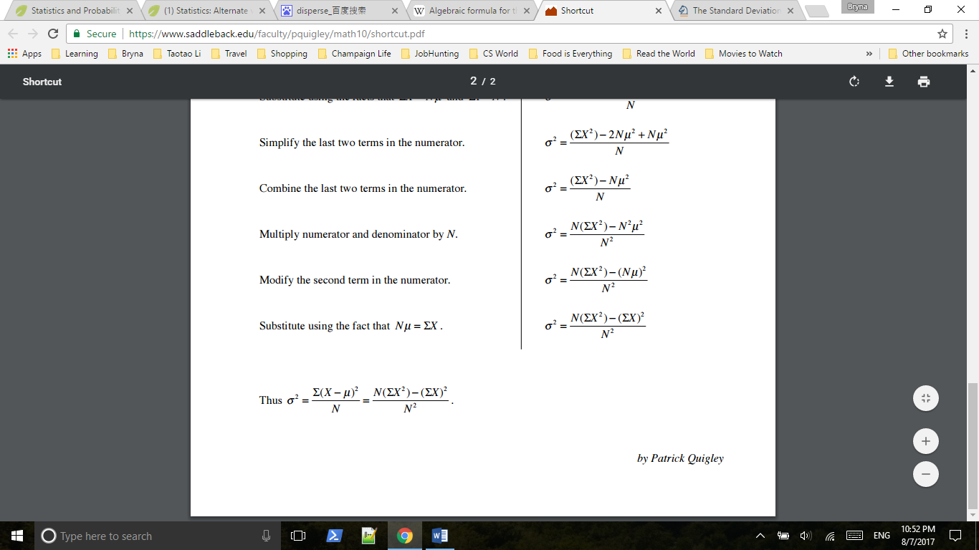

## 4.3 More on standard deviation

### Sample variance

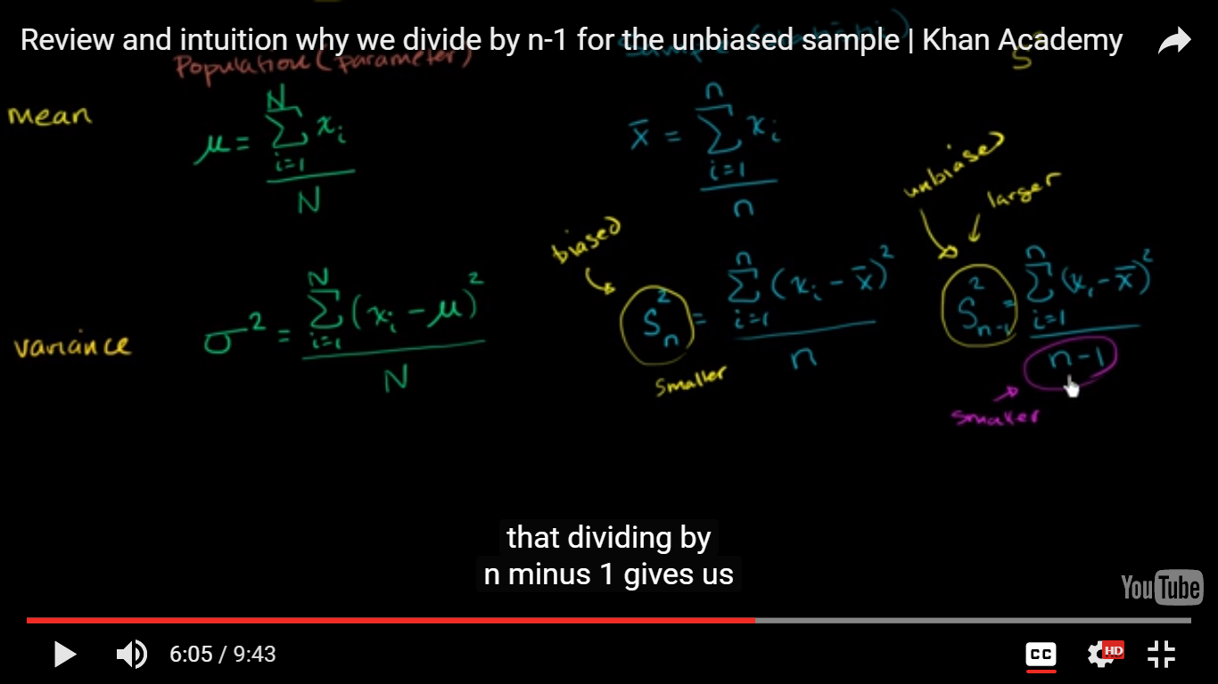

Sample number = n ( Population number = N), sample mean = $\overline{x}$

Review and intuition why we divide by n-1 for the unbiased sample variance?

Because your sample mean is always going to sit inside your data, while the true population mean could be outside of it, you’re likely to underestimate the true population variance

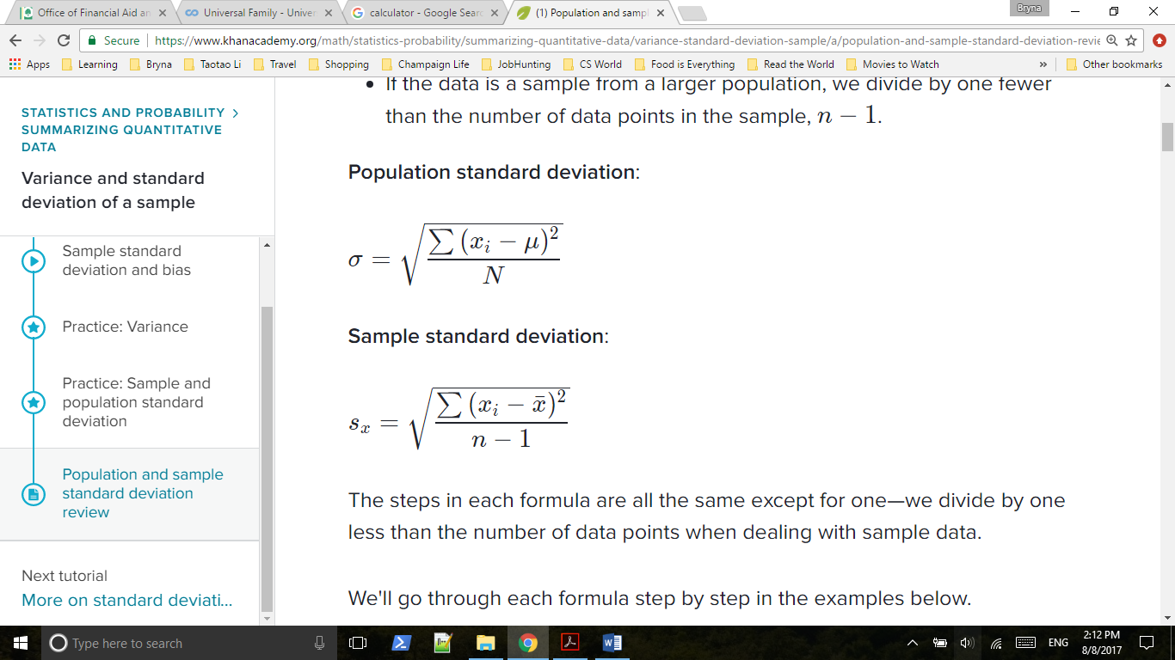

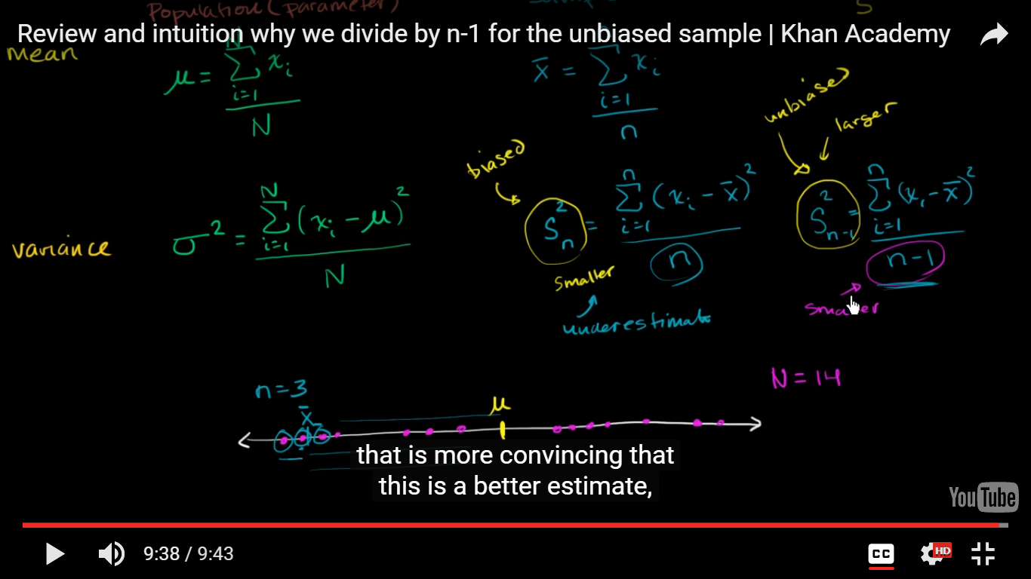

### Why we divide by n - 1 in variance

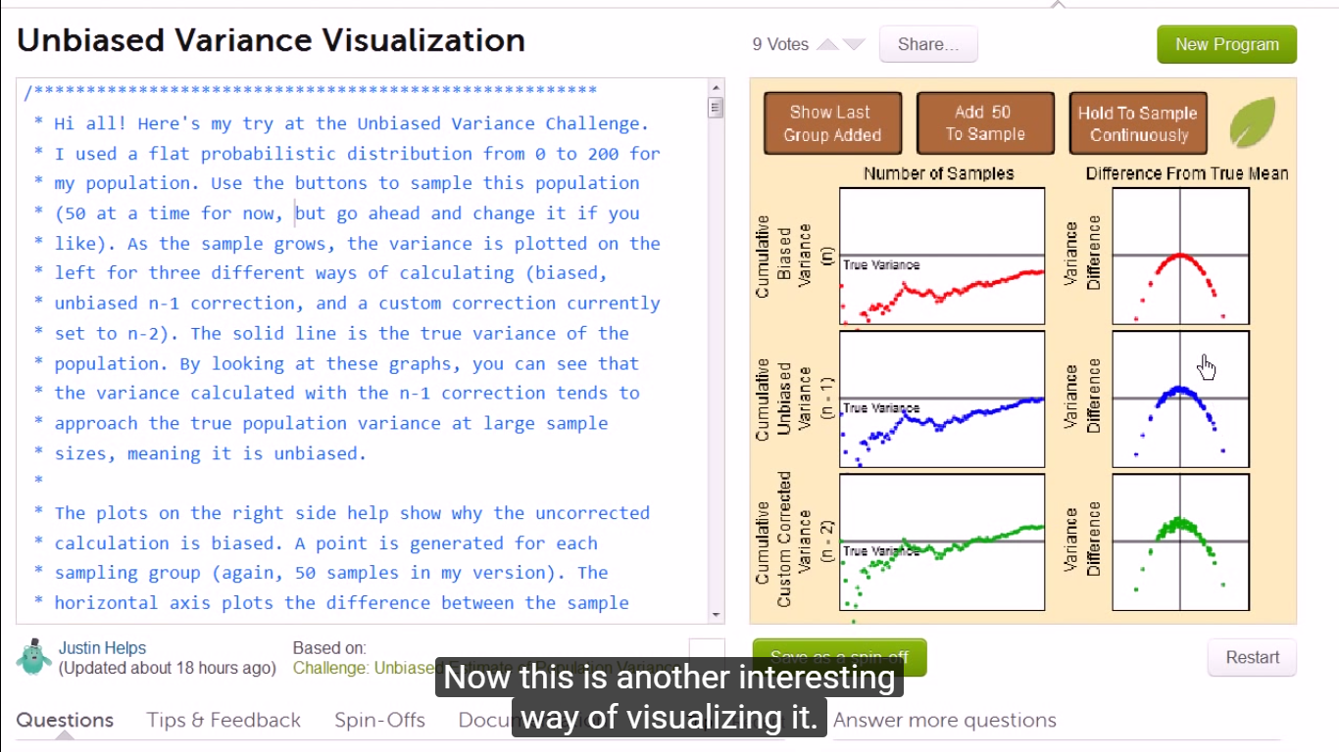

### Simulation showing bias in sample variance

When you have a smaller sample size, you’re more likely to get a sample mean that is a bad estimate( far from the population mean) and to significantly underestimate the sample variance .

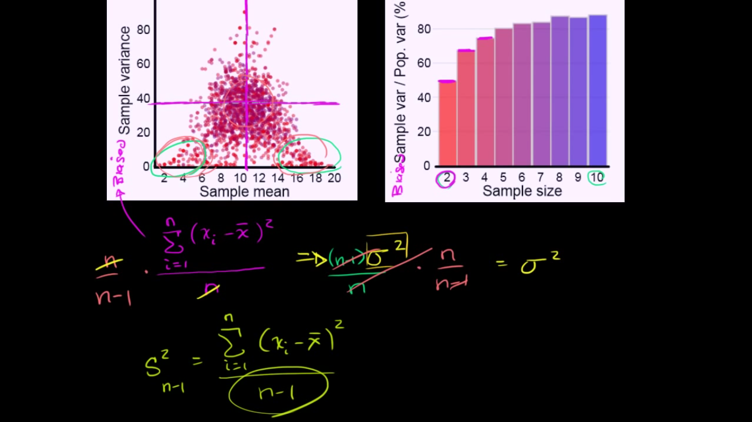

## 4.4 Box and whisker plots

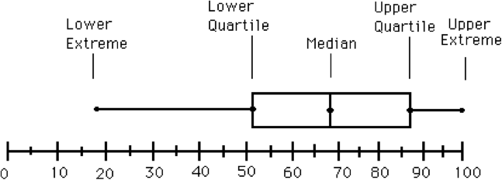

Judging outliers in a dataset

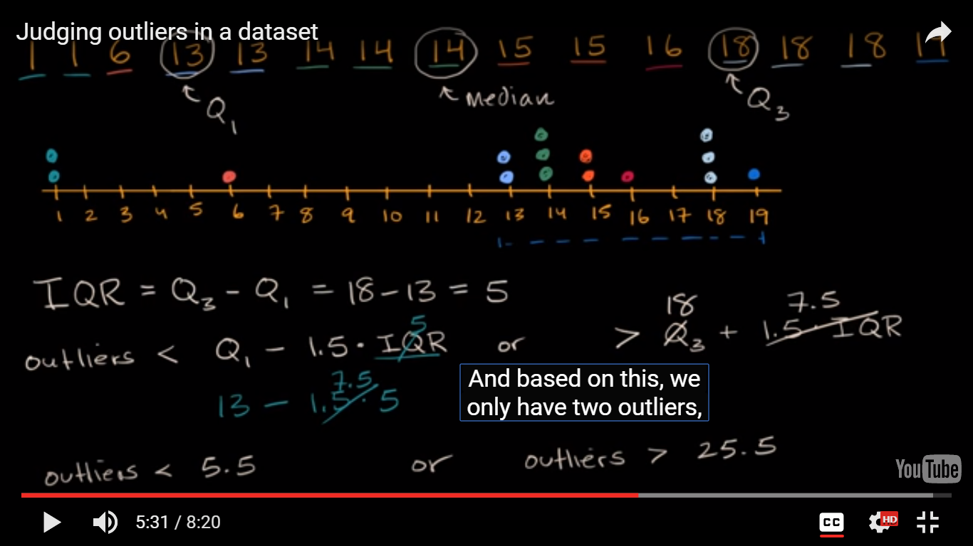

A commonly used rule says that a data point is an outlier if it is more than 1.5\* IQR1 point, 5 above the third quartile or below the first quartile. Said differently, low outliers are below Q​1​​−1.5⋅IQR

and high outliers are above Q​3​​+1.5⋅IQR

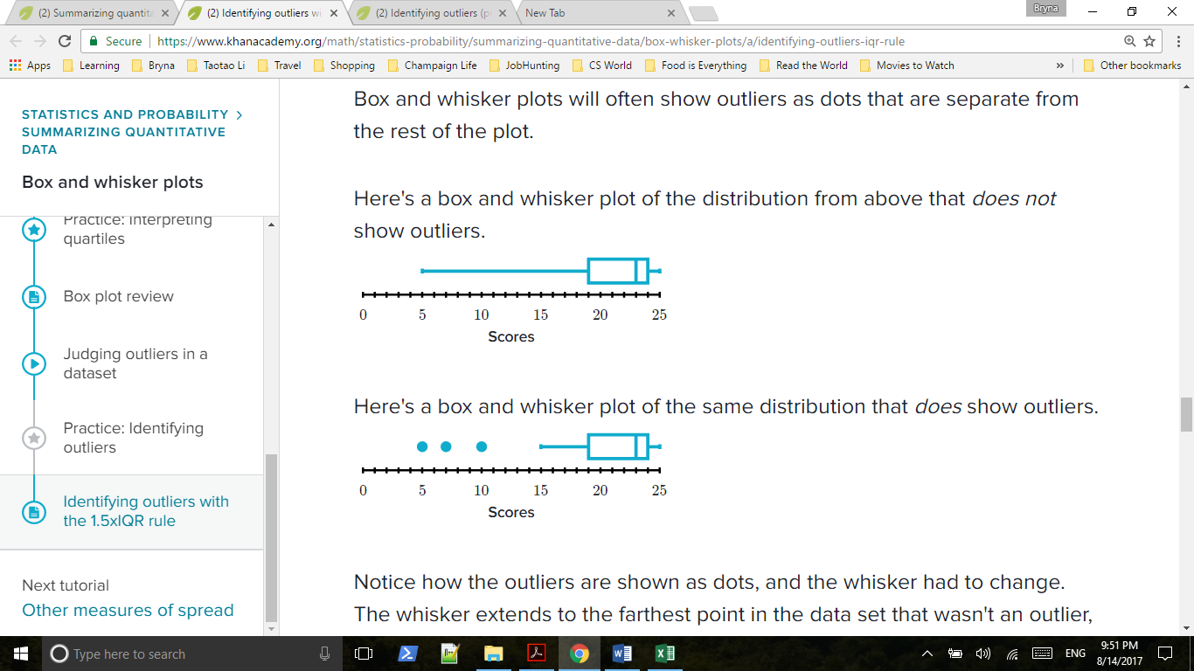

## 4.5 Other measures of spread

### Range and midrange

Range: The range is the difference between the largest and smallest numbers.

Midrange: The midrange is the average of the largest and smallest number.

### Mean absolute deviation (MAD)

Here are the formulas for standard deviation (SD) and the formula for mean absolute deviation (MAD), both of which are measures of spread:

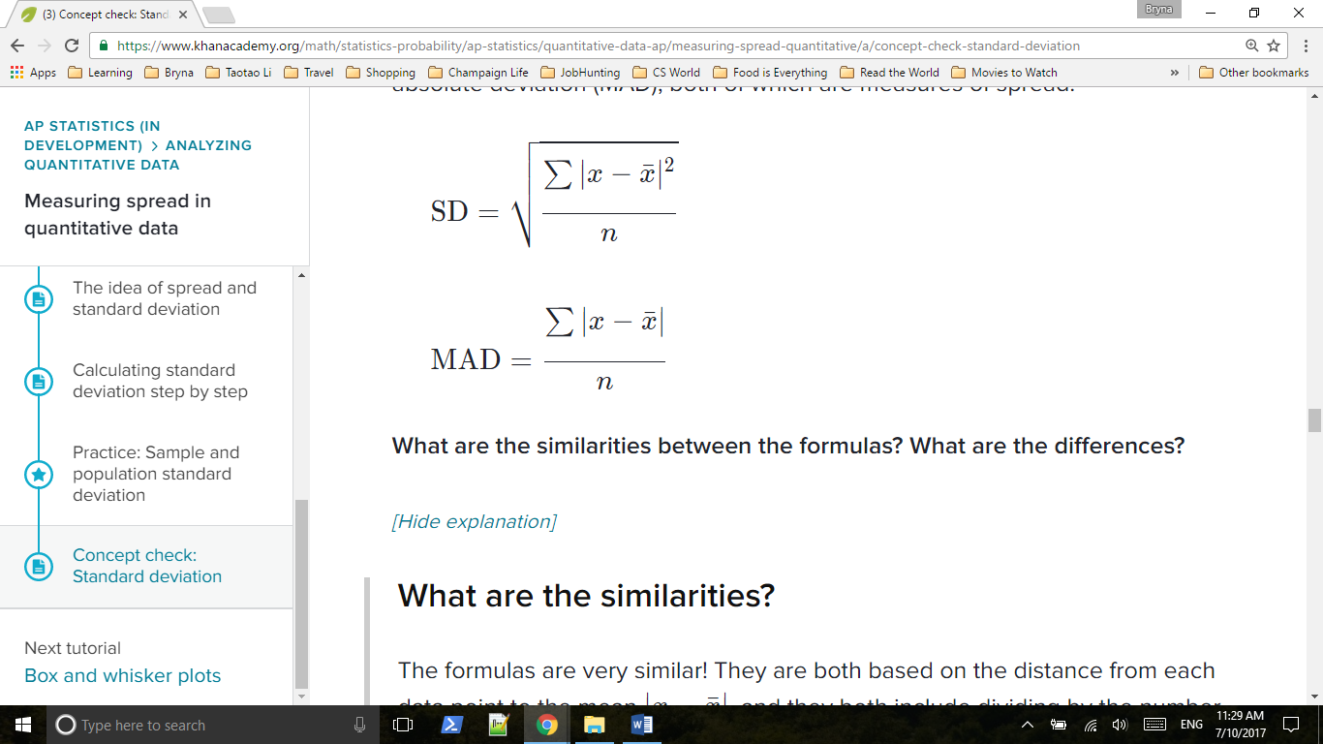

**What are the similarities between the formulas? What are the differences?**

# 5. Modeling data distributions

## 5.1 Percentiles (cumulative relative frequency)

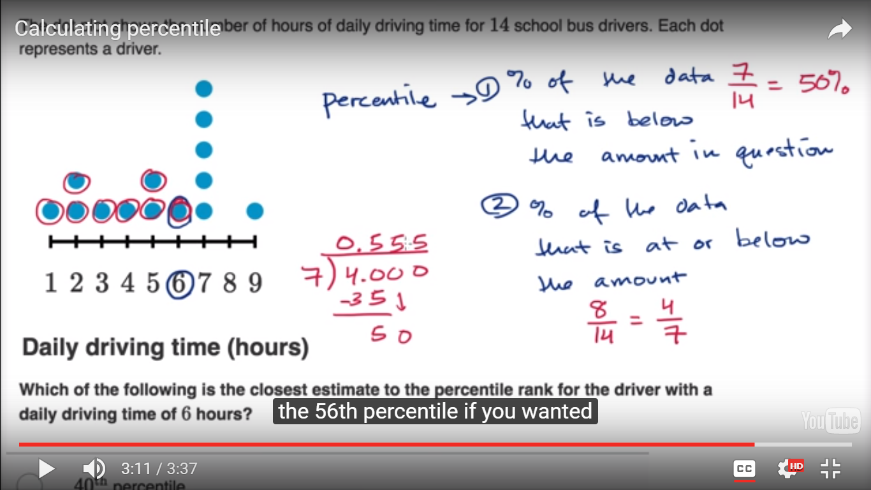

### Analyzing a cumulative relative frequency graph

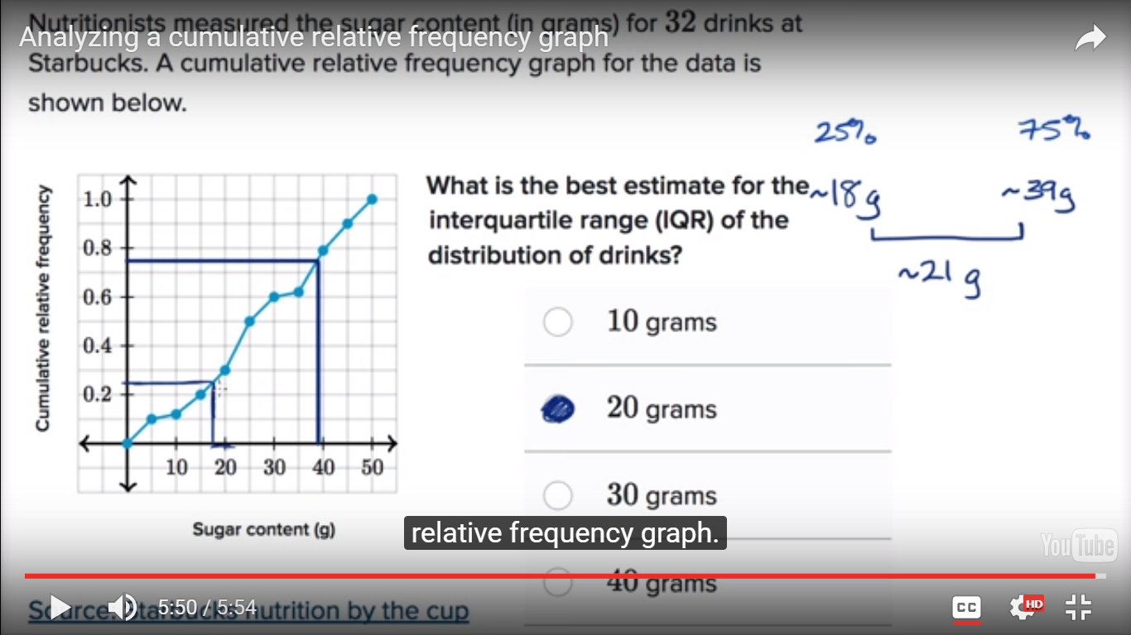

## 5.2 Z-scores

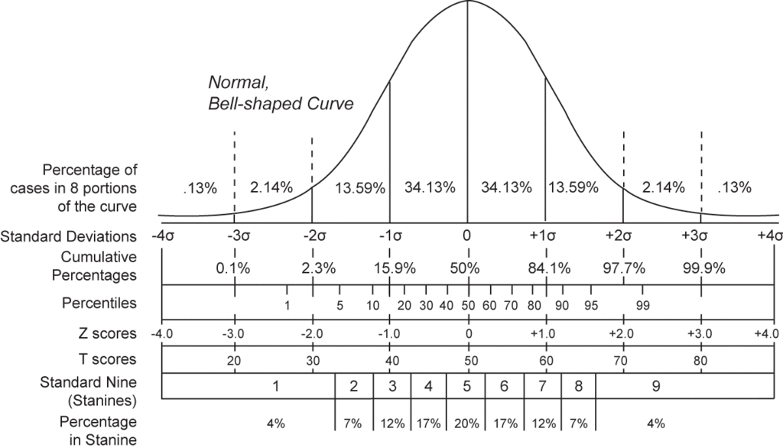

 z = X - μ / σ

Z-score means how many sd way from the mean

## 5.3 Effects of linear transformations

### How parameters change as data is shifted and scaled

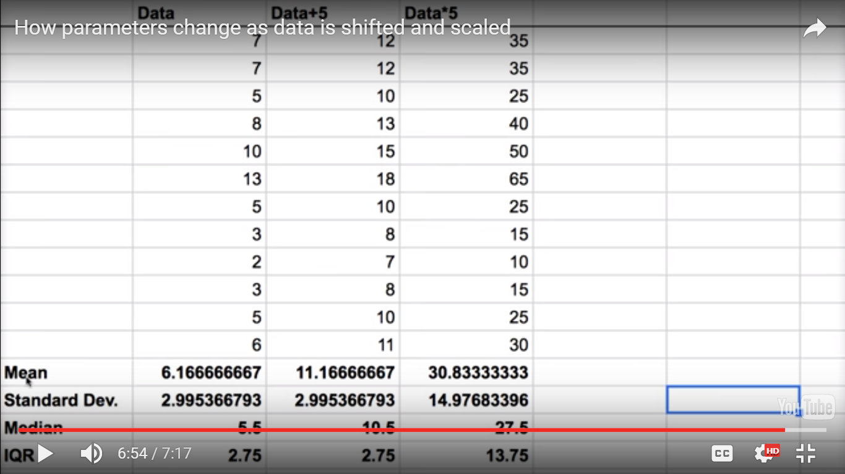

If you scale a random variable, the corresponding mean will be scaled by the same amount. If you shift a random variable, the corresponding mean will be shifted by the same amount.

For std and IQR, if you shift the data, they will stay the same, but if you scale the data, they will scale by the same rate.

## 5.4 Density curves

Density curve is a visualization of a distribution where the data points can take on any value in a continuum

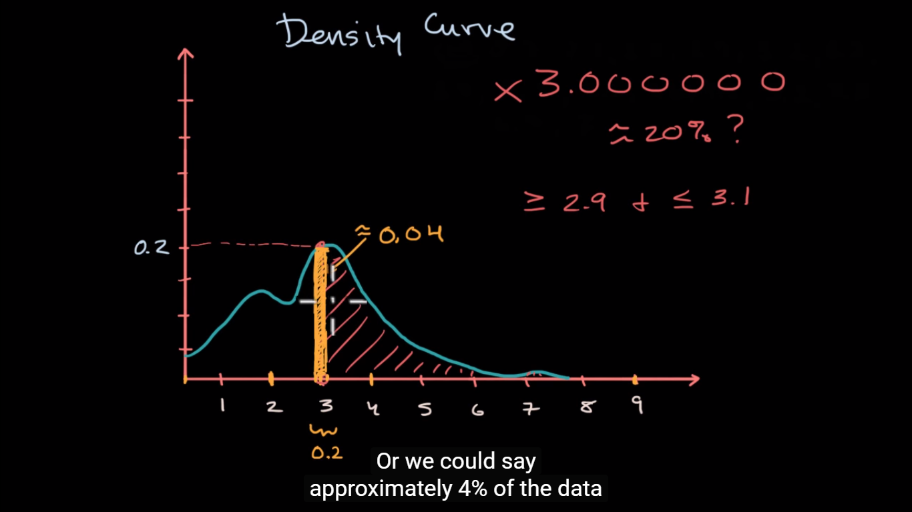

### Median, mean and skew from density curves

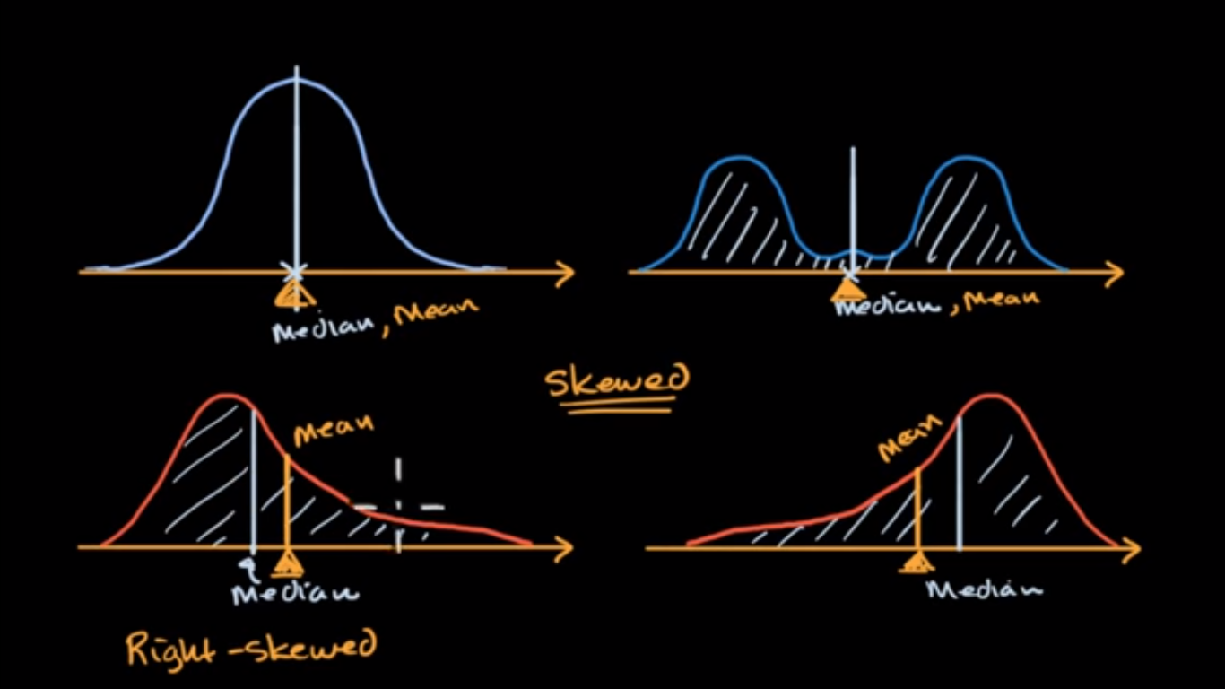

Mean comes out of the idea of weighted average of all possible values, since left part of median has the same number as right part, but right has greater values, mean will be skewed to the right.

## 5.5 Normal distributions and the empirical rule

The **empirical rule**, also known as the three-sigma **rule** or the 68-95-99.7 **rule**, provides a quick estimate of the spread of data in a normal distribution given the mean and standard deviation. Specifically, the empirical rule states that for a normal distribution:

68% of the data will fall within one standard deviation of the mean.

95% of the data will fall within two standard deviations of the mean.

Almost all (99.7%) of the data will fall within three standard deviations of the mean.

The empirical rule is used as a rough gauge of normality. When a number of data points fall outside the three standard deviation range, it can indicate non-normal distributions.

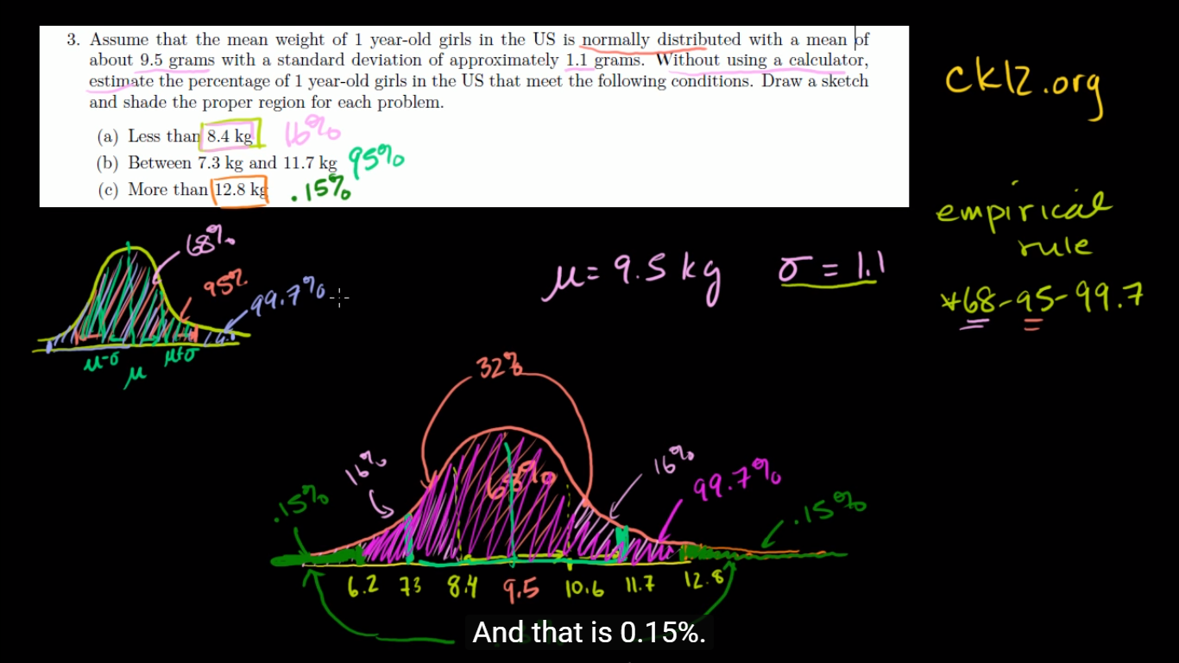

### Introduction to the normal distribution

**The central limit theorem** (**CLT**) establishes that, in most situations, when [independent random variables](https://en.wikipedia.org/wiki/Statistical_independence) are added, their properly normalized sum tends toward a [normal distribution](https://en.wikipedia.org/wiki/Normal_distribution) (informally a "*bell curve*") even if the original variables themselves are not normally distributed. The theorem is a key concept in probability theory because it implies that probabilistic and statistical methods that work for normal distributions can be applicable to many problems involving other types of distributions.

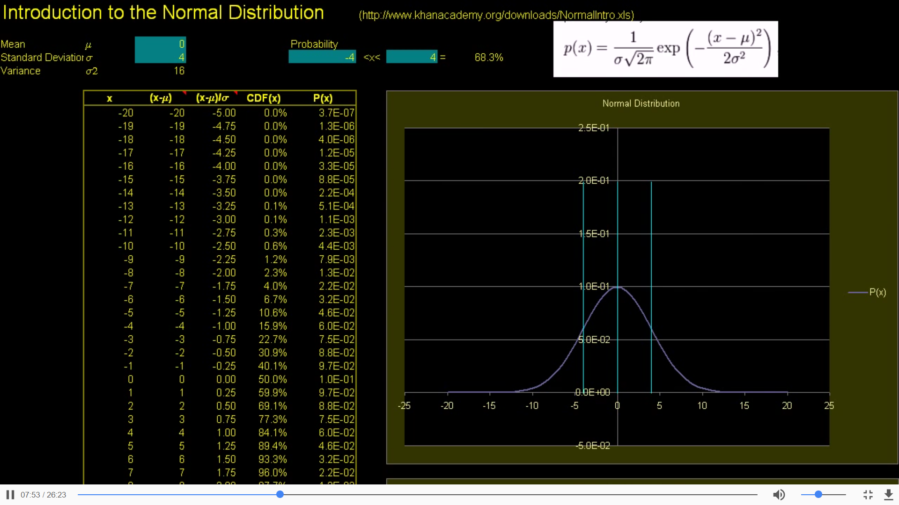

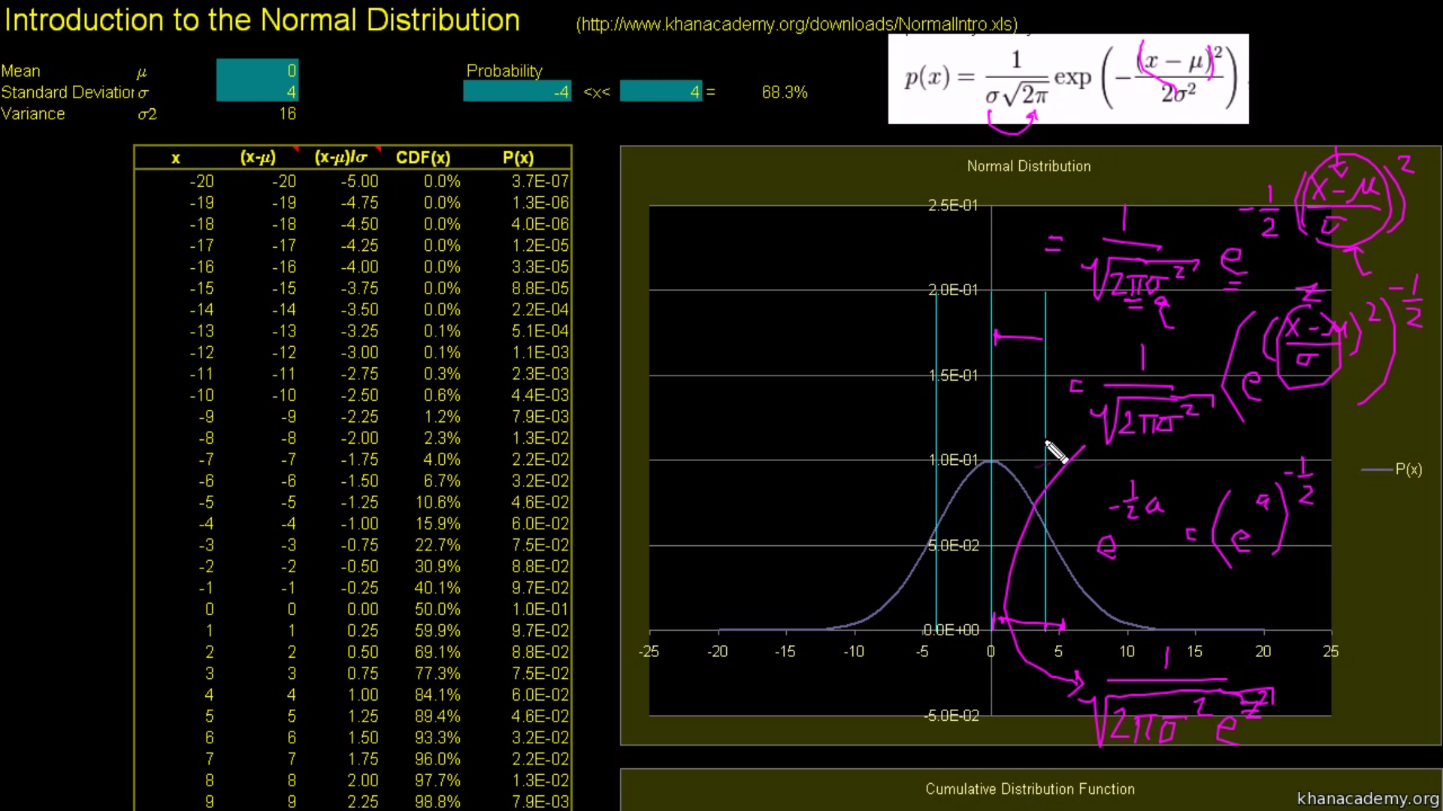

(x-*µ)*  *σ = z-score,*  *σ2= variance*

*P(x) = 1/ $\sqrt{2* π* σ^{2}* e^{z^{2}}}$*

**cumulative distribution function** (**CDF**, also **cumulative density function**) of a real-valued [random variable](https://en.wikipedia.org/wiki/Random_variable) *X*, or just **distribution function** of *X*, evaluated at *x*, is the [probability](https://en.wikipedia.org/wiki/Probability) that *X* will take a value less than or equal to *x. x < 20 的概率大约是100.0*

*-1<x<1的概率= -∞ <x< 1的概率 减去-∞ <x< -1的概率*

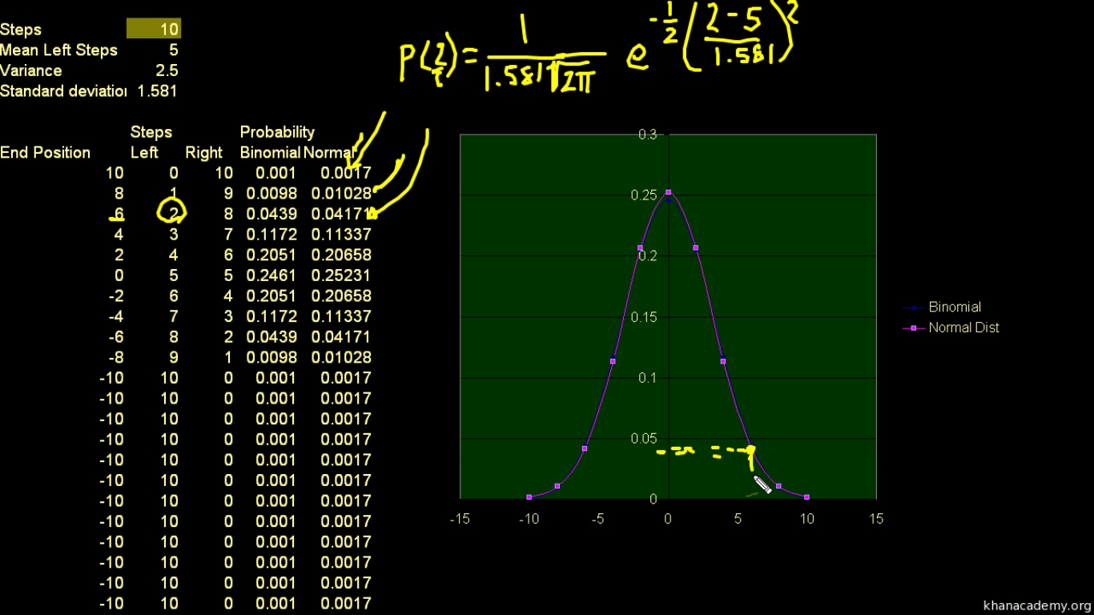

### Normal distribution excel exercise

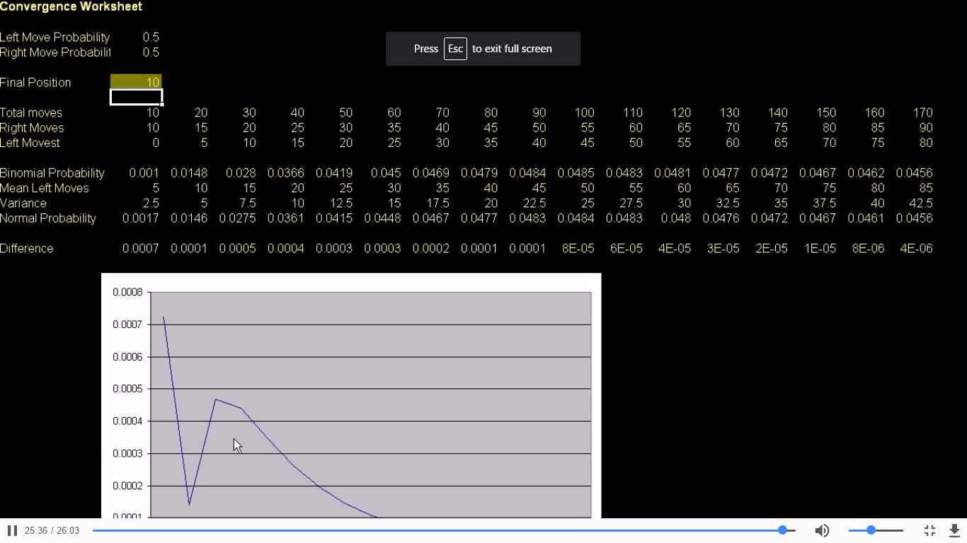

As total number of moves gets larger and larger, the difference between what normal probability distribution tells us and binomial probability of distribution tells us gets smaller and smaller.

## Normal distribution calculations

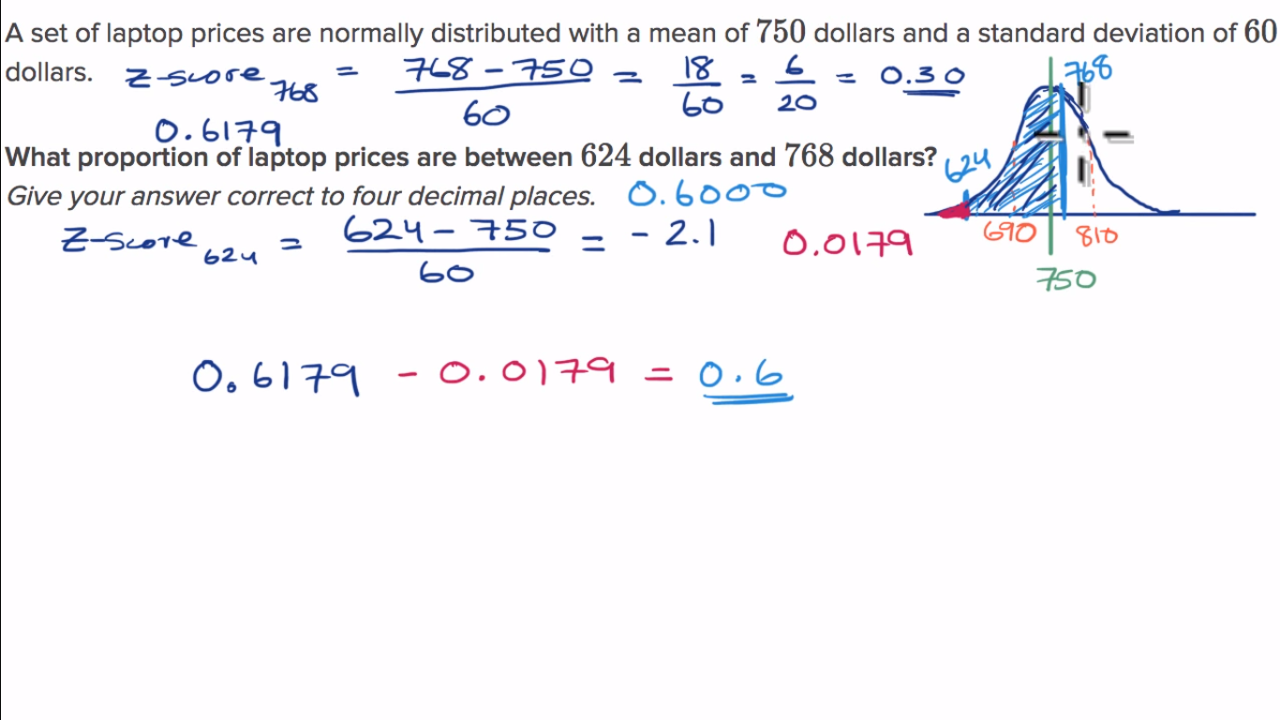

Note that for z-scores, the area under standard normal curve is to the left of z

Z1=-2.1, p1 = 0.6179(check the table from -3.4 to -0.0)

Z2 = 0.3, p2 = 0.0179(check the table from 0.0 to 3.4)

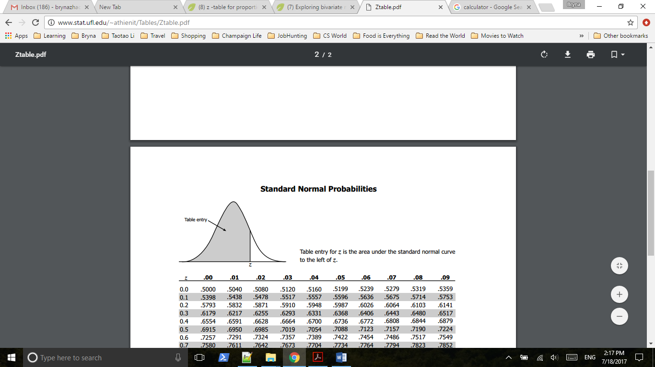

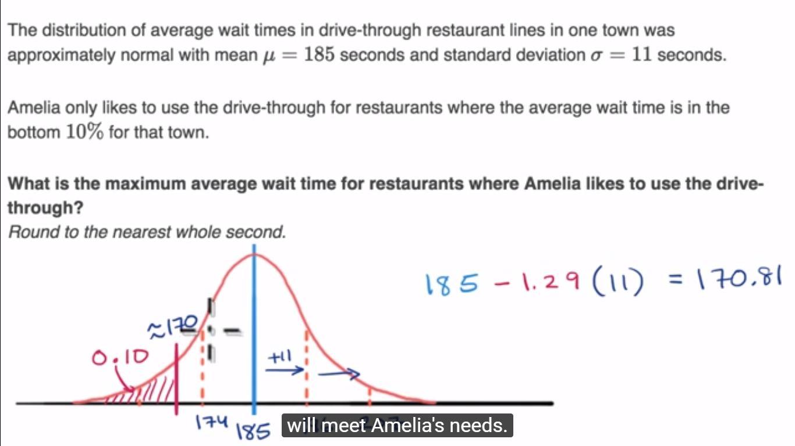

# 6. Exploring bivariate numerical data

## 6.1 Introduction to scatterplots

### Bivariate relationship linearity, strength and direction

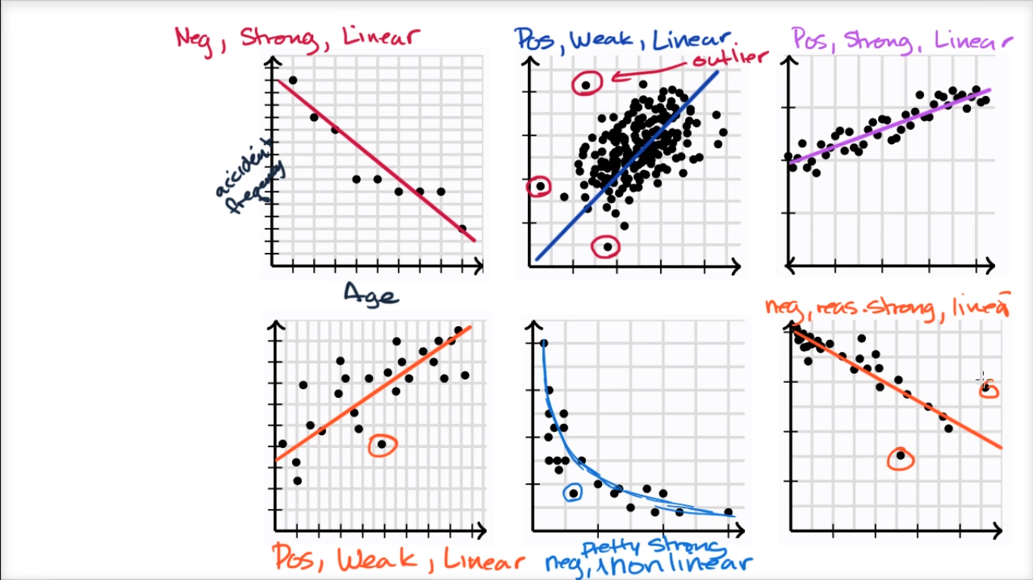

## 6.2 Correlation coefficients

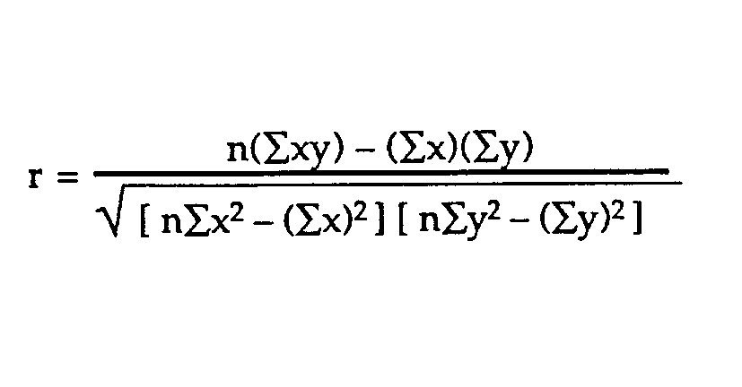

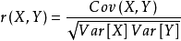

r is coefficient correlation相关系数, r2 is coefficient determination决定系数(表征依变数Y的变异中有多少百分比,可由控制的自变数X来解释)

If r =1, it means that an upwards sloping line can completely describe the relationship

If r=-1, it means a downwards sloping line can completely describe the relationship

If r=0, a line isn’t describing the relationship well at all

If both z-scores are positive ( or negative), it will help contribute an r toward to 1

If one positive one negative, the product is negative, it will take away the sum, r=>-1

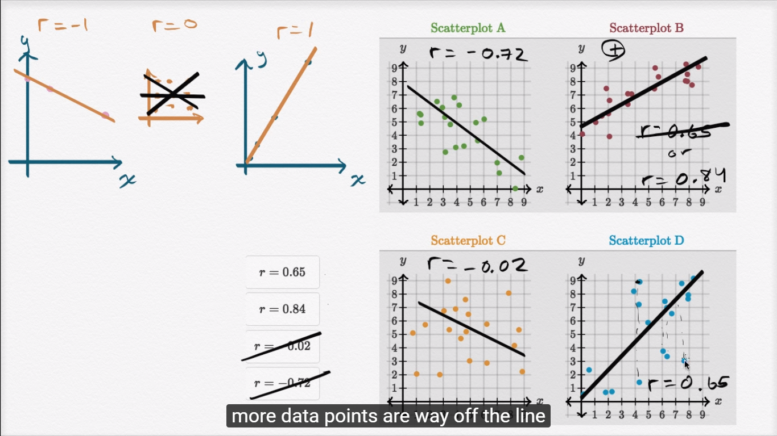

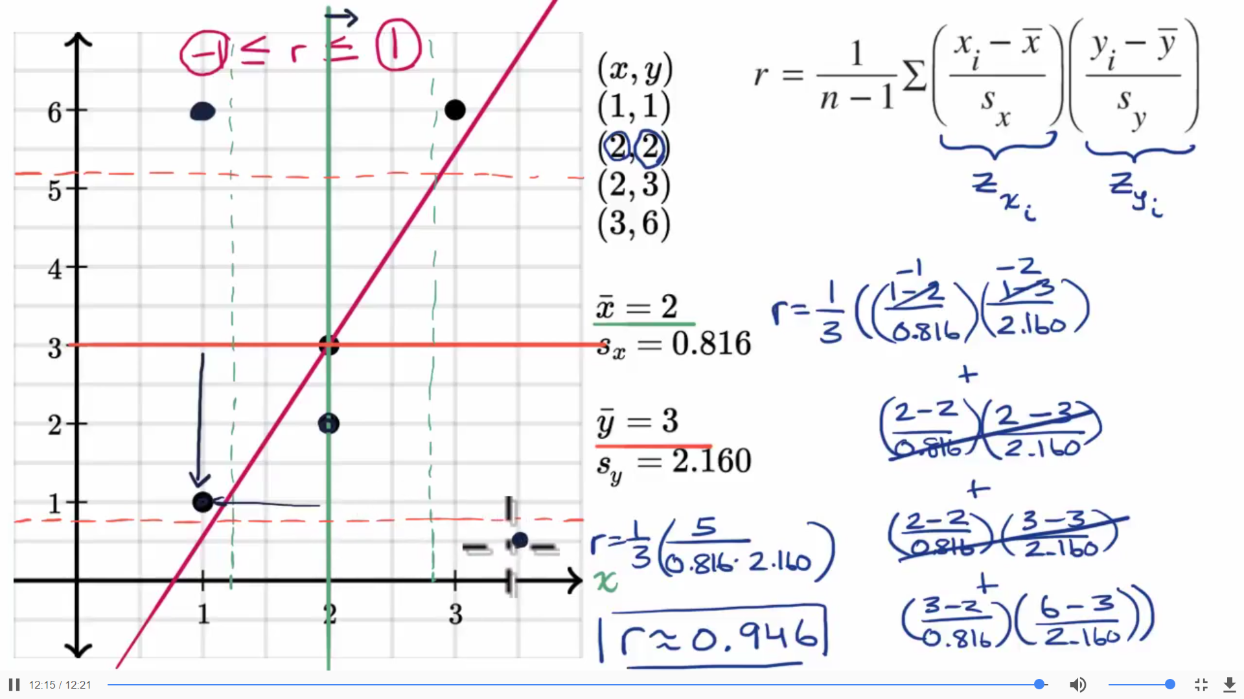

Point (1,2), 两个乘数都是负的，乘积为正，contribute to the R

Point (1,6),x负Y正，成绩为负，will take away the R

## 6.3 Introduction to trend lines

## 6.4 Least-squares regression equations

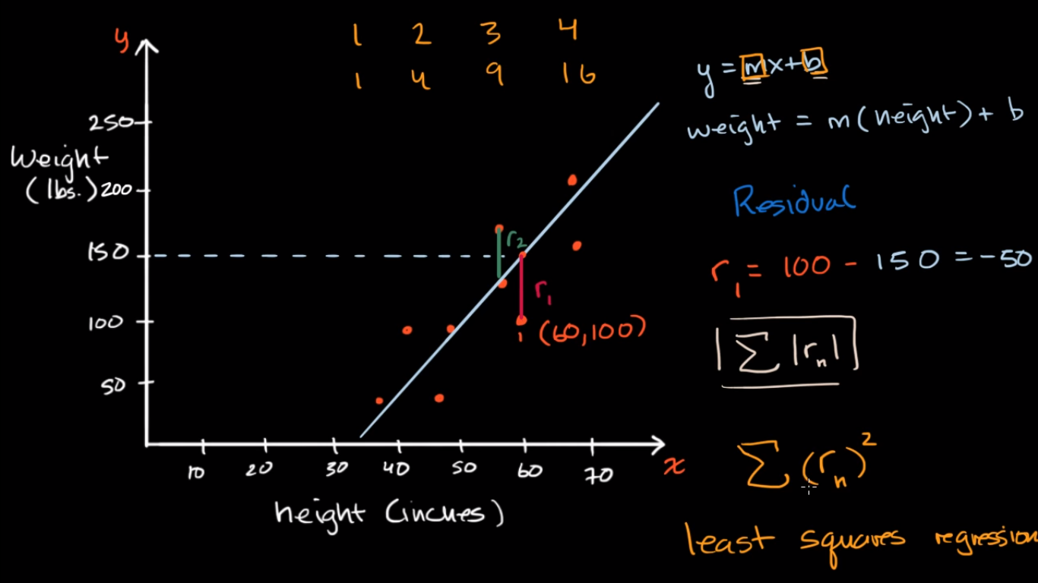

Residual = actual - predicted

The difference between the actual point and what haven been predicted, is called a residual.

### Calculating the equation of a regression line

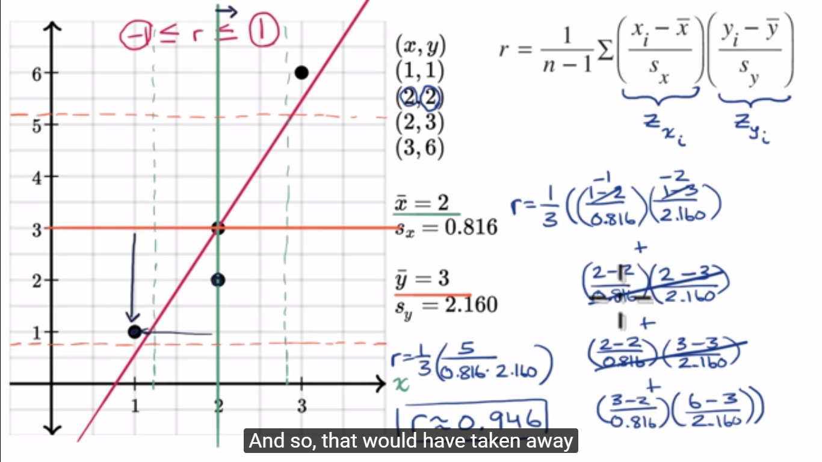̂̂̂

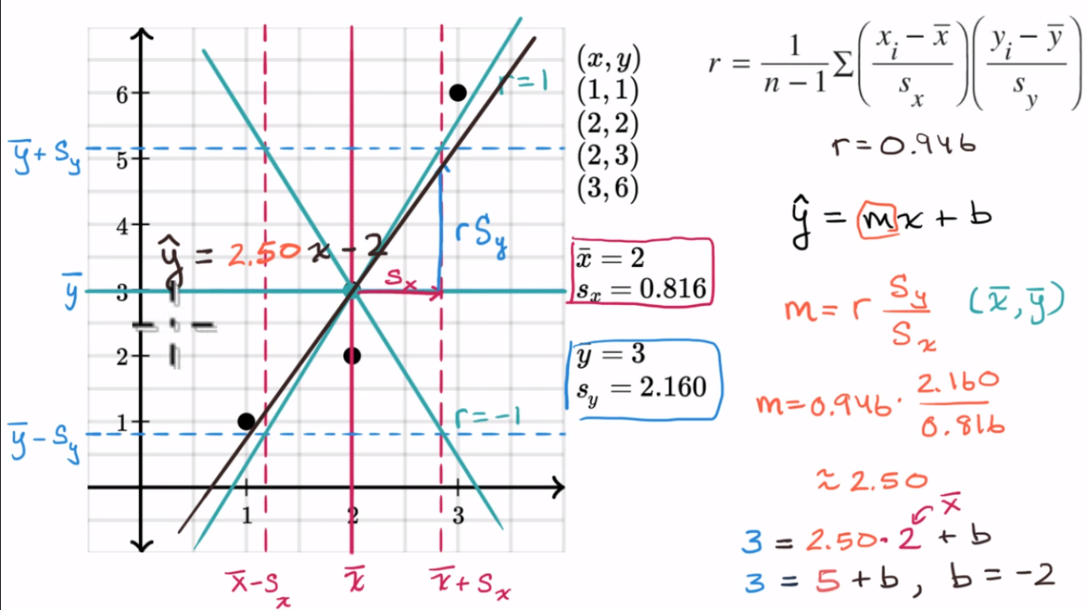

ŷ =mx+b, for regression line, we put a hat over it

For a least squares regression line, it definitely has the point of sample mean of x and sample mean of y (x̅, y̅)

m = r \* (Sy / Sx), when r = 1, m = Sy / Sx

## 6.5 Assessing the fit in least-squares regression

### Residual plots

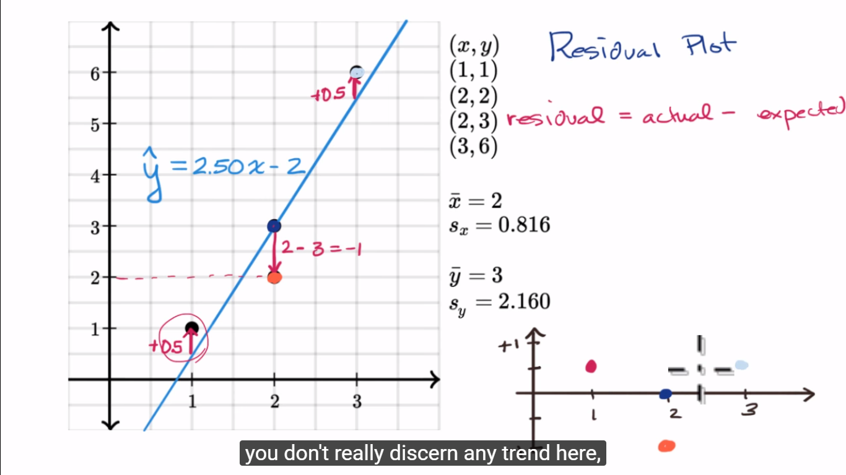

If you see some type of trend, isn’t a good fit. Maybe try a non-linear model.

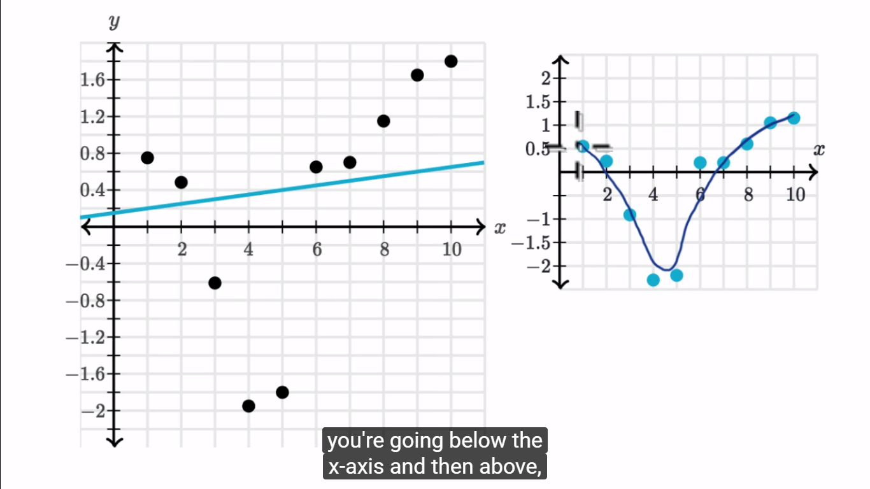

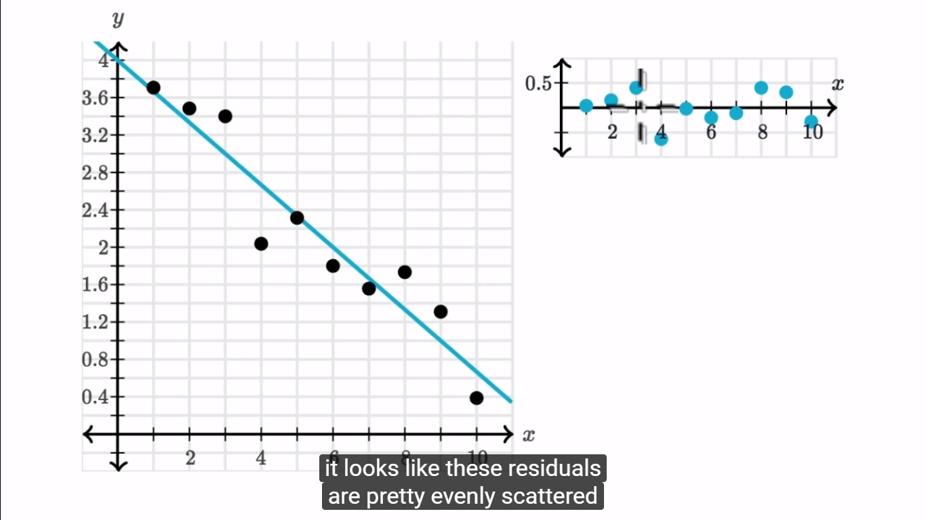

This is a good fit.

### R-squared or coefficient of determination

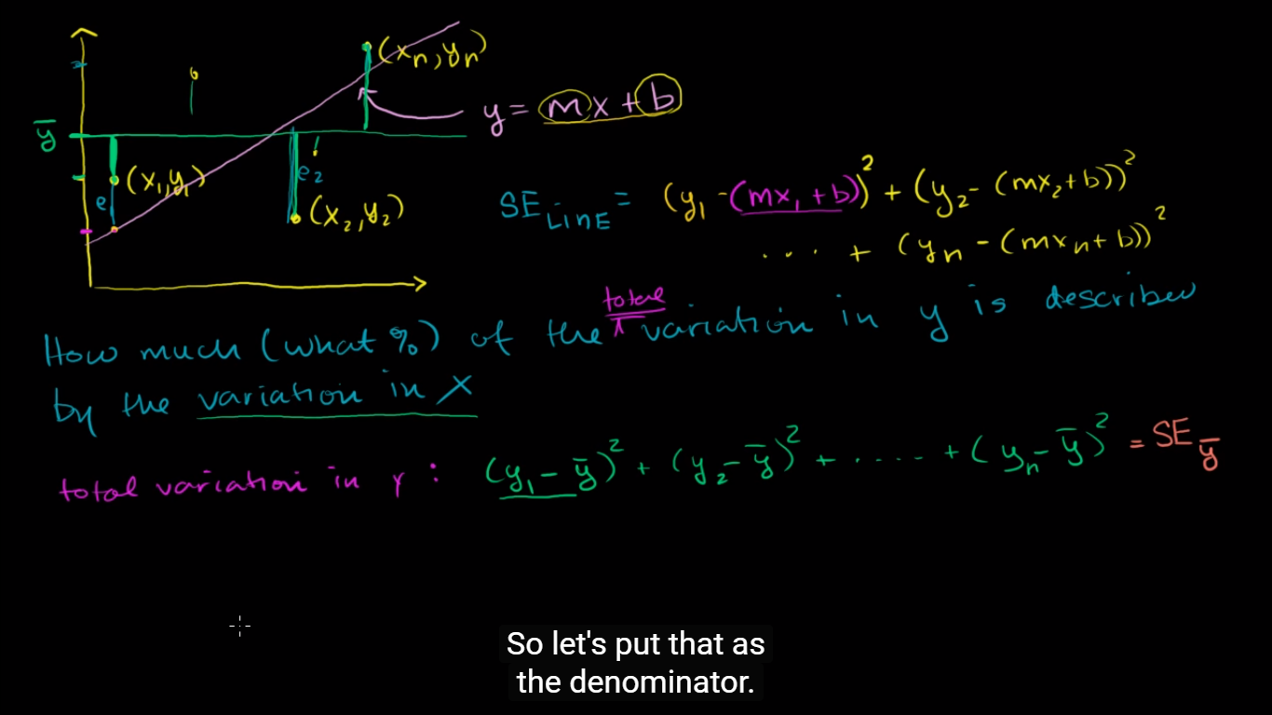

SEline is the squared error from the line, is how much of the variation in y is not described by the regression line;

SEy̅ is the squared error from y’s mean, or the total variation in y

SEline/ SEy̅ is how much (what %) of the total variation is not described by the variation in x ( or the line)

1- SEline/ SEy̅ is r2, coefficient determination

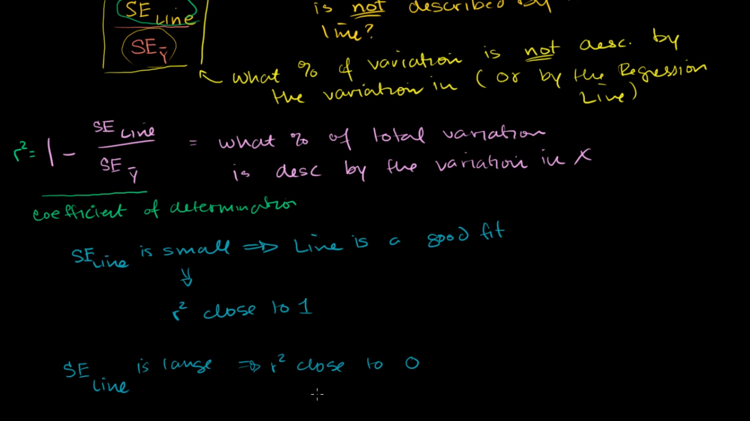

SEline is small, r2 close to 1; big, close to 0

### Standard deviation of residuals or Root-mean-square error (RMSD)

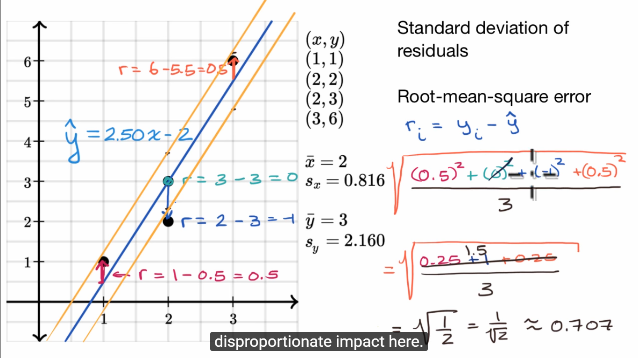

We are squaring the residuals, so outliers will have disproportionate impact here.

Another way, we could find the mean and calculate the absolute residuals, but the first way better xplains how much a model disagrees with the actual data.

### Interpreting computer regression data

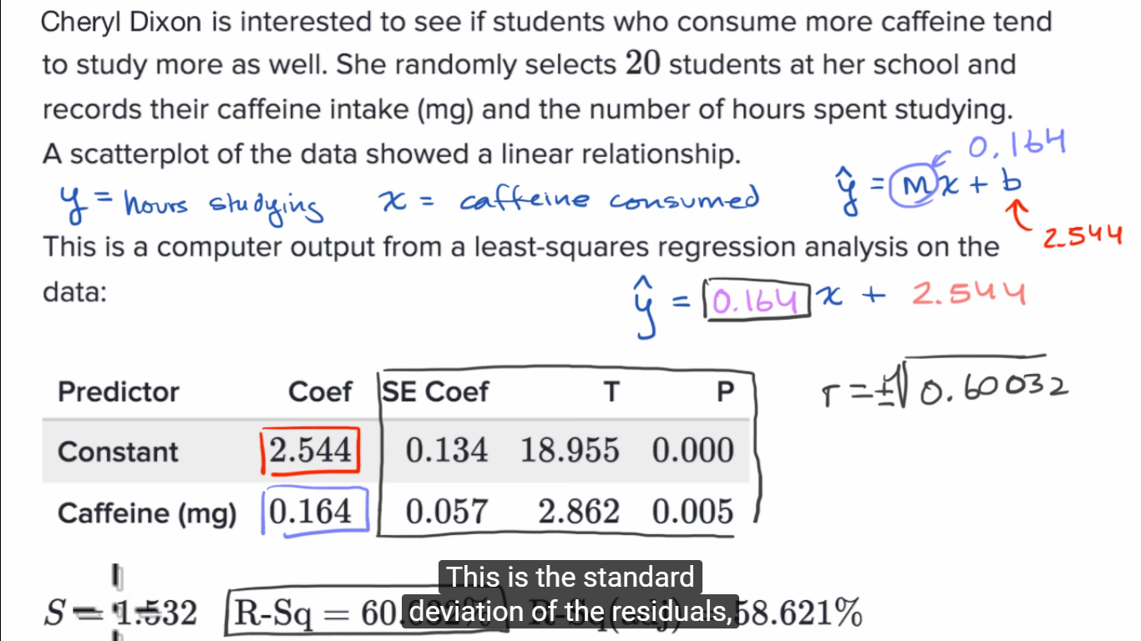

Coefficient => m

Constant => b

R has the same + or – as m

### Impact of removing outliers on regression lines

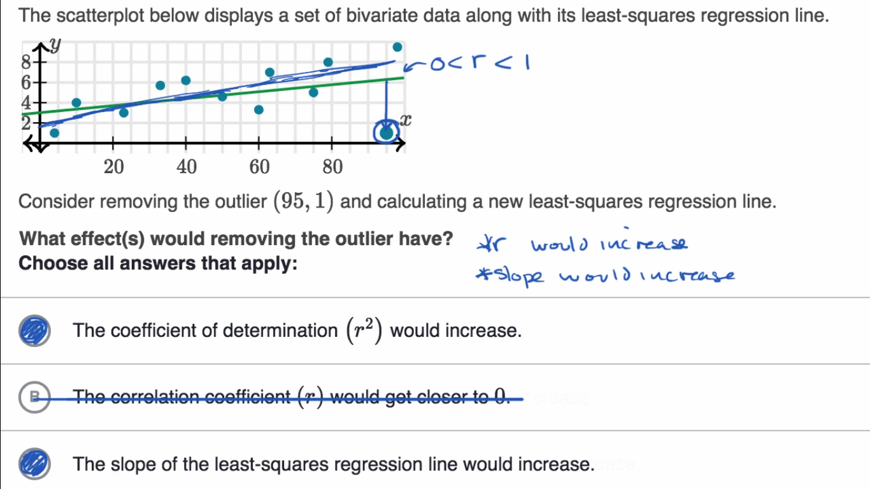

## 6.6 More on regression

### Regression line example

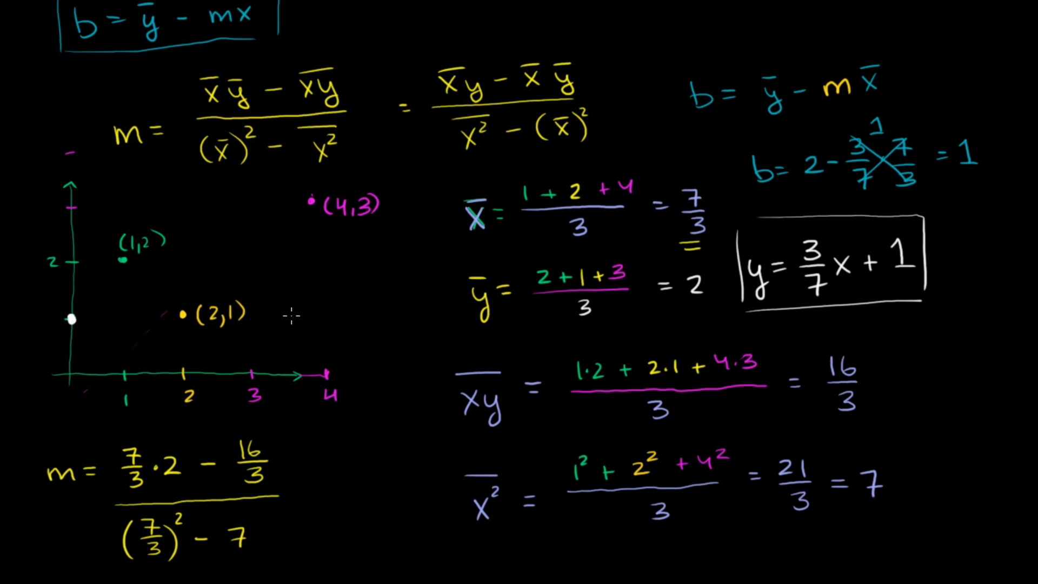

### Calculating R-squared

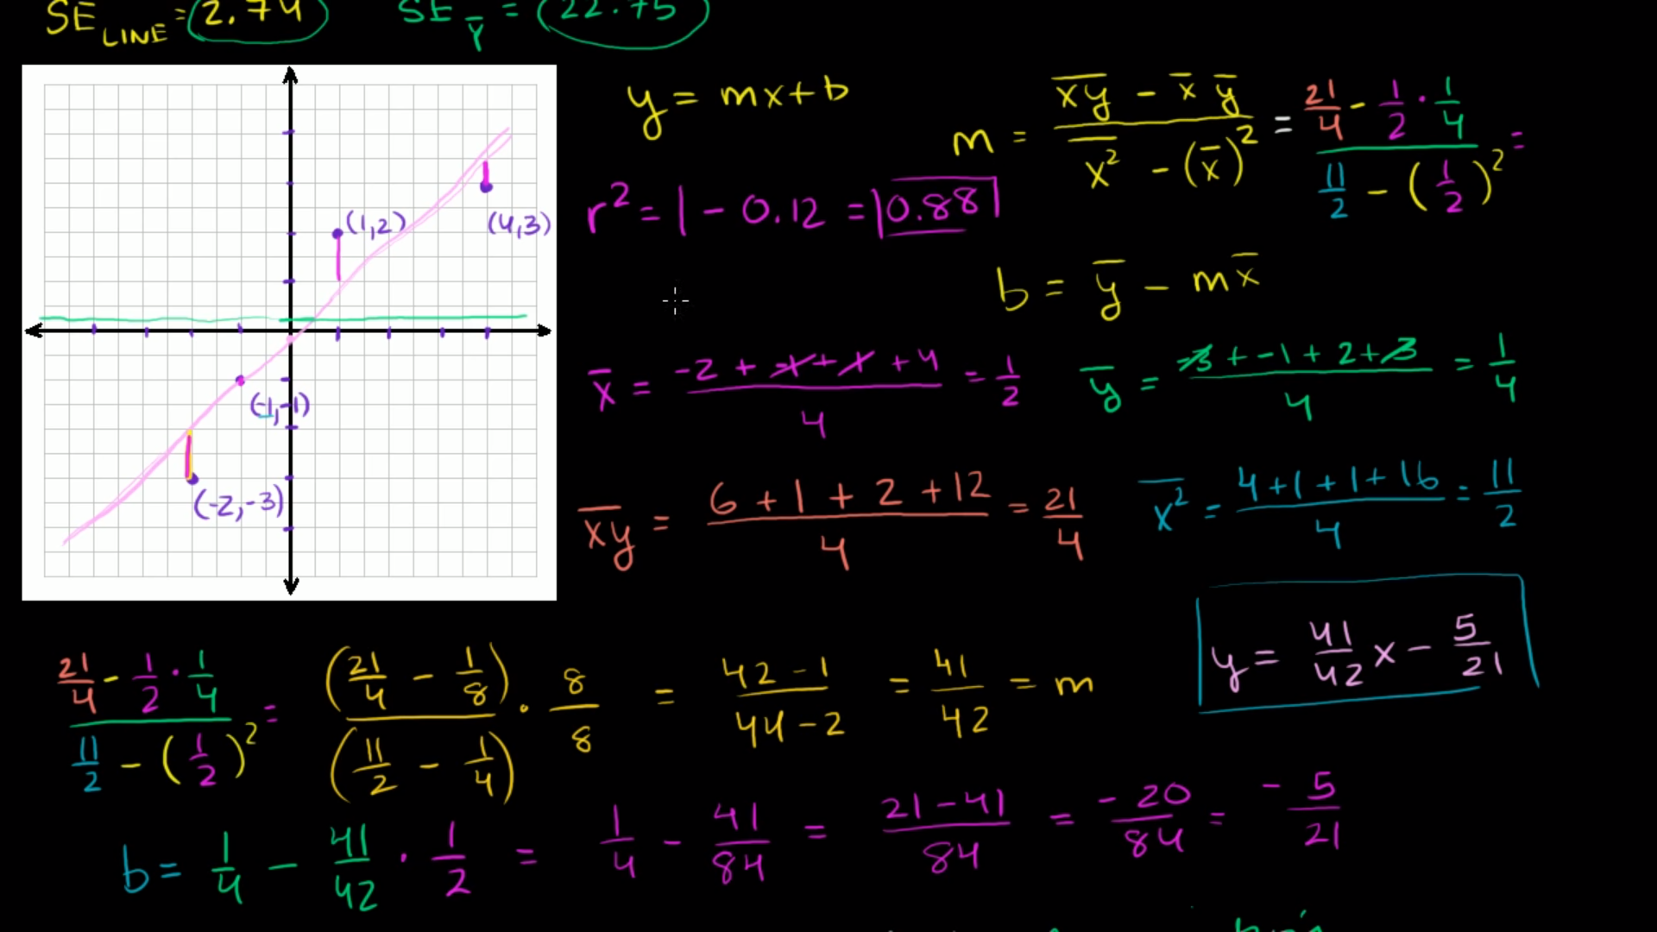

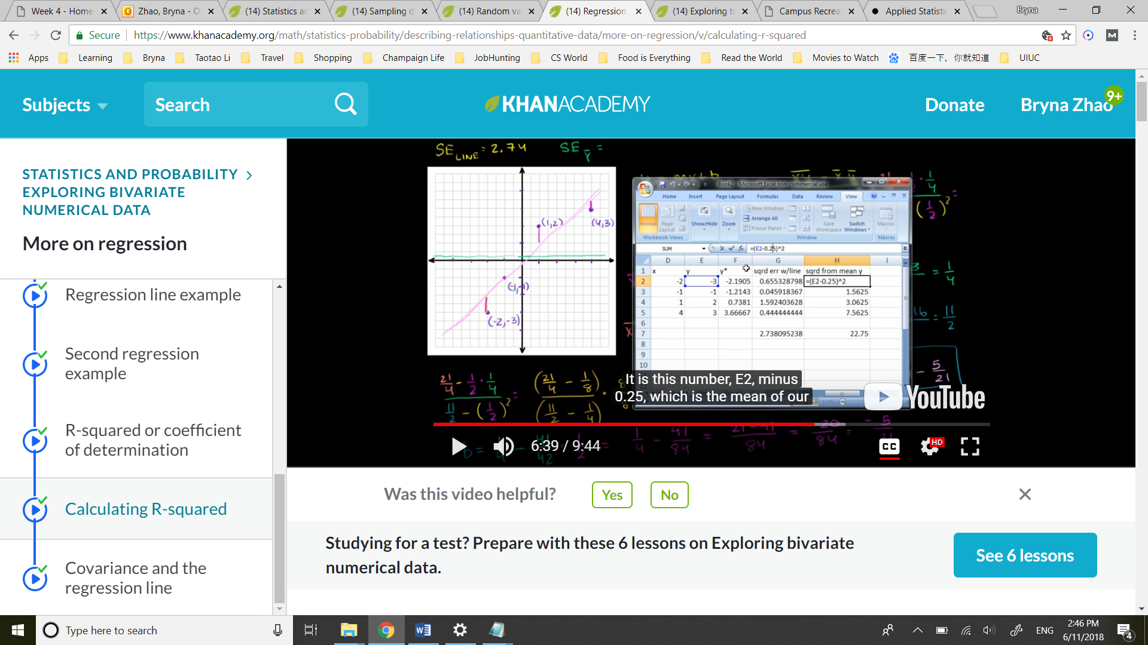

R2 = 1 – sqrd error / sqrd from mean y

The **Gauss–Markov theorem** tells us that when estimating the parameters of the simple linear regression model β0 and β1, the β^0 and β^1 which we derived are the **best linear unbiased estimates**, or BLUE for short.

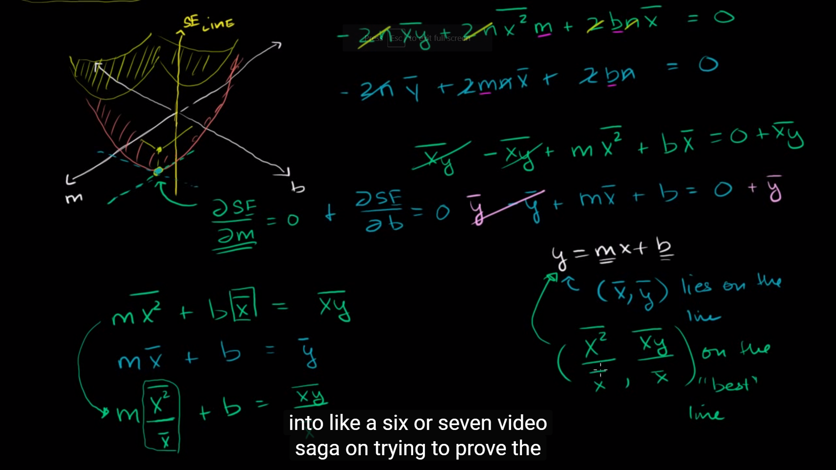

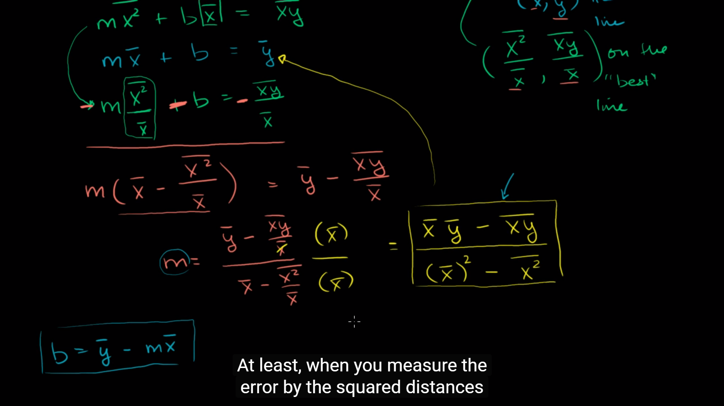

# 7. Probability

## Multiplication rule

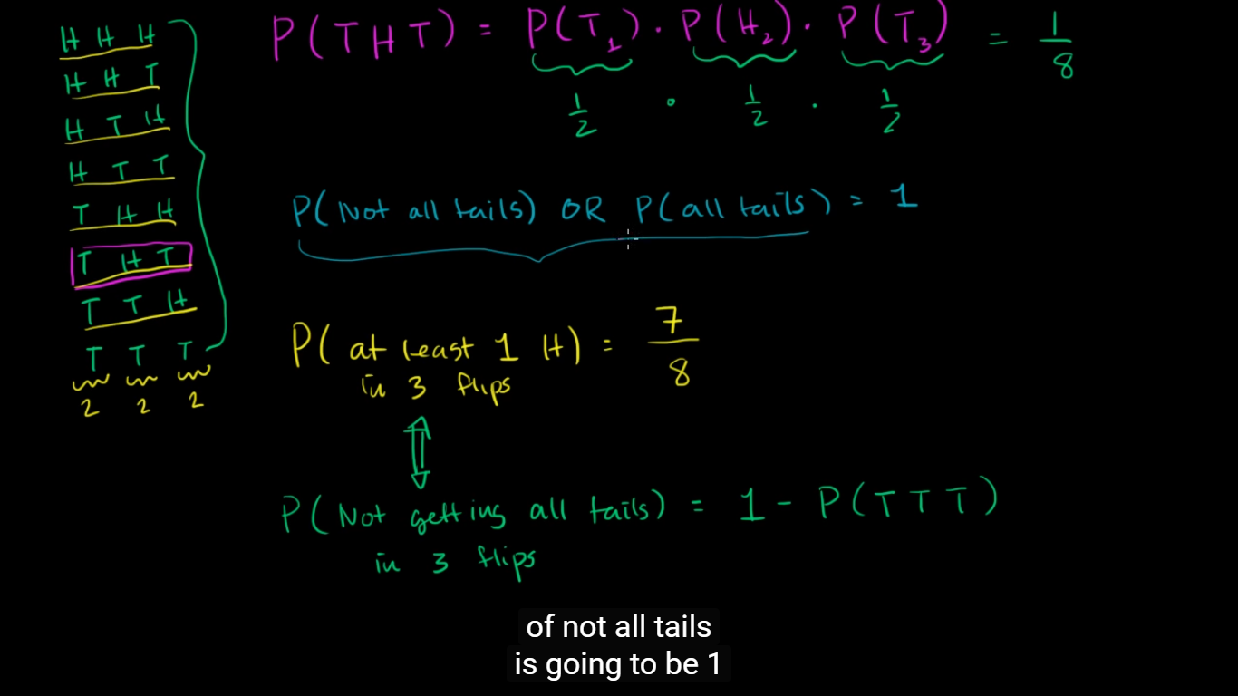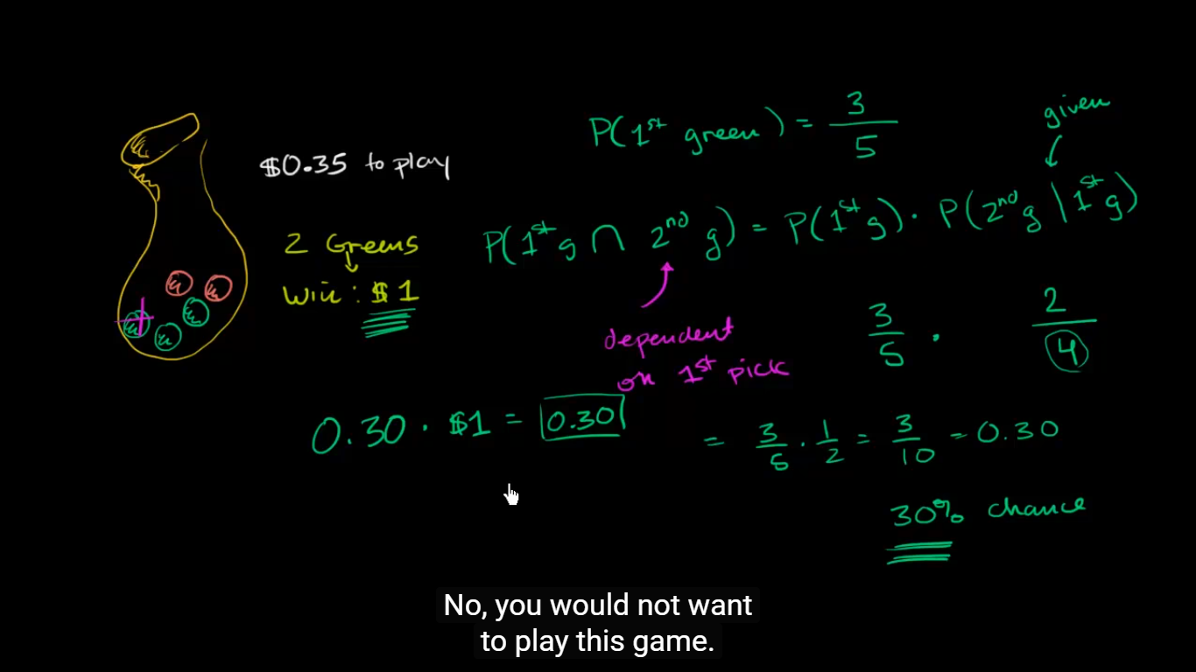

## Conditional probability

### Conditional probability with Bayes' Theorem

1 fair coin and 1 double-sided coin, heads, what is the probability that he flips the fair coin?

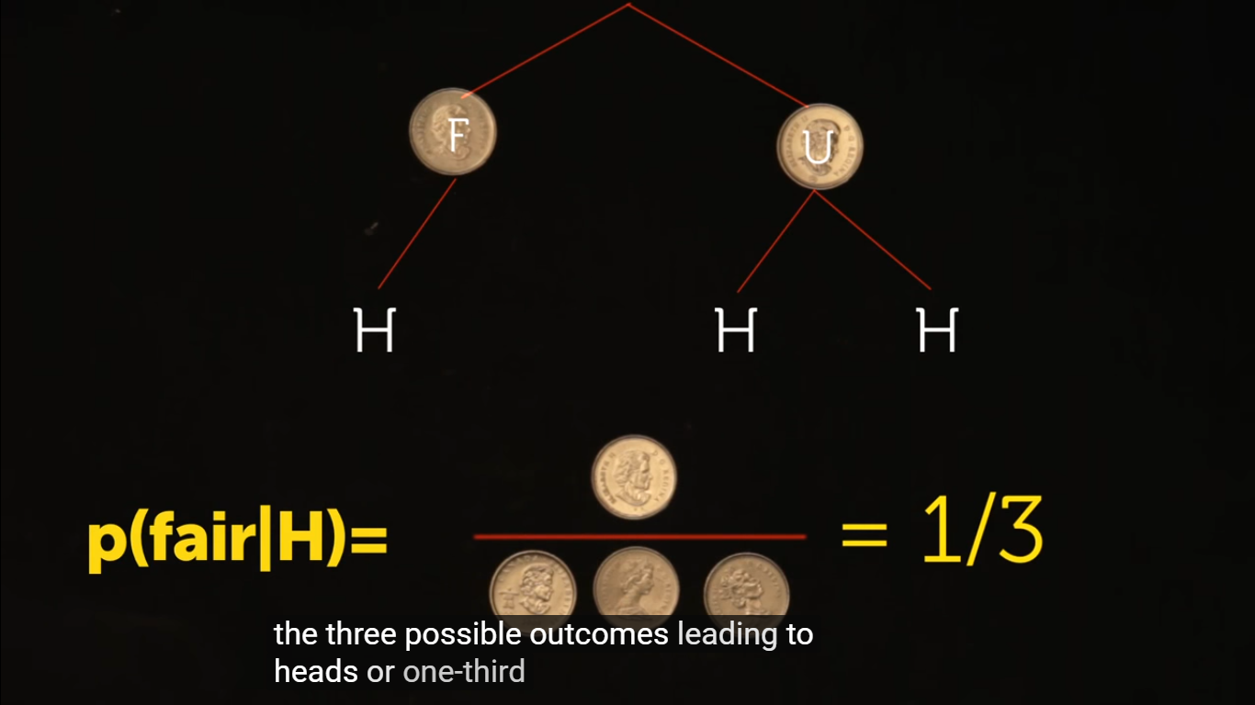

Flip again and heads, what is the probability that he flips the fair coin?

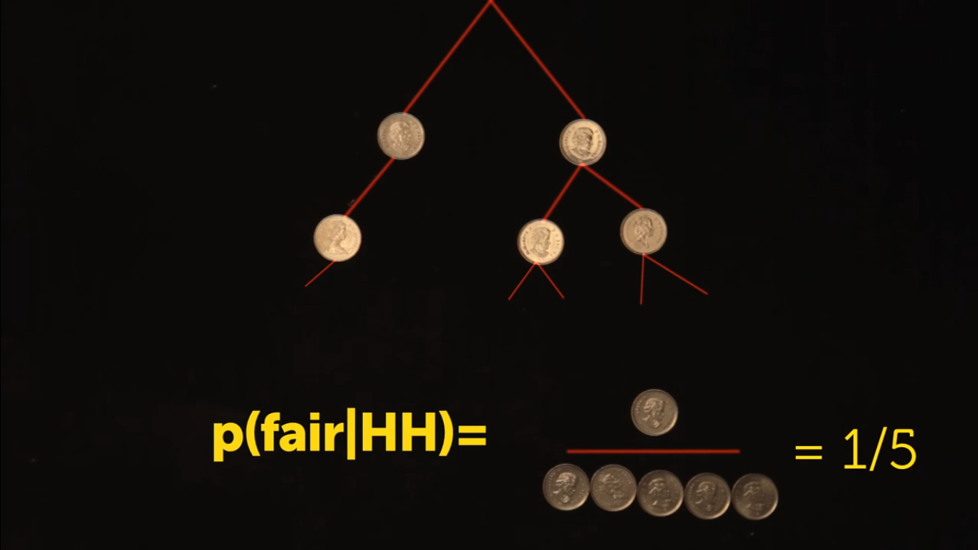

3 coins, 2 fair, 1 biased (2/3 of the time lands heads)

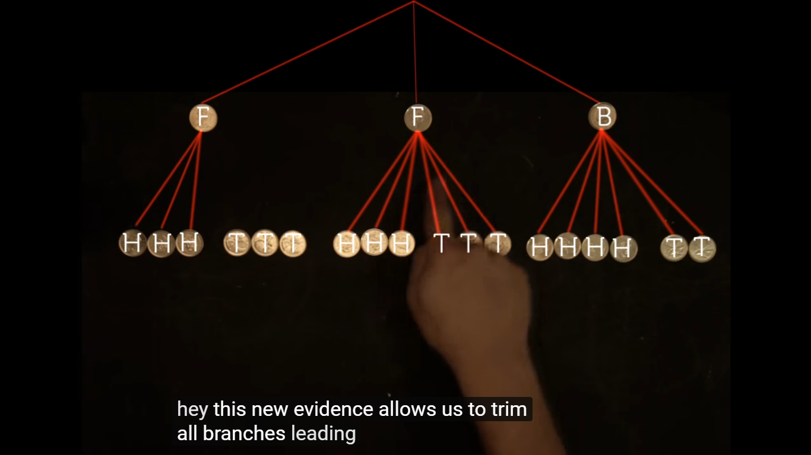

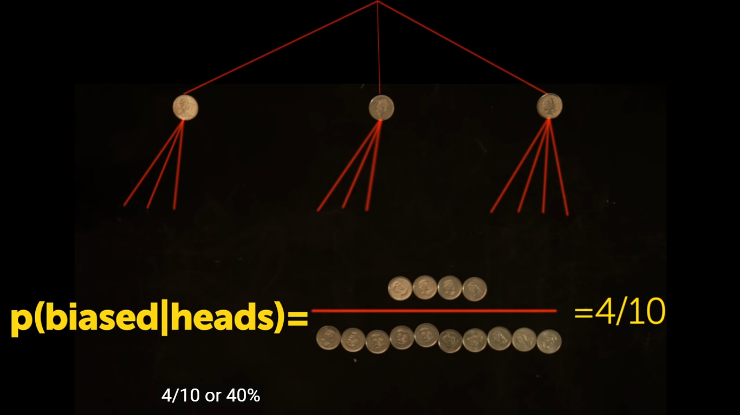

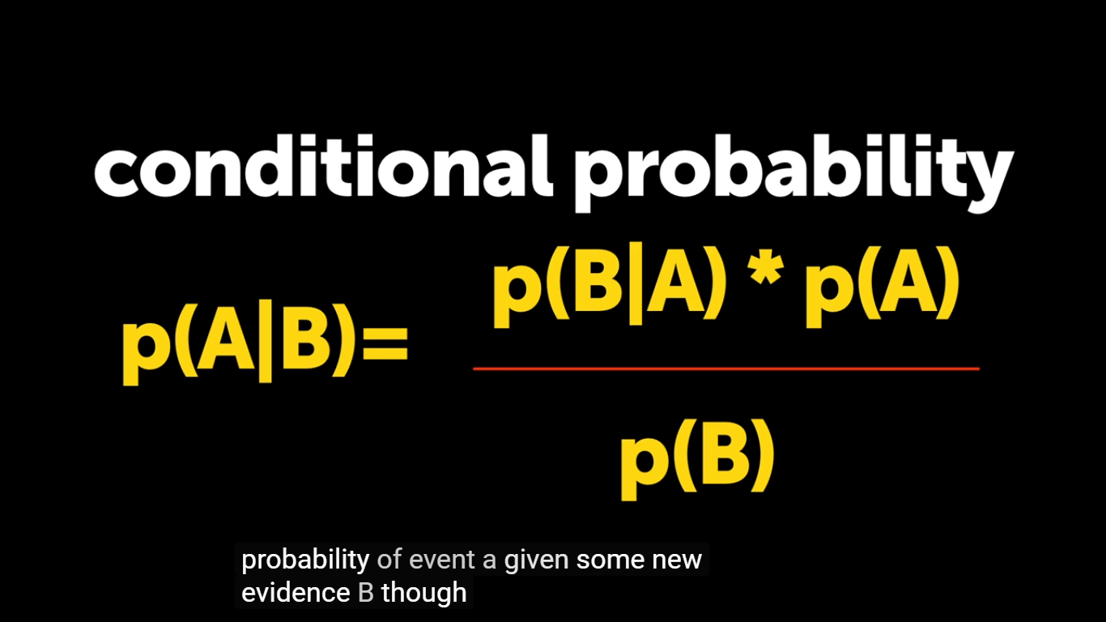

### Conditional probability and independence

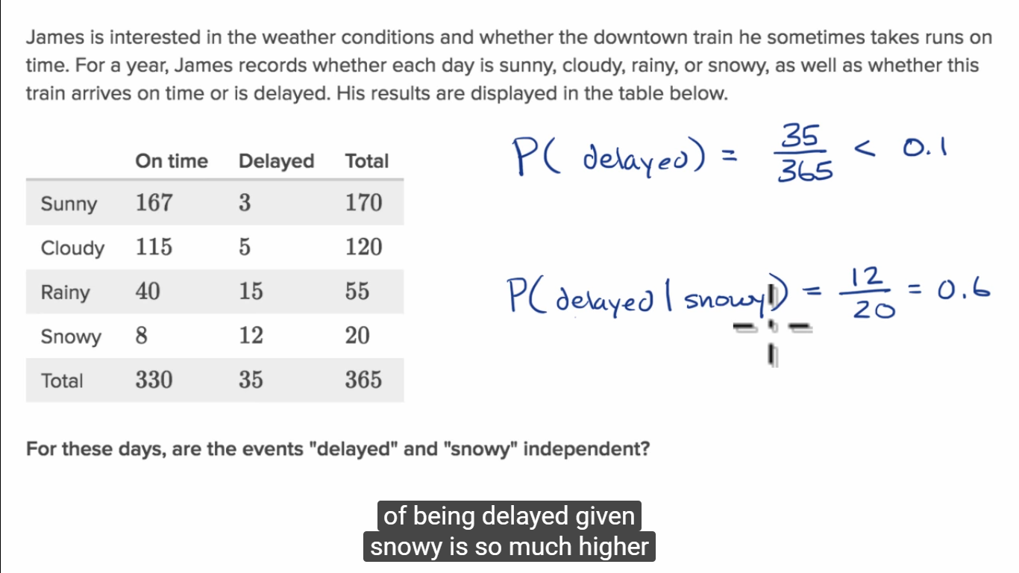

Not independent

### Conditional probability tree diagram example

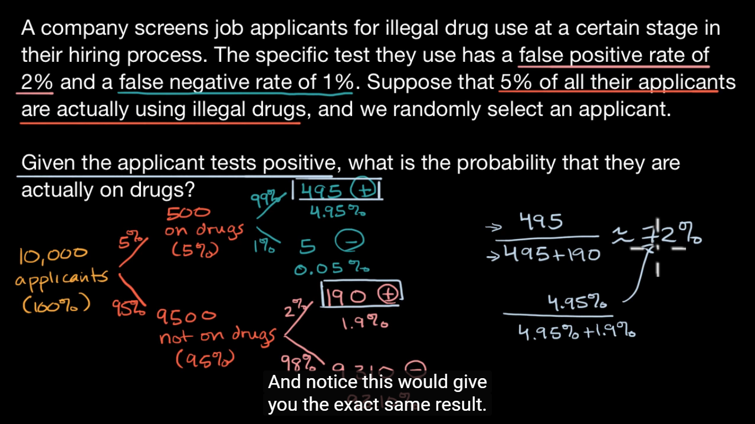

Why 28% is much larger than 2%, is because at the original division, between those who take drugs and don’t take drugs, most don’t take. 2% of the larger group leads to a greater influence of false positive rate.

Review:

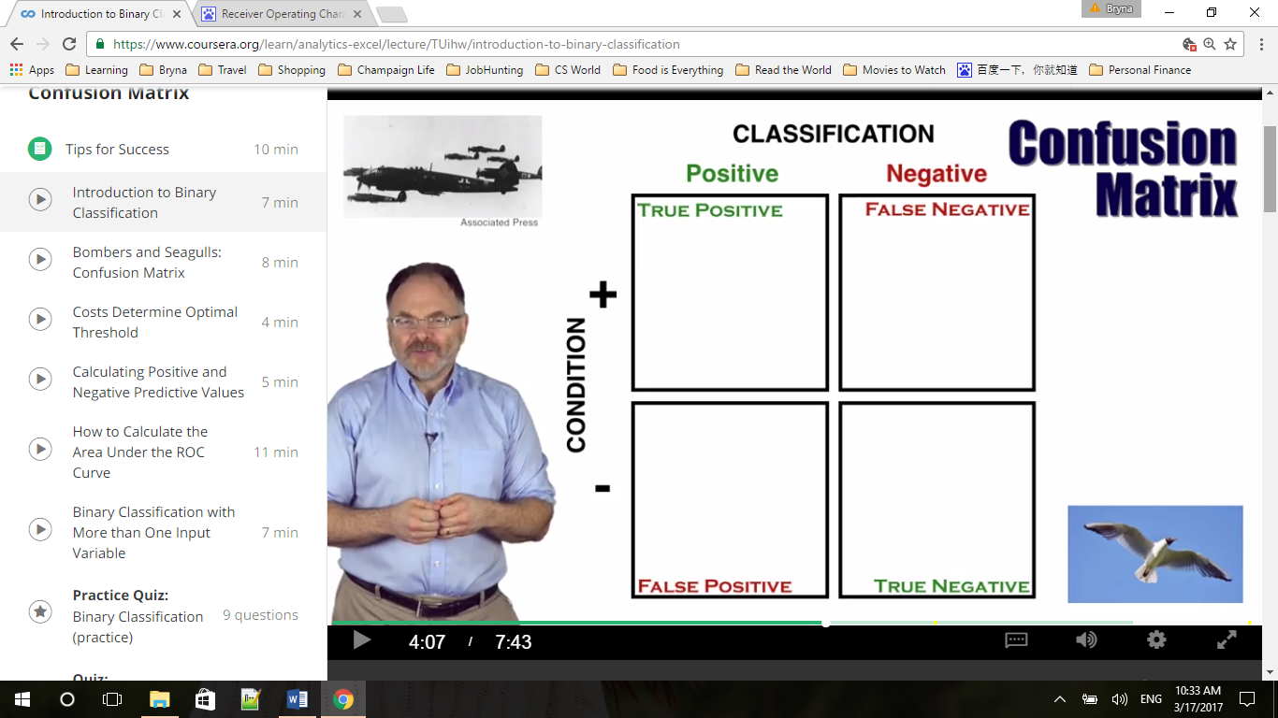

Note that a false positive rate is the total number of false positive classifications, divided by total number of seagulls( not positive) . The true positive rate is the total number of true positive classification, divided by the total number of bombers.

FPR = FP/(FP+TN) 假正类率

TPR = TP/(TP+FN) 真正类率

TNP = TN/(FP+TN) 真负类率 1-FPR

|  |  |  |  |  |  |  |  |
| --- | --- | --- | --- | --- | --- | --- | --- |
| Confusion Matrix |  |  |  |  |  |  |  |
| Total 10000 |  |  |  | Test Classification  **Y** | | |  |
|  |  |  |  | "Positive" |  | "Negative" | |
|  |  |  |  | 495+190 | c |  | d |
|  |  |  |  |  |  |  |  |
| Condition **X** | "+" | 500 | a | 99%\*500=495 | e | 1%\*500 | f |
|  |  |  |  |  |  |  |  |
|  | "-" | 9500 | b | 2%\*9500=190 | g | 98%\*9500 | h |
|  |  |  |  |  |  |  |  |

|  |  |  |  |  |  |  |  |
| --- | --- | --- | --- | --- | --- | --- | --- |
| Conditional Probabilities | |  |  | Name |  |  |  |
| p(Test POS | "+") |  | e/a | 0.60 | True Positive Rate | |  |  |
| p(Test NEG | "+") |  | f/a | 0.40 | False Negative Rate | | |  |
| p(Test POS | "-") |  | g/b | 0.03 | False Positive Rate | |  |  |
| p(Test NEG | "-") |  | h/b | 0.97 | True Negative Rate | | |  |
|  |  |  |  |  |  |  |  |
| p("+" | Test POS) |  | e/c | 0.90 | Positive Predictive Value (PPV) | | | |
| p( "-" | Test POS) |  | g/c | 0.10 | 1- PPV |  |  |  |
| p("+" | Test NEG) |  | f/d | 0.15 | 1- NPV |  |  |  |
| p("-" | Test NEG) |  | h/d | 0.85 | Negative Predictive Value (NPV) | | | |

So in this case, given FNR, FPR => PPV(e/c)

# 8. Random variables

## Discrete random variables

Expected value of a discrete random variable, E(X) or µ or µX, is the 'long-run mean' in the sense that, if as more and more values of the random variable were collected (by sampling or by repeated trials of a probability activity), the sample mean becomes closer to the expected value.

Variance and standard deviation of a discrete random variable

σ =  

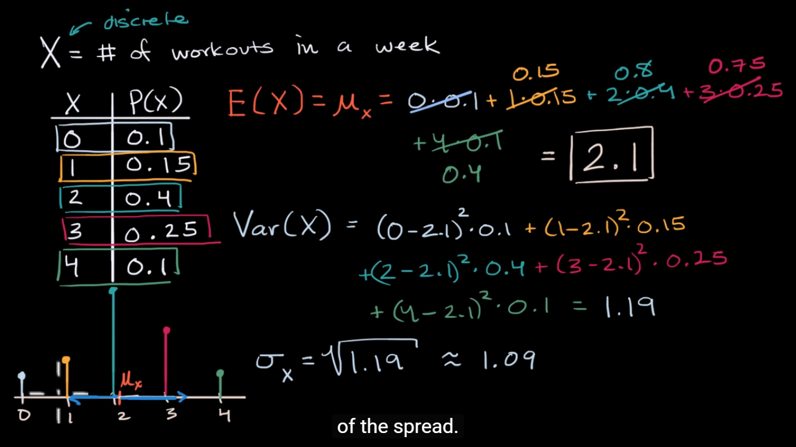

## Transforming and combining random variables

#### Example transforming a discrete random variable

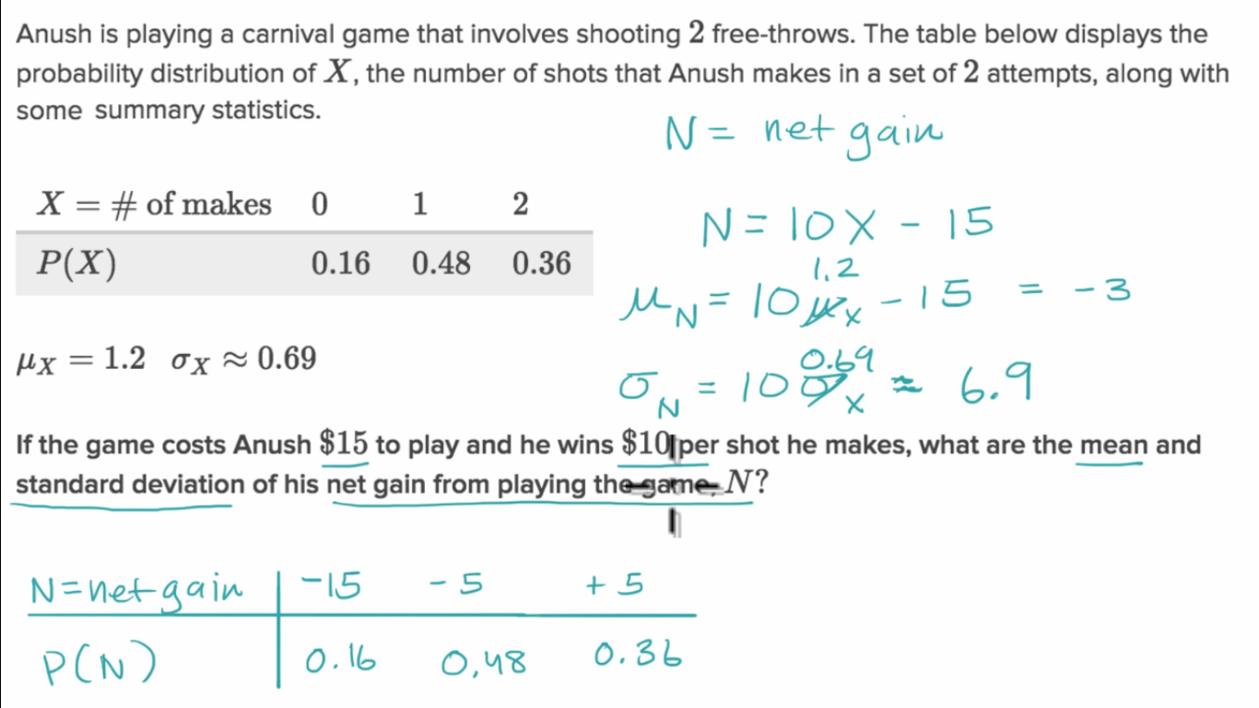

If you scale a random variable, the corresponding mean will be scaled by the same amount. If you shift a random variable, the corresponding mean will be shifted by the same amount. Therefore, mean of N will be 10 times of the mean of X minus 15, while for standard deviation, shift should not affect the spread, only scale matters.

#### Analyzing distribution of sum of two normally distributed random variables

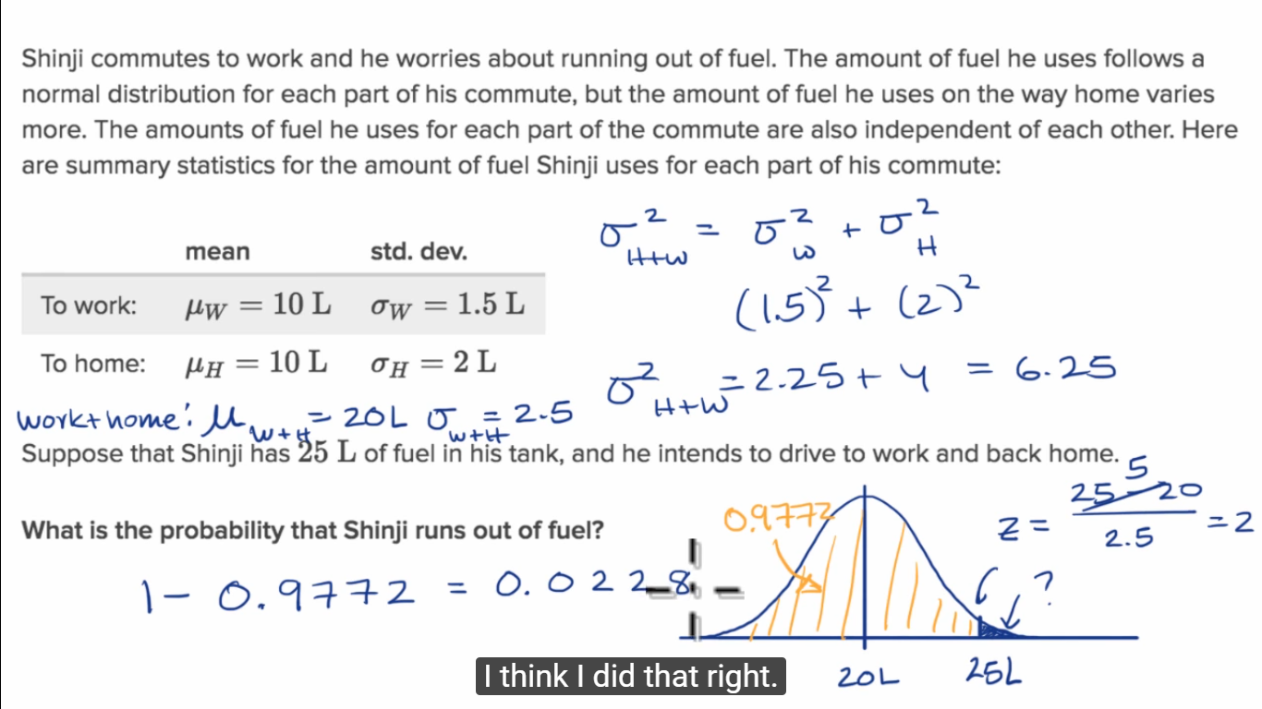

Amazingly, the distribution of a sum of two [normally distributed](http://mathworld.wolfram.com/NormalDistribution.html) independent variates  and  with means and variances  and , respectively is another normal distribution

|  |  |
| --- | --- |
| P_(X+Y)(u)=1/(sqrt(2pi(sigma_x^2+sigma_y^2)))e^(-[u-(mu_x+mu_y)]^2/[2(sigma_x^2+sigma_y^2)]), |  |

which has mean

|  |  |
| --- | --- |
| mu_(X+Y)=mu_x+mu_y |  |

and variance

|  |
| --- |
| sigma_(X+Y)^2=sigma_x^2+sigma_y^2. |

#### Analyzing the difference in distributions

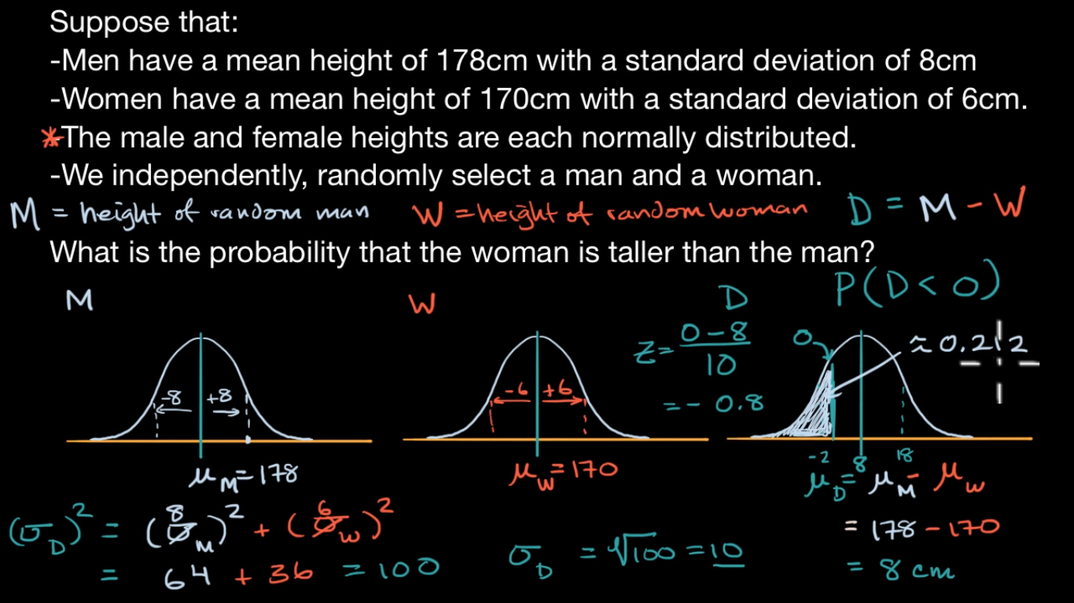

the distribution of a difference of two [normally distributed](http://mathworld.wolfram.com/NormalDistribution.html) variates  and  with means and variances  and , respectively, is given by

|  |  |  |  |
| --- | --- | --- | --- |
| P_(X-Y)(u) | = | int_(-infty)^inftyint_(-infty)^infty(e^(-x^2/(2sigma_x^2)))/(sigma_xsqrt(2pi))(e^(-y^2/(2sigma_y^2)))/(sigma_ysqrt(2pi))delta((x-y)-u)dxdy |  |
| http://mathworld.wolfram.com/images/equations/NormalDifferenceDistribution/Inline8.gif | = | (e^(-[u-(mu_x-mu_y)]^2/[2(sigma_x^2+sigma_y^2)]))/(sqrt(2pi(sigma_x^2+sigma_y^2))), |  |

where  is a [delta function](http://mathworld.wolfram.com/DeltaFunction.html), which is another [normal distribution](http://mathworld.wolfram.com/NormalDistribution.html) having mean

|  |  |
| --- | --- |
| mu_(X-Y)=mu_x-mu_y |  |

and [variance](http://mathworld.wolfram.com/Variance.html)

|  |
| --- |
| sigma_(X-Y)^2=sigma_x^2+sigma_y^2. |

## Poisson process

# 9. Sampling Distributions

## 9.1 What is a sampling distribution?

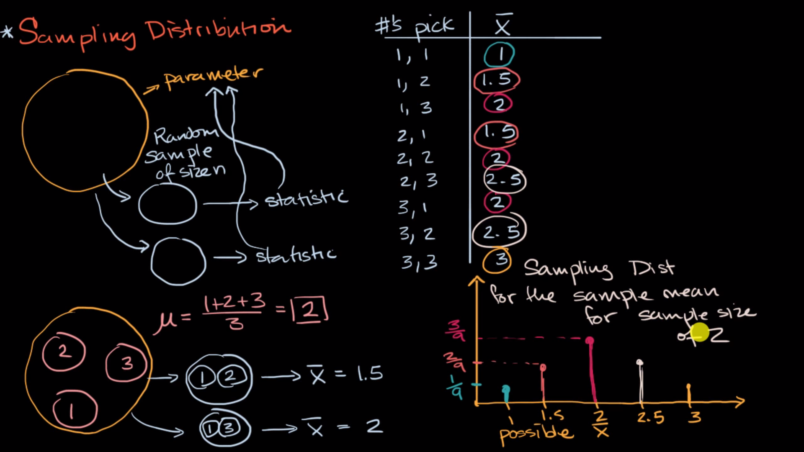

# 10. Confidence intervals

## 10.1 Introduction to confidence intervals

### Confidence intervals and margin of error

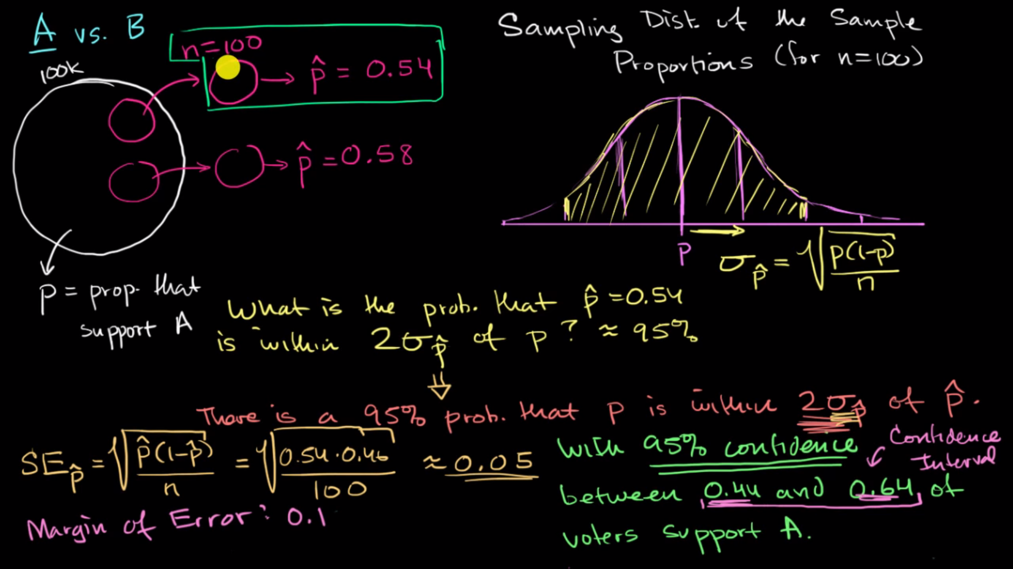

There’s 95% chance that our sample proportion is within two standard deviation of the true proportion.

Is equivalent to

There is a 95% probability that the population proportion p is within two standard deviations of p-hat

margin of error = standard deviation \* critical value

SEp-hat \* 2(sd) = 0.05 \* 2 = 0.1

0.54 – 0.1 = 0.44, 0.54 + 0.1 = 0.64, 0.44 ~ 0.64 confidence interval

### Confidence interval simulation

And when sample size increases, the confidence interval narrows.

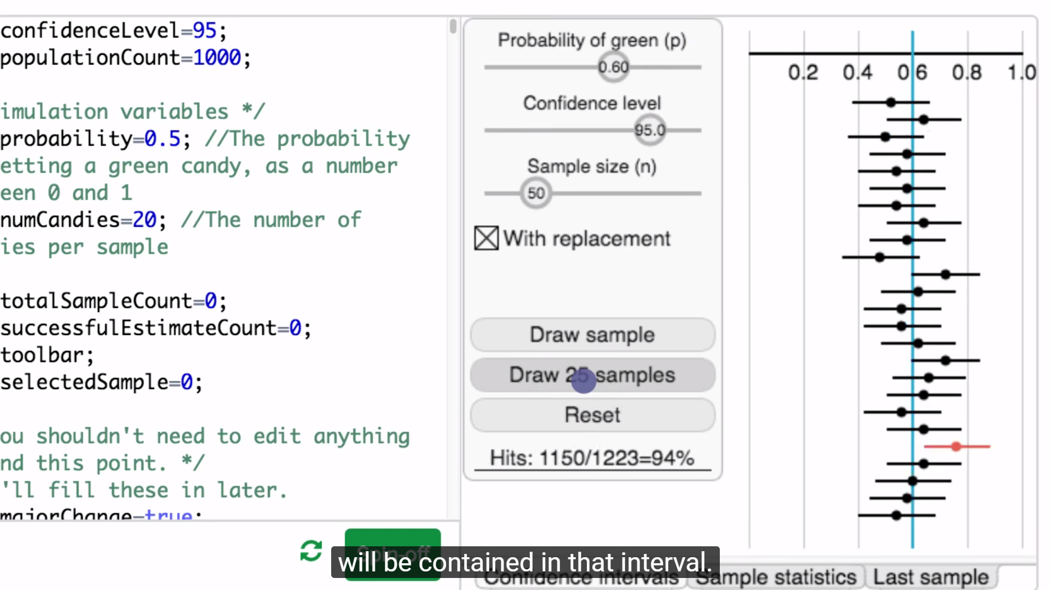

### Interpreting confidence level example

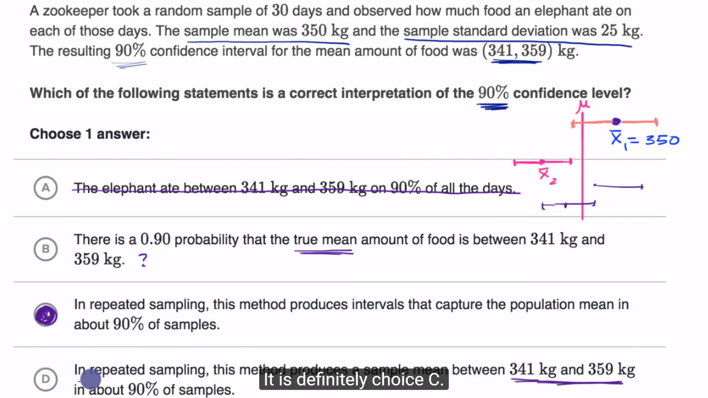

## 10.2 Estimating a population proportion

### Margin of error 1

## 10.3 Estimating a population mean

### Introduction to t statistics

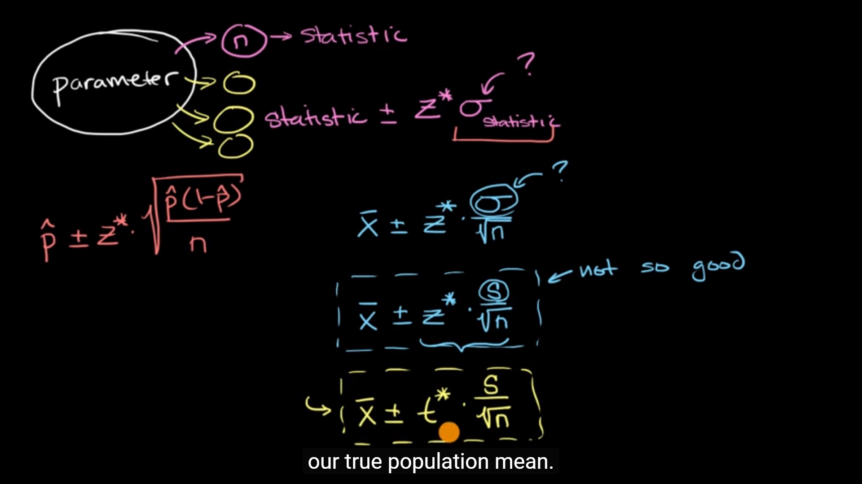

we use t statistics when building confidence intervals for a mean using the sample standard deviation in place of the population standard deviation.

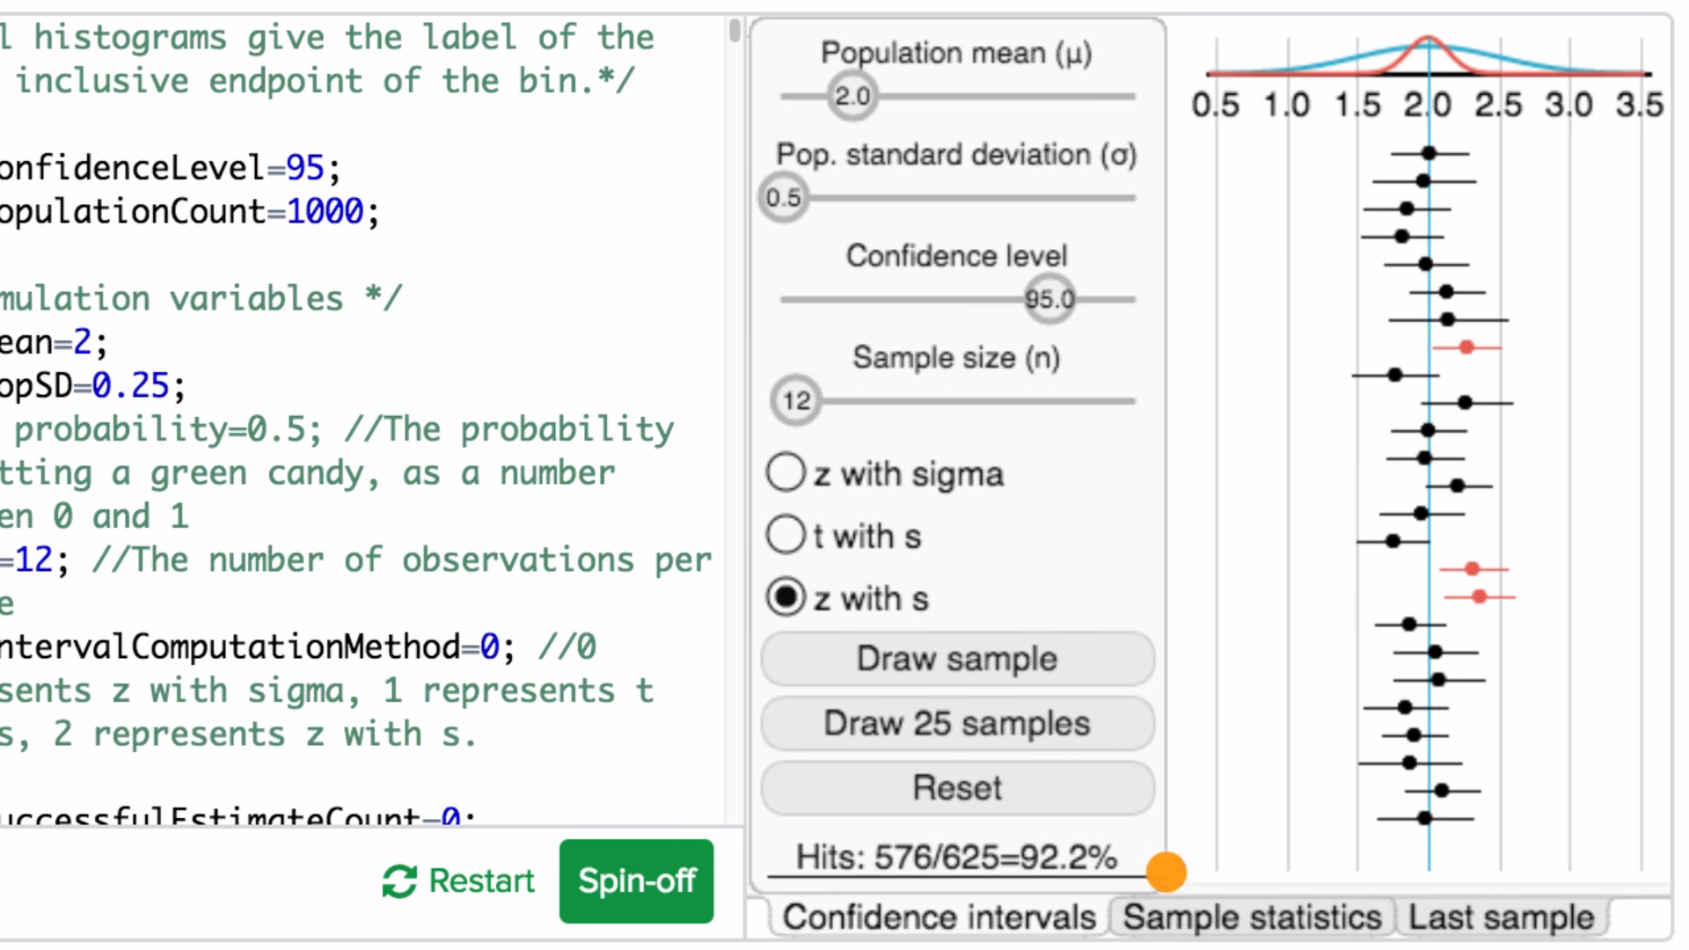z with s, only 92.2%

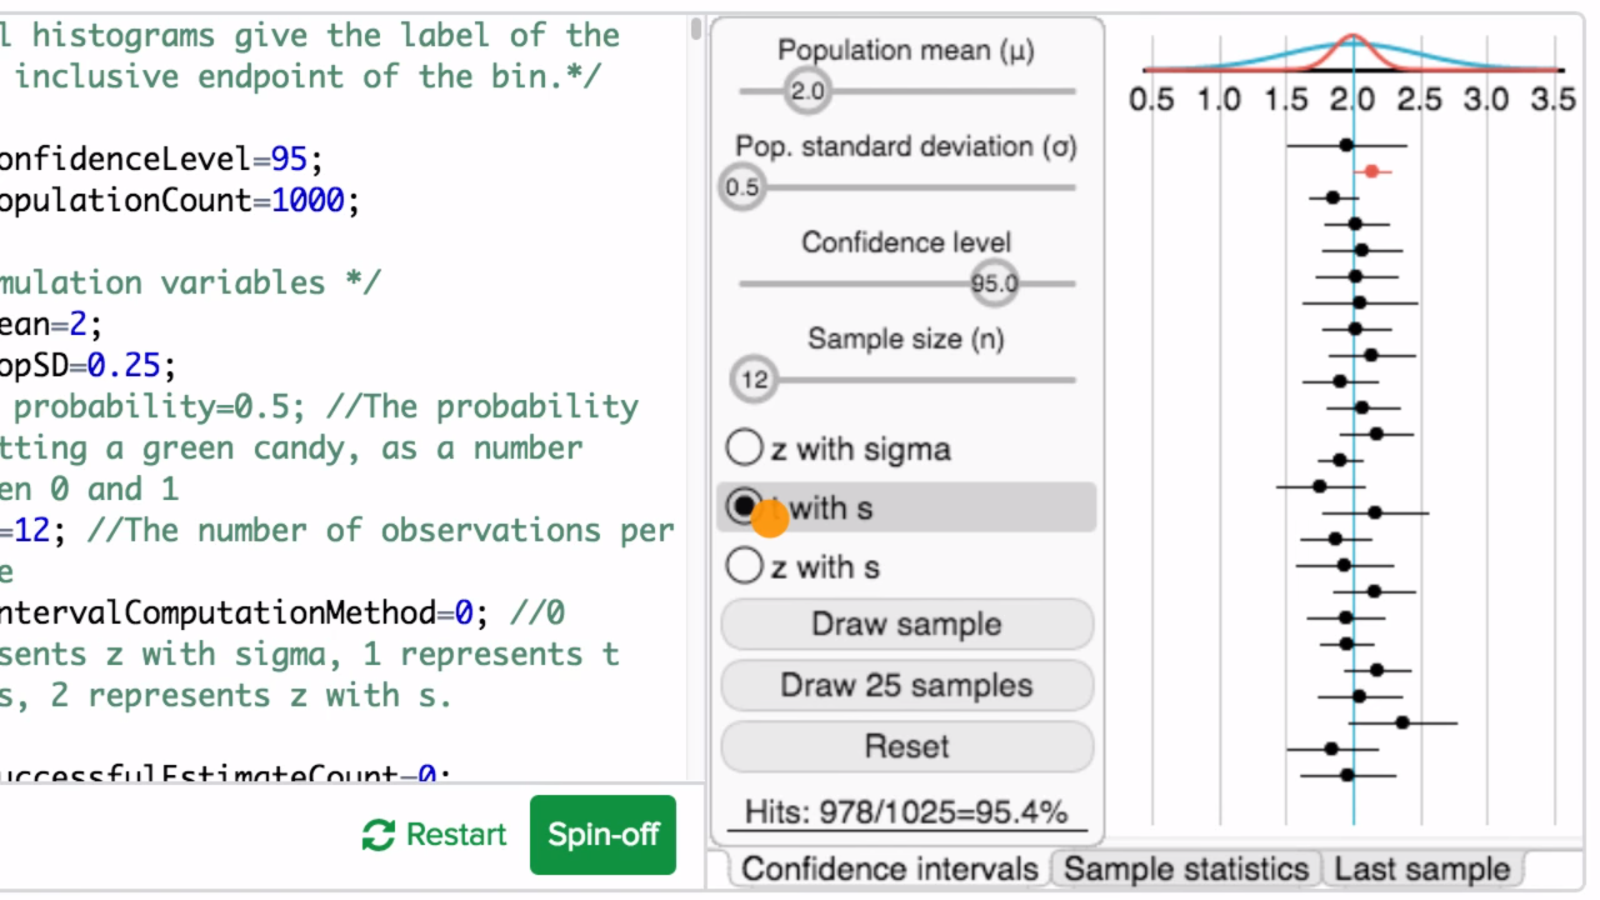

t with s, 95.4%

### Example finding critical t value

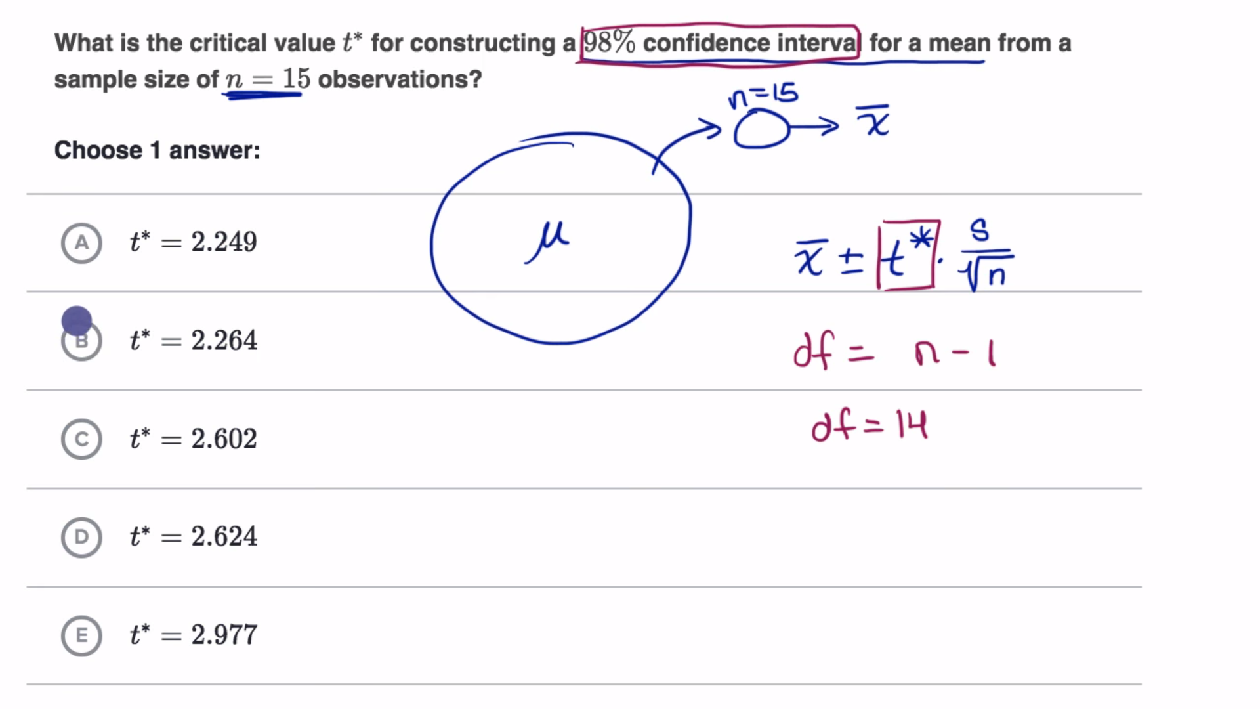

Degree of freedom = sample-size – 1

### Example constructing a t interval for a mean

(1-95%)/2 = 0.025

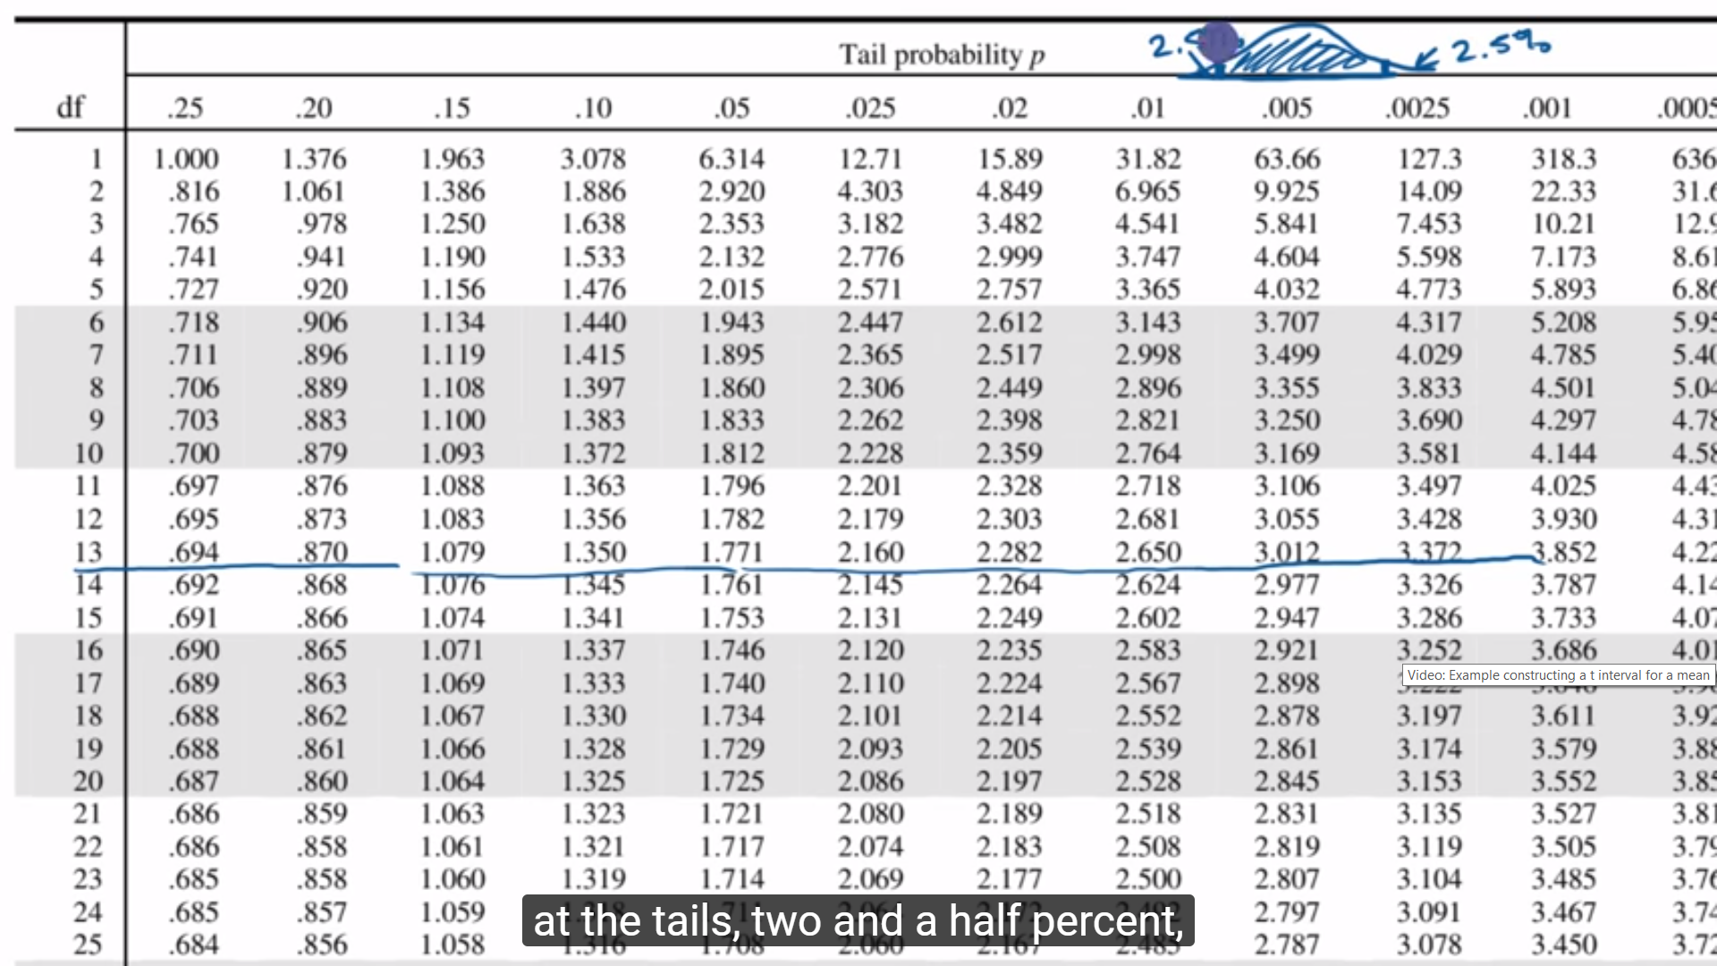

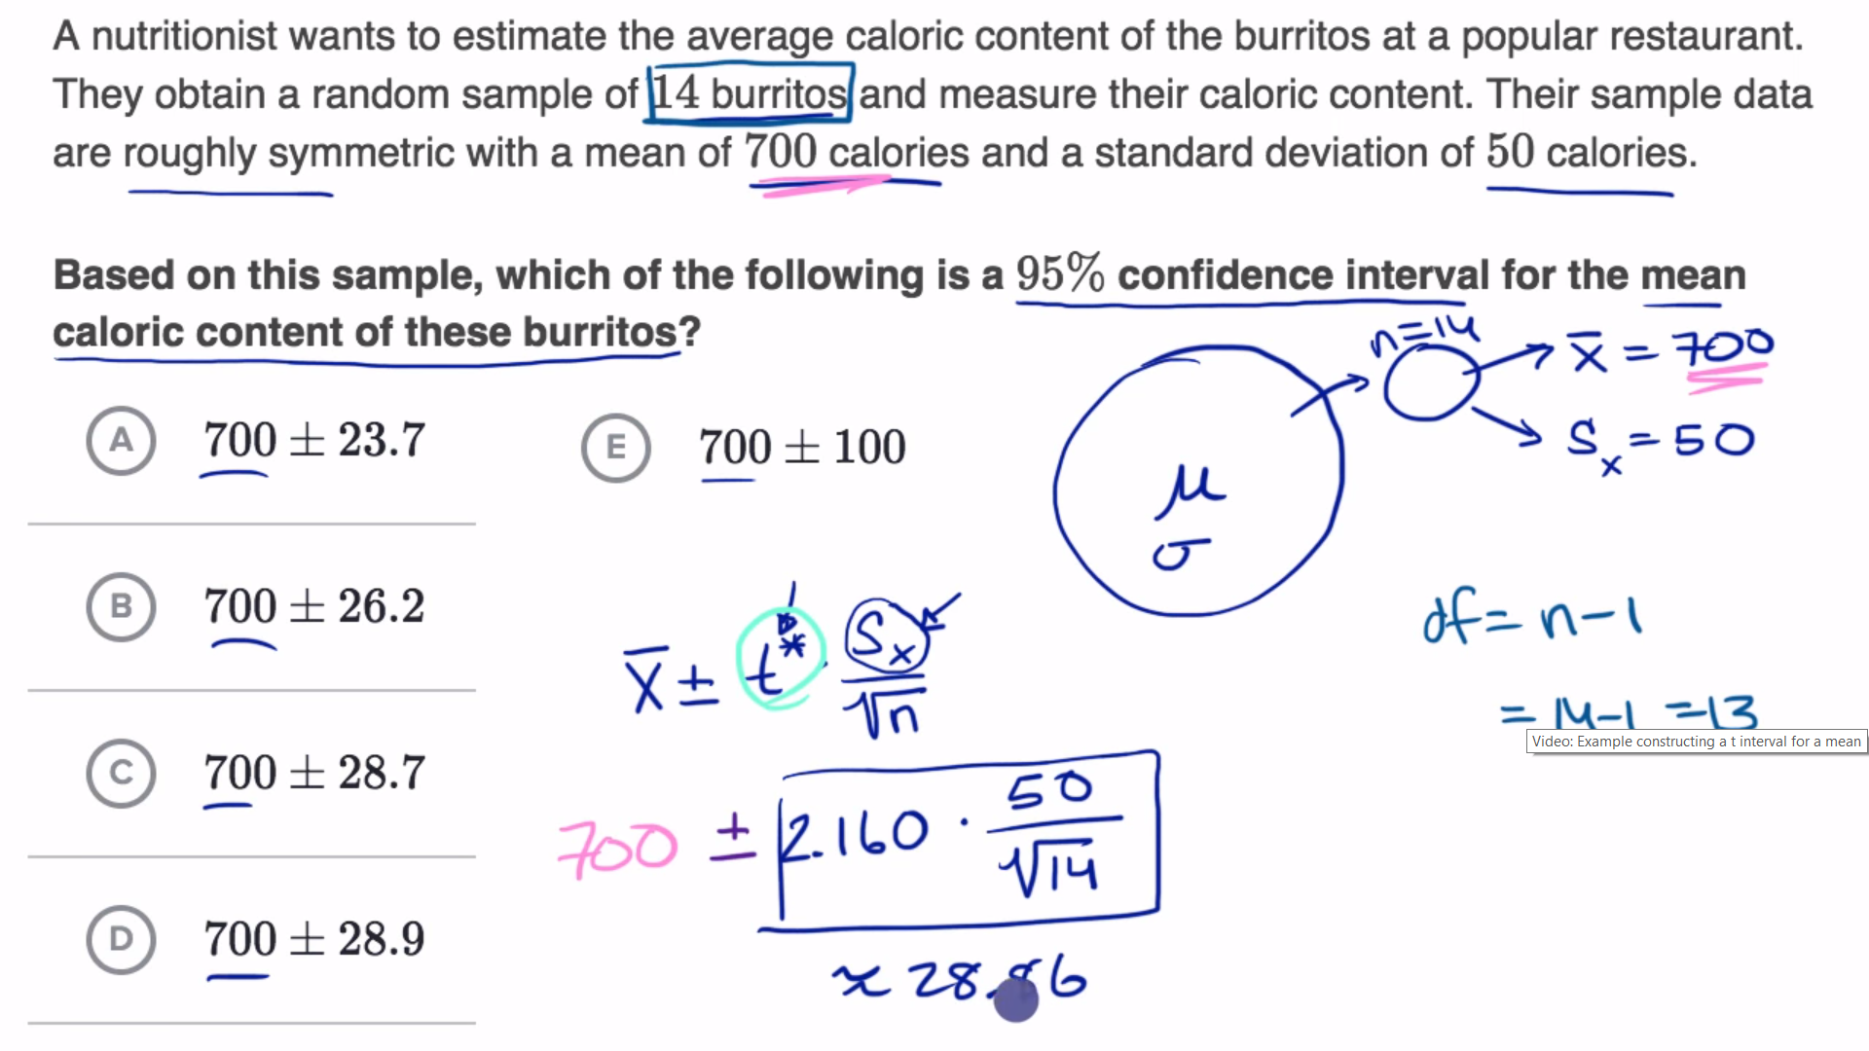

Random, normal and independent

### Confidence interval for a mean with paired data

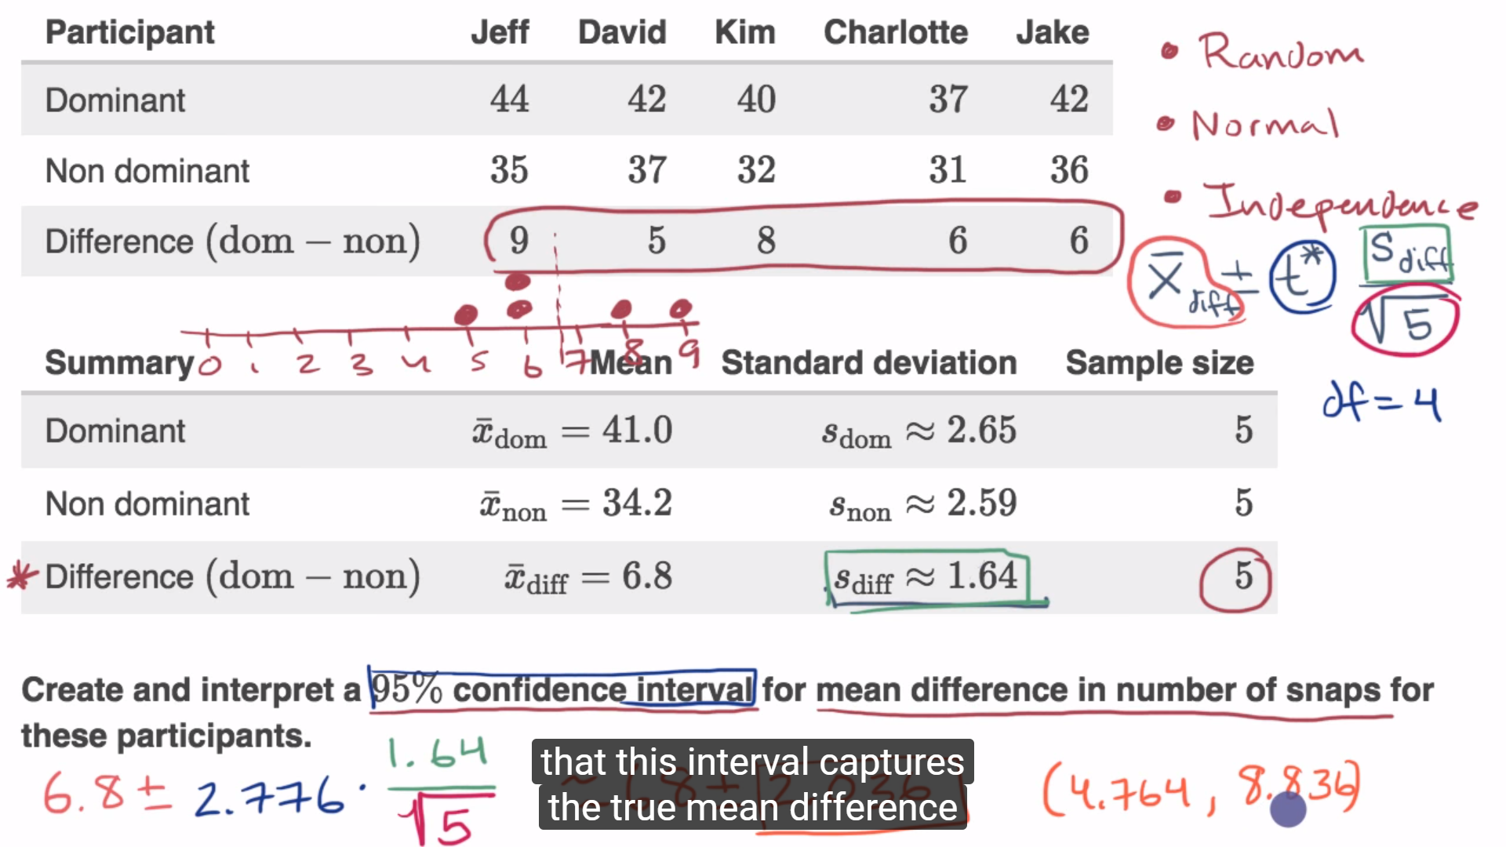

### Sample size for a given margin of error for a mean

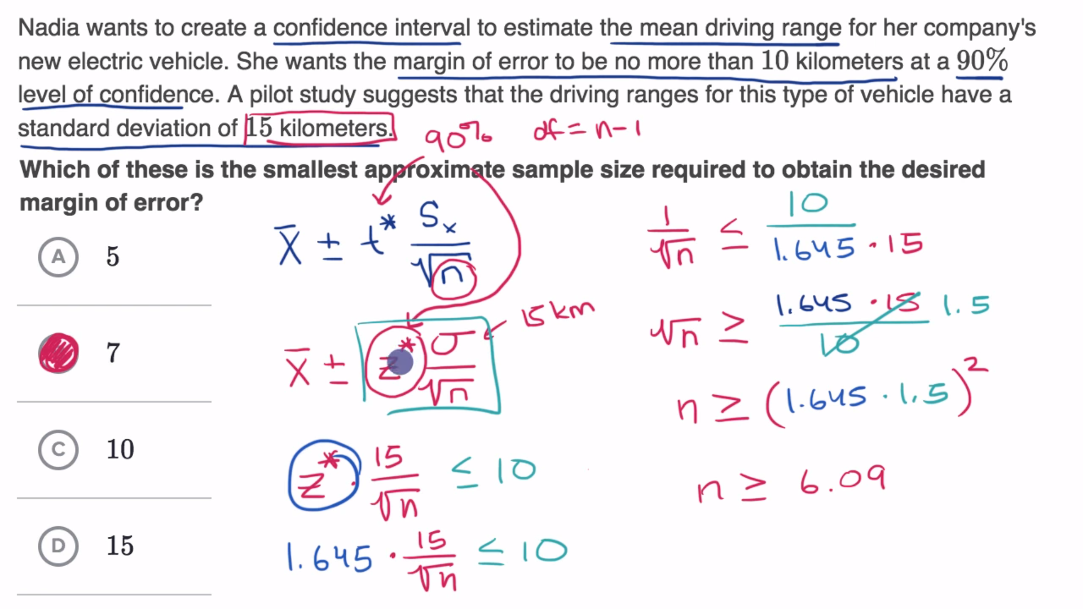

### Small sample size confidence intervals

T-distribution: fatter tails since you’re underestimating the sd

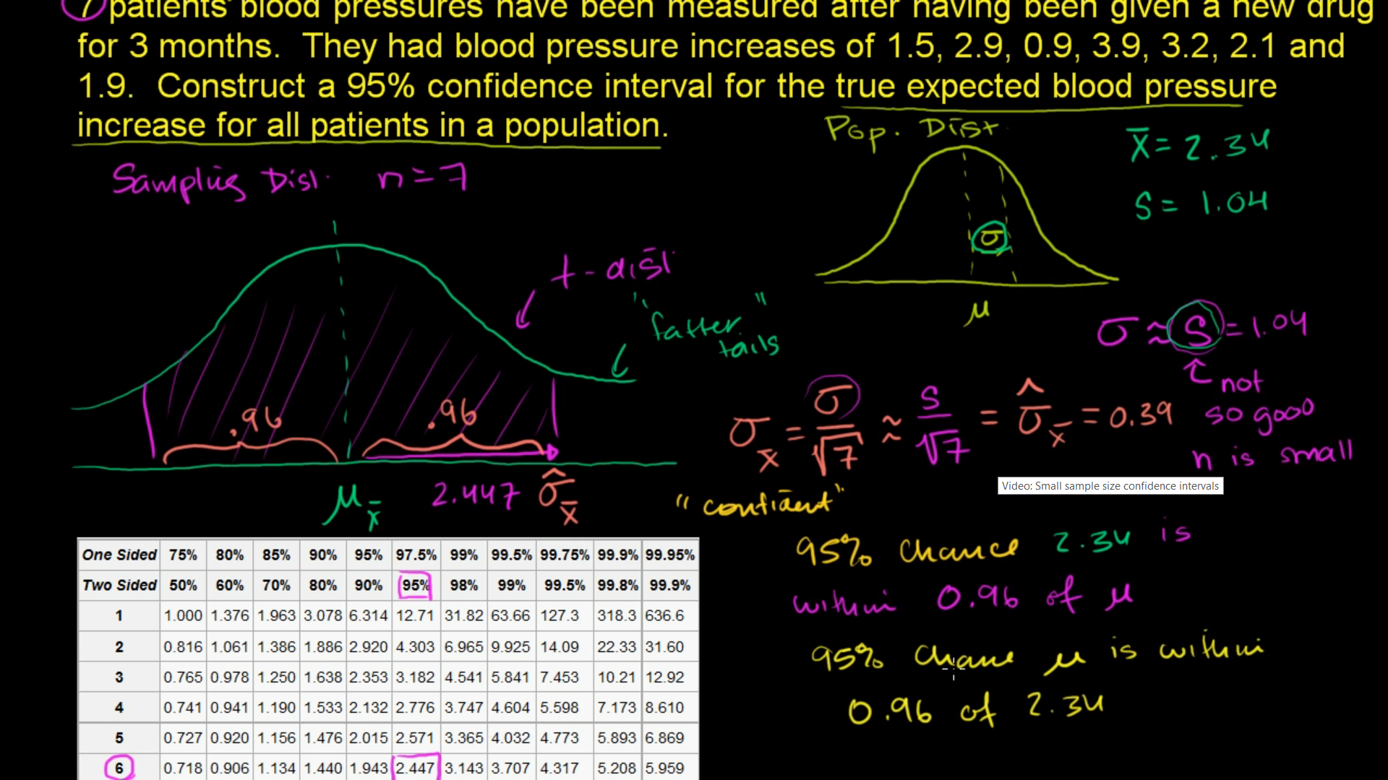

# 11. Significance tests (hypothesis testing)

## 11.1 The idea of significance tests

### Examples of null and alternative hypotheses

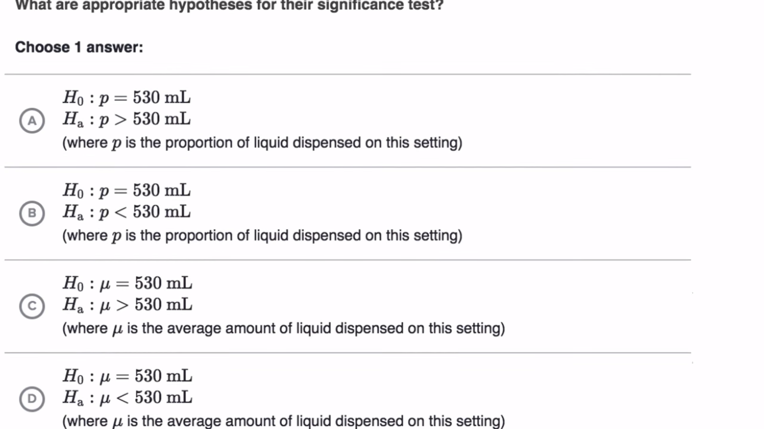

Null hypothesis: things that happen as expected, no difference

Alternative hypothesis: new news

### P-values and significance tests

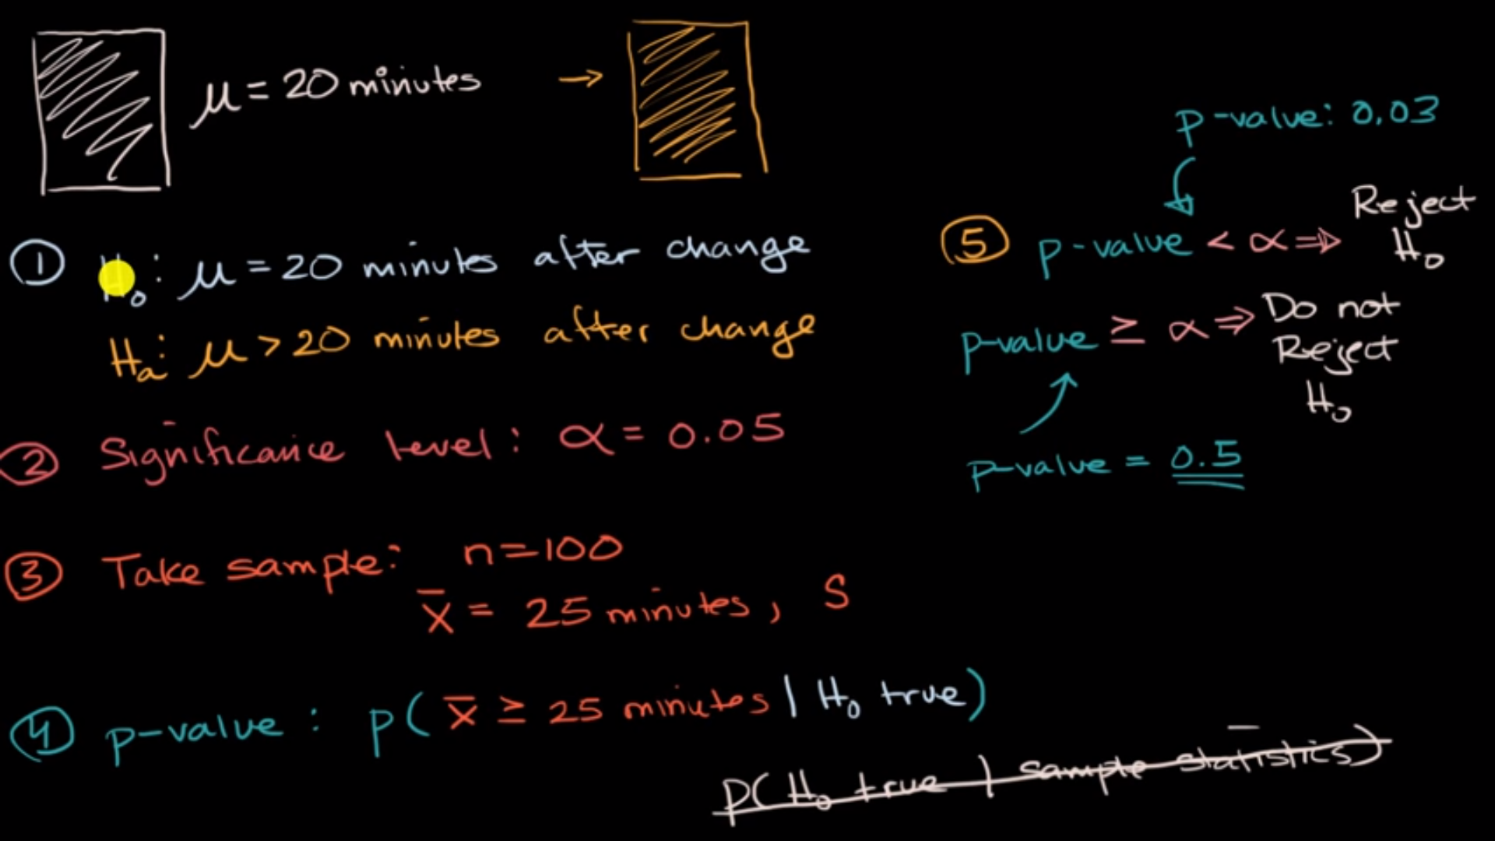

H0: no difference

Ha: news/change/difference

p-value: the probability of getting a statistic at least this far away from the mean when the null hypothesis is true, conditional probability that our sample mean is greater or equal to 25 when we take a sample size n=100 given null hypothesis is true

p-value = 0.03 < 0.05, means the probability of getting that sample is 3%

=> reject the null hypothesis => there is a difference

P(X >= 25 | H0 true) correct

P(H0 true | sample statistics) wrong

### Comparing P-values to different significance levels

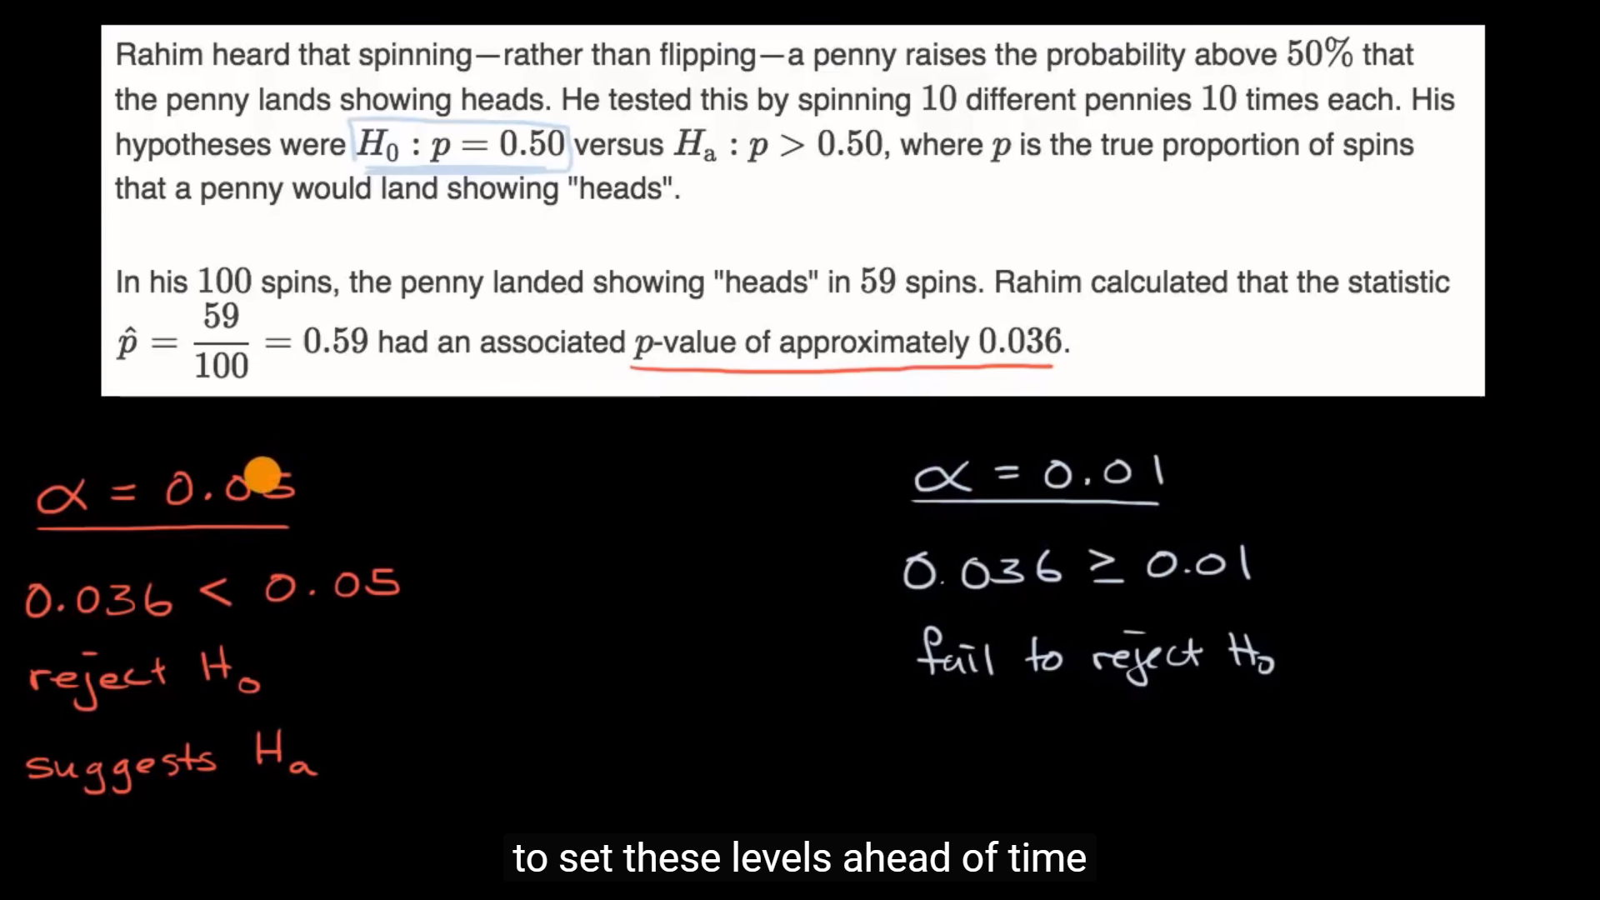

## 11.2 Error probabilities and power

p-value is the probability of getting a statistic at least as extreme as the one we observed when the null hypothesis is true

type I error: significant level is too high

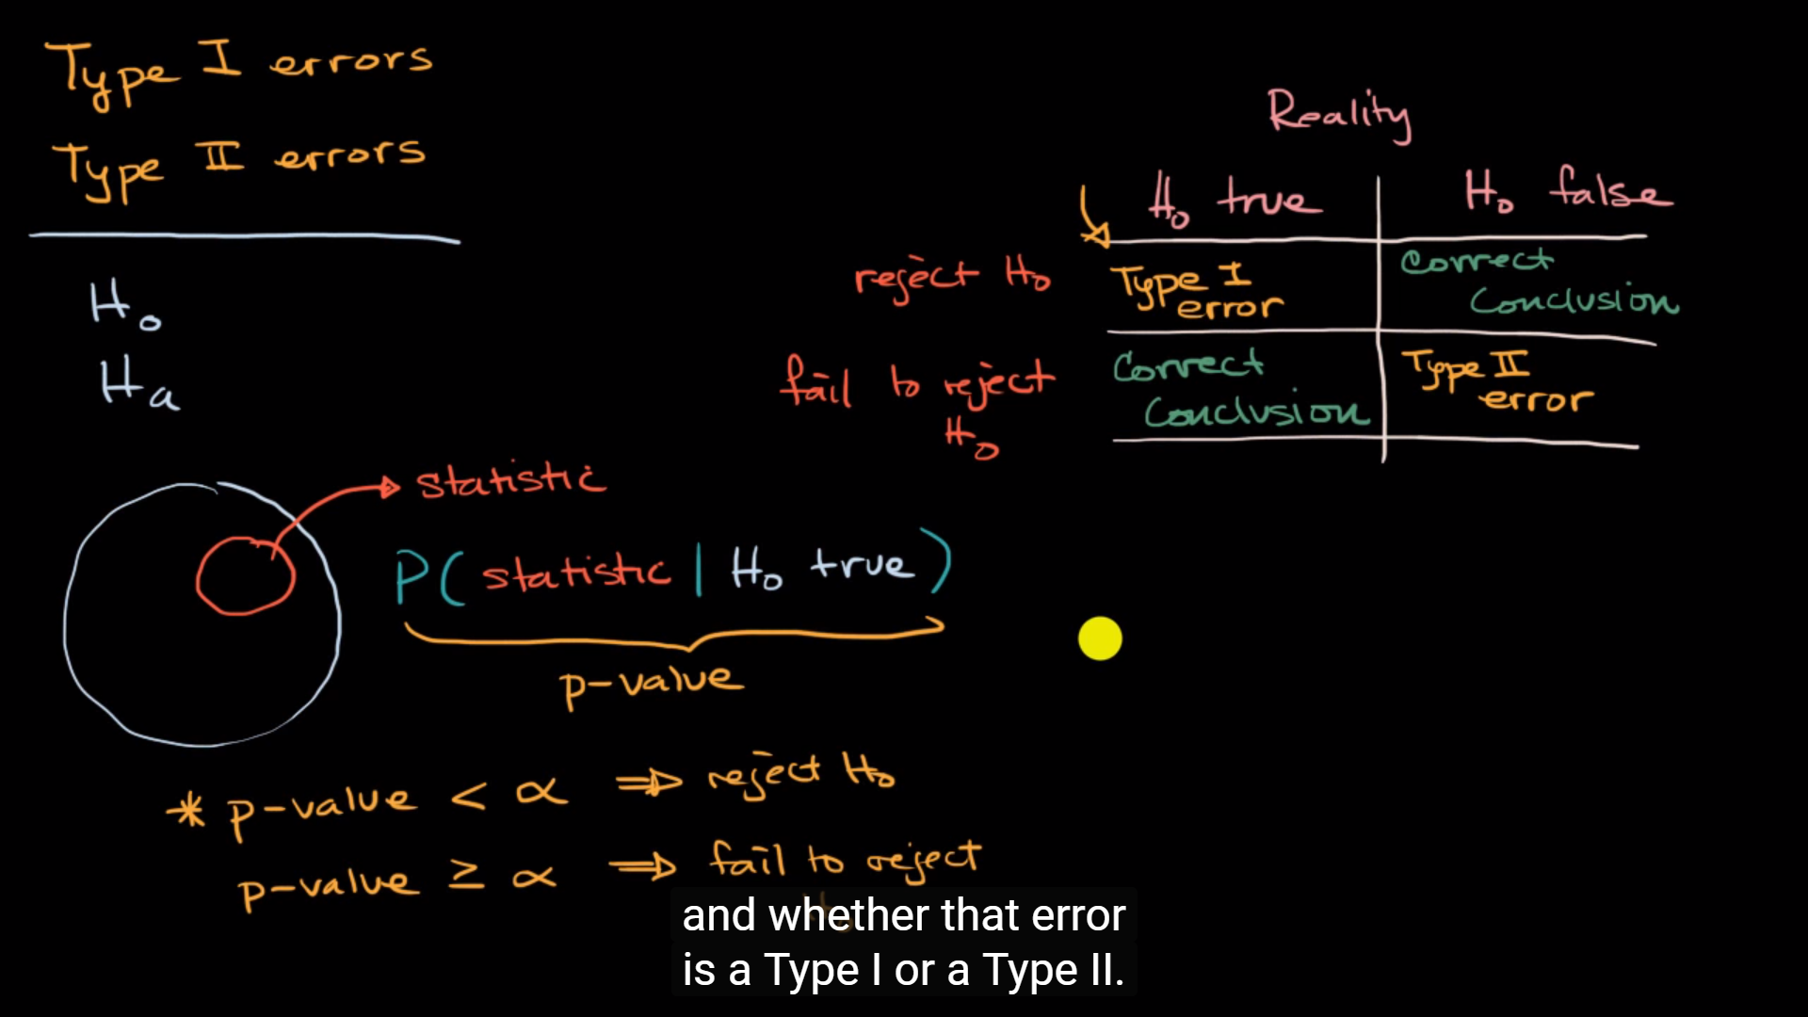

## 11.4 Tests about a population mean

### When to use z or t statistics in significance tests

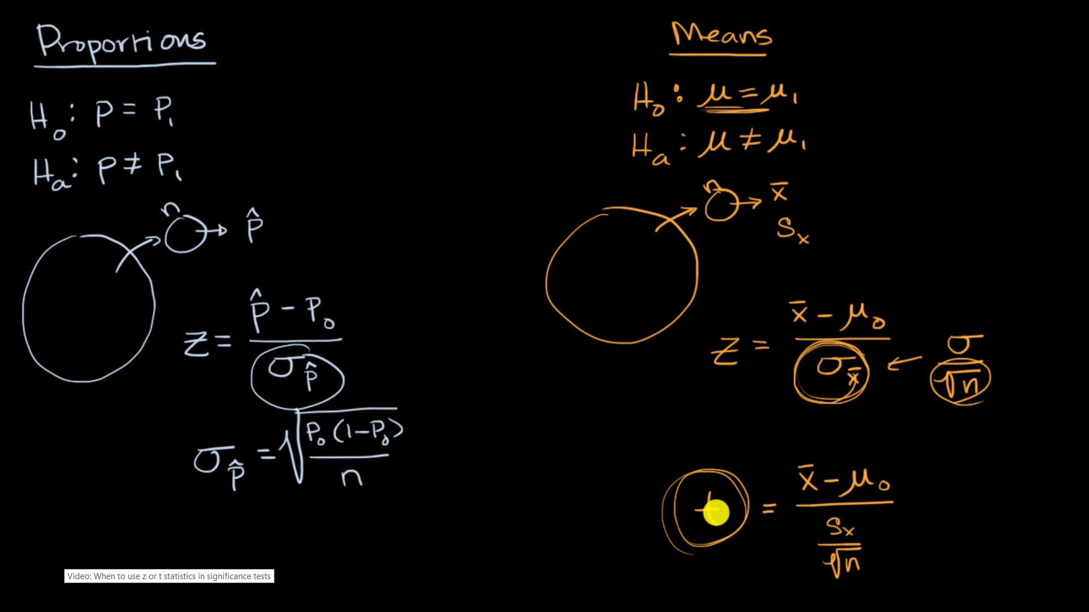

### Example calculating t statistic for a test about a mean

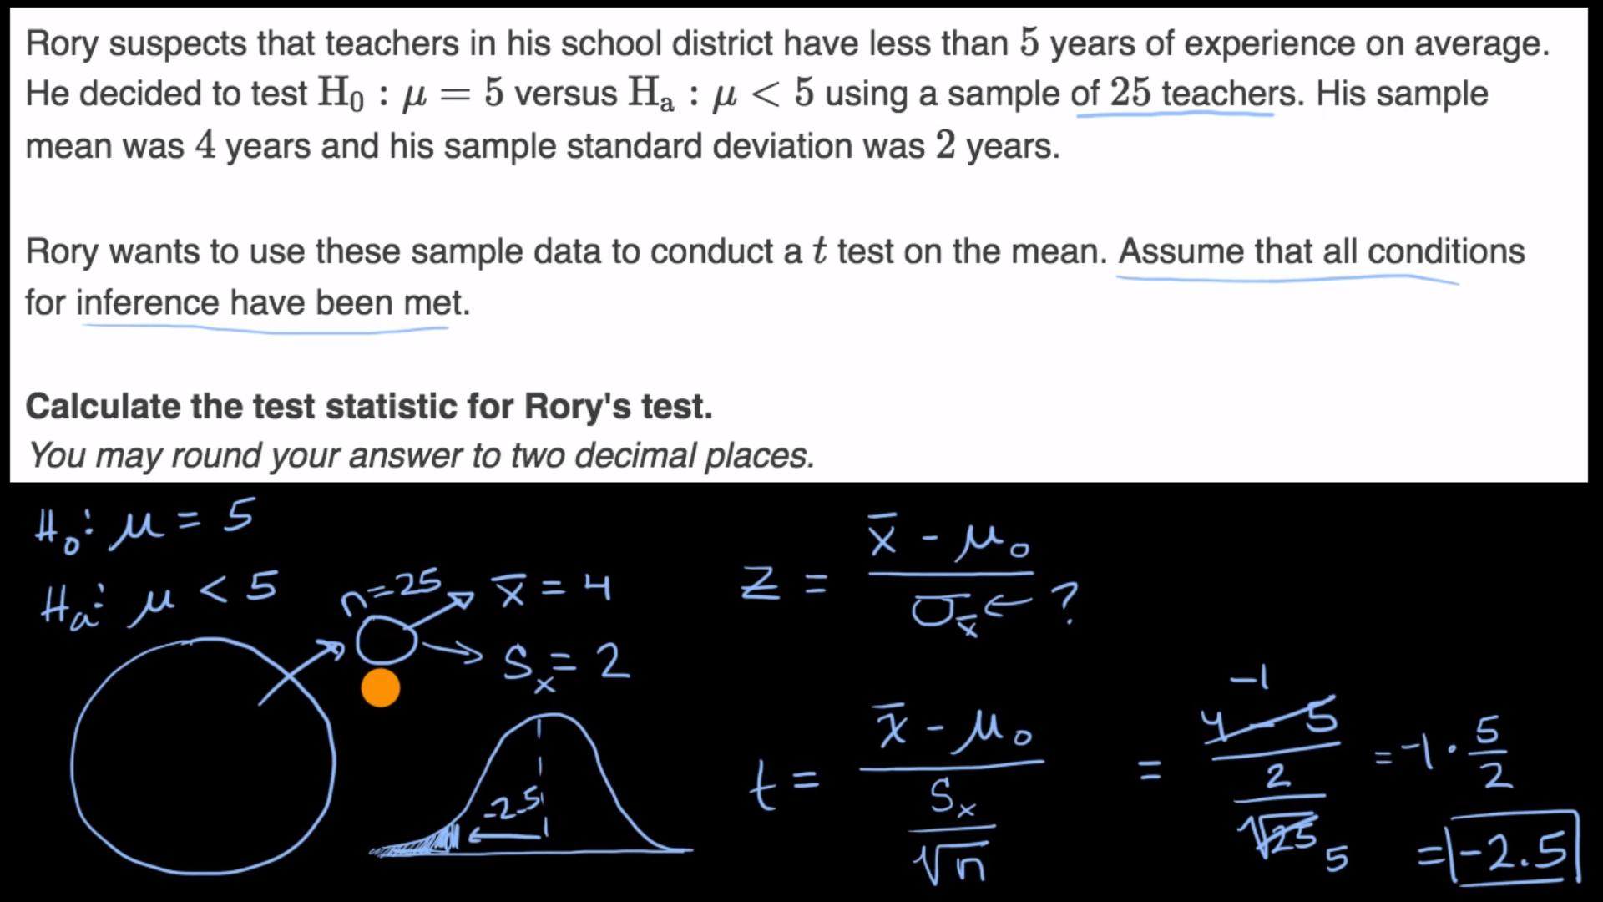

Proportion => p-value more

Mean = > t-test more

## 11.5 More significance testing videos

### One-tailed and two-tailed tests

Two-tailed

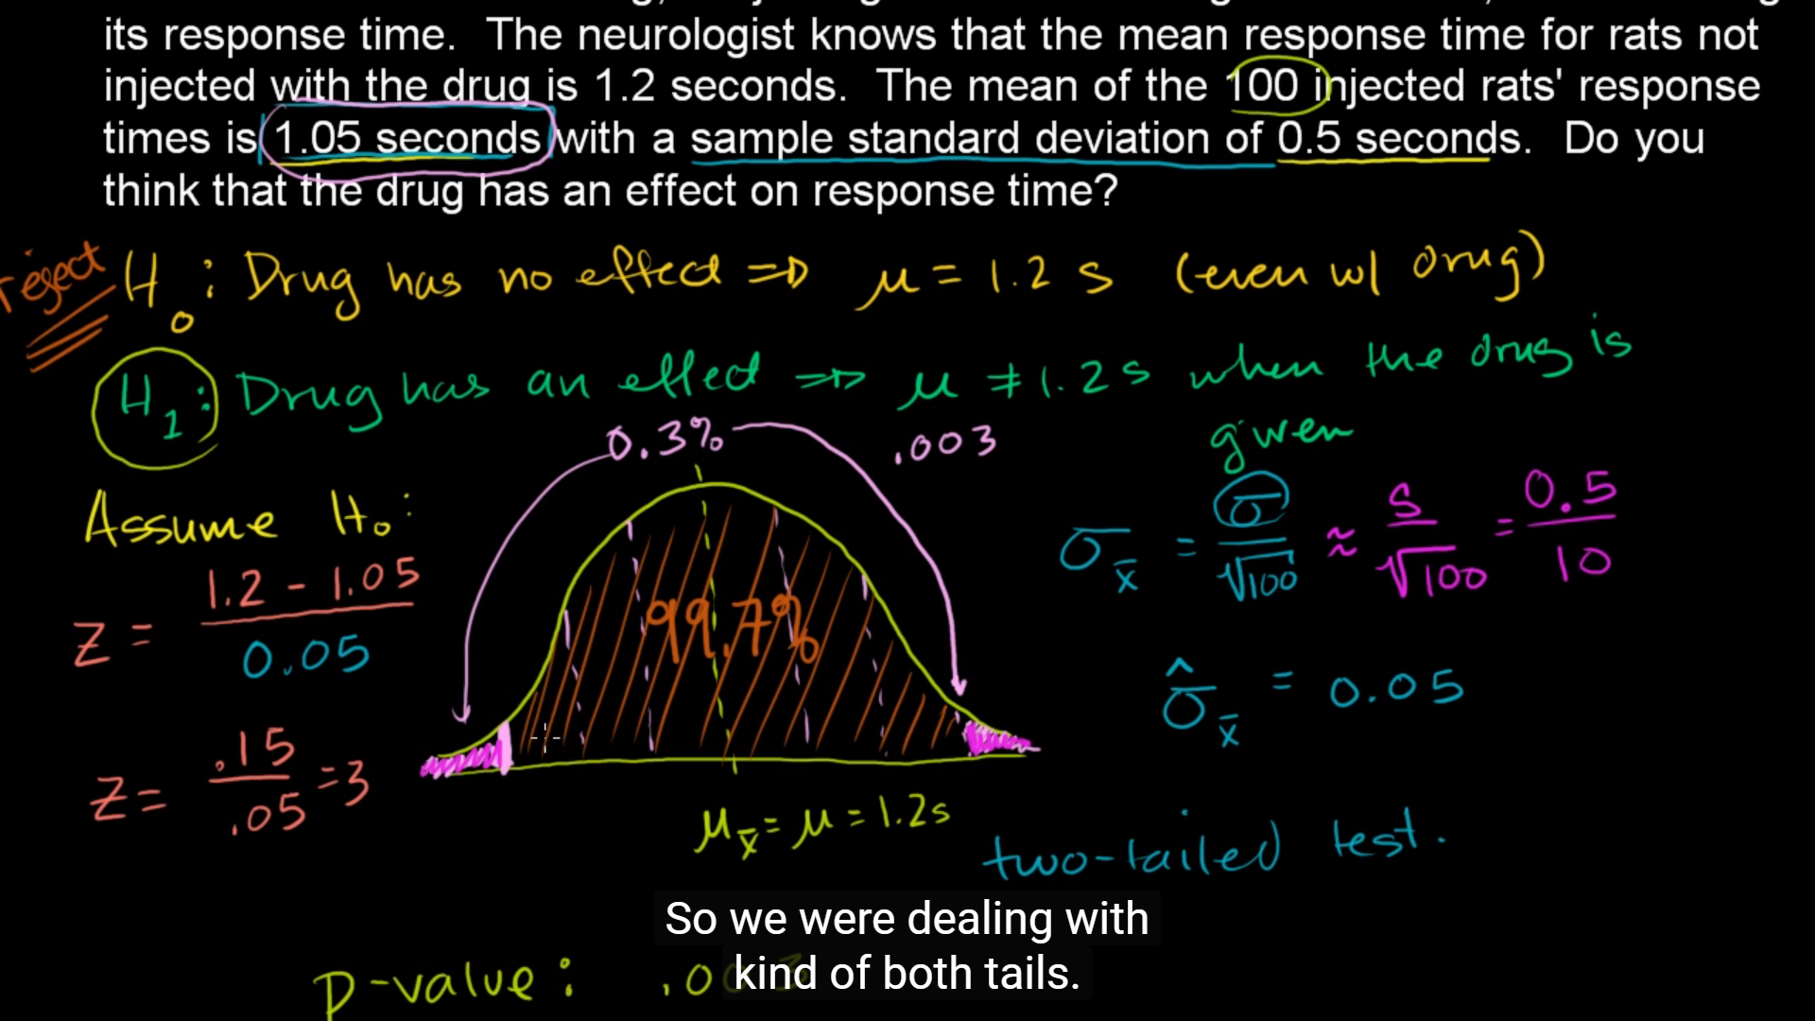

One-tailed

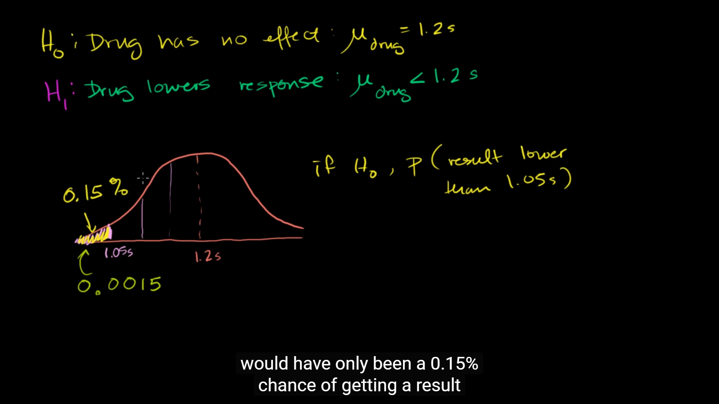

# Comparing two means

# chi-square tests

## Chi-square goodness-of-fit tests

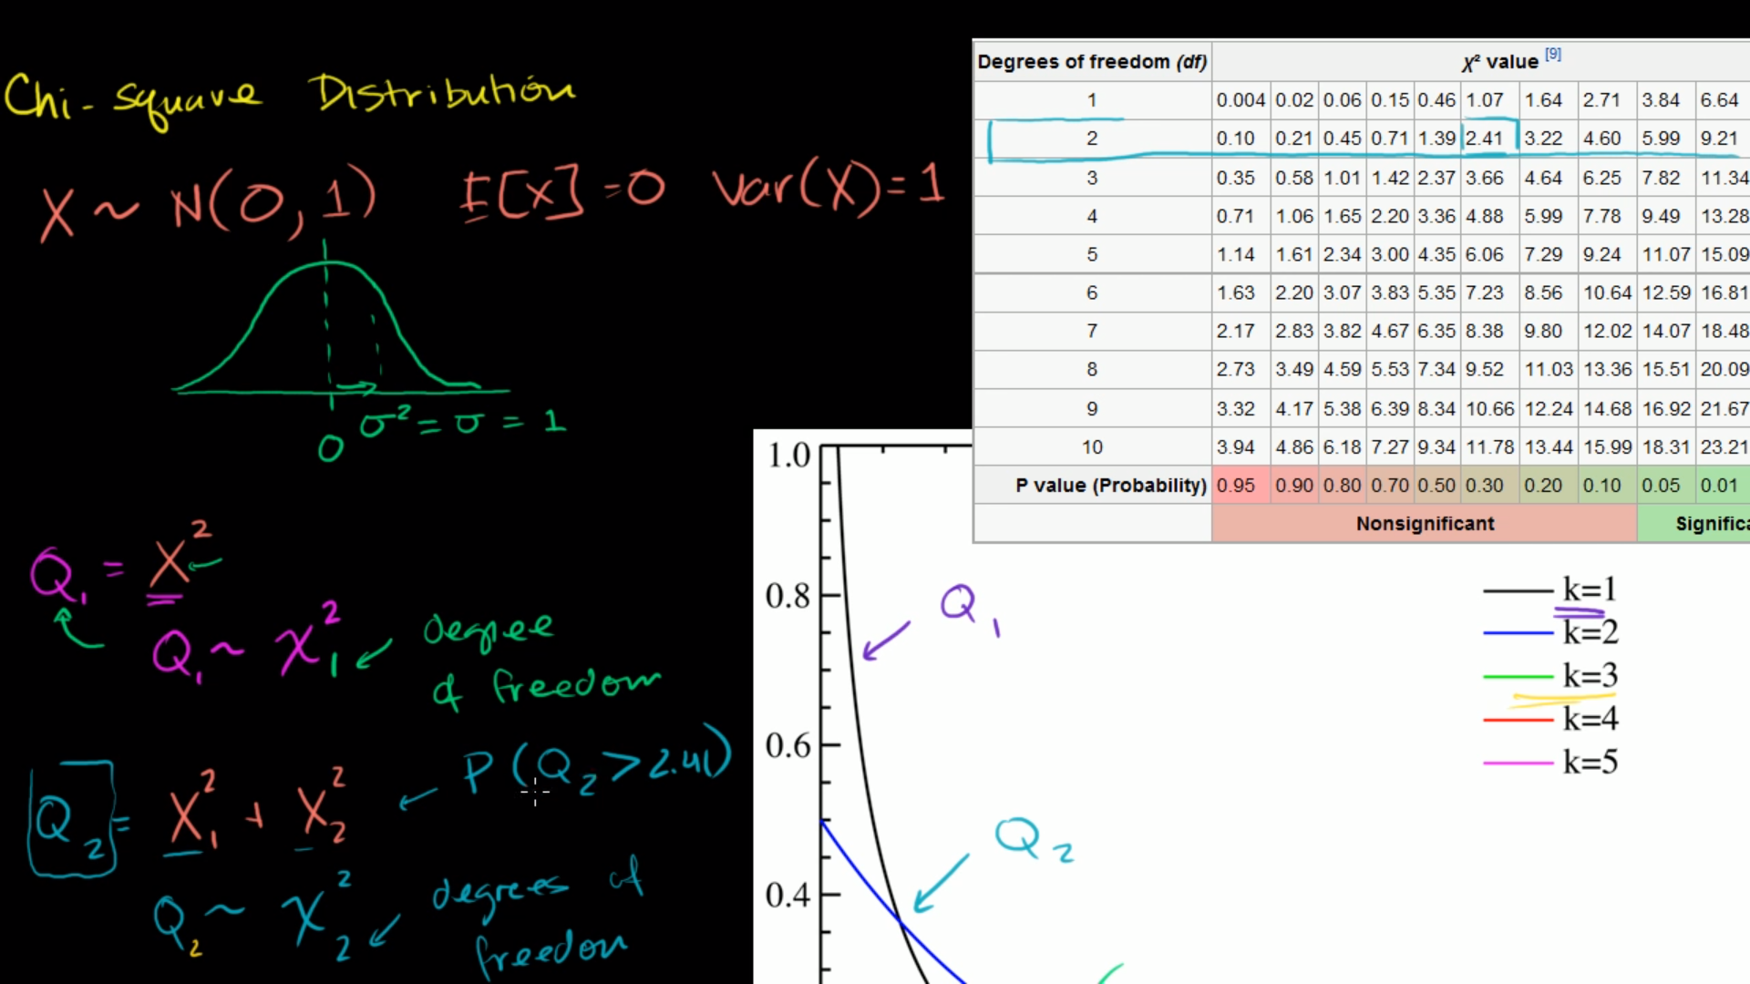

X is a normal random variable with a mean of 0 and a variance of 1

Greek letter chi, χ

Q2 has 2 degrees of freedom because we’re adding 2 of random distributed x here

P(Q2 > 2.41) = 30%(p-value)

No below 0 since squared values

It’s measuring essentially error from an expected value

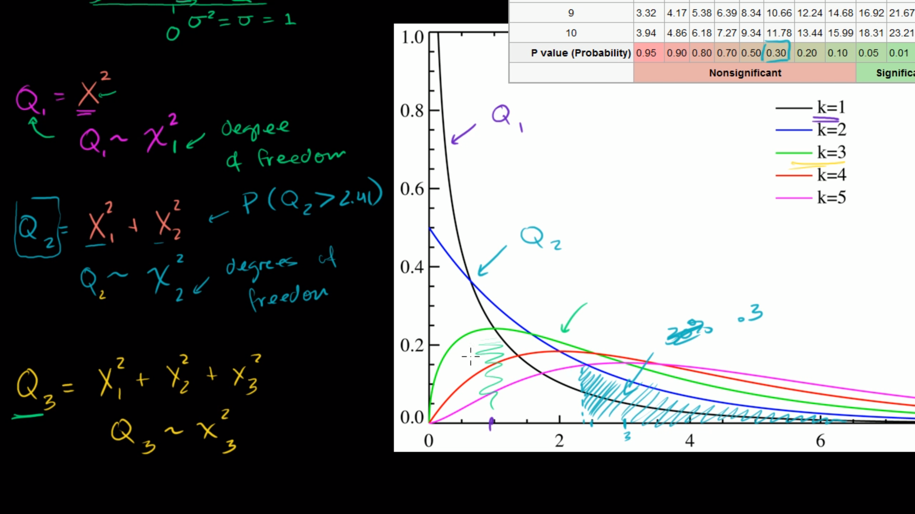

# Analysis of variance (ANOVA)

ANOVA 1: Calculating SST (total sum of squares)

How much of this total variance( or the squared sum) comes from the variation within each of these groups vs the variation between the groups

ANOVA 2: Calculating SSW and SSB (total sum of squares within and between)

6 out of 30 comes from a variation within these samples

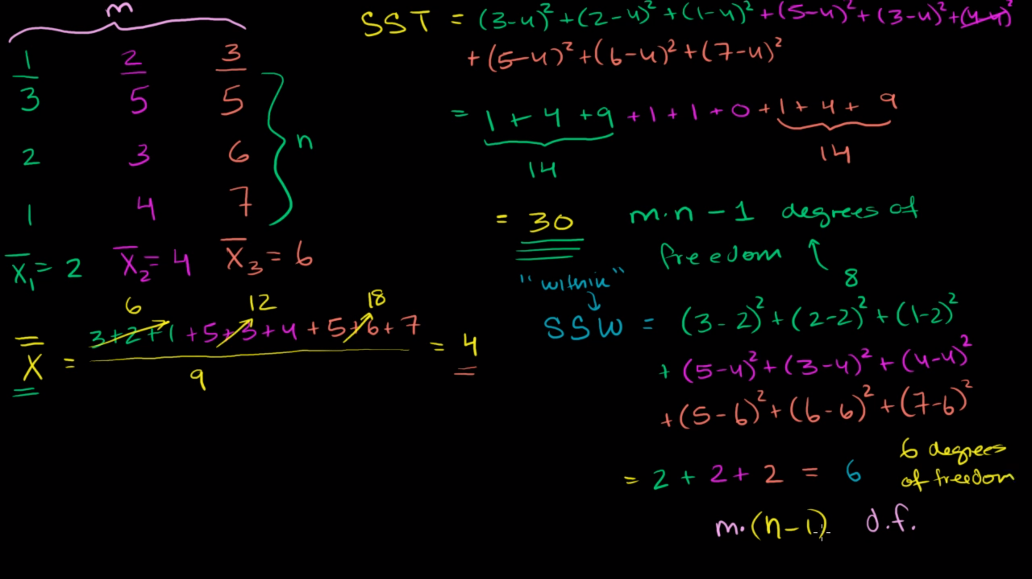

Df: truly independent data points assuming you know the central statistic

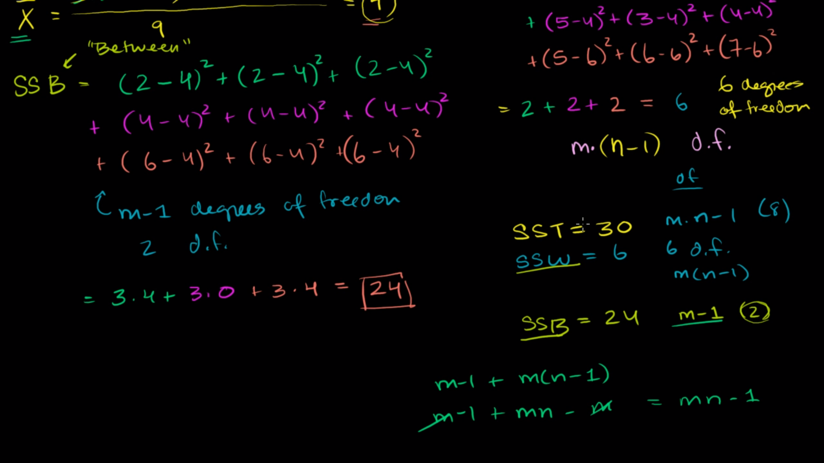

SSB: variation between the means of the samples

## ANOVA 3: Hypothesis test with F-statistic

F distribution: ratio of two Chi-squared distributions that may or may not have different degrees of freedom

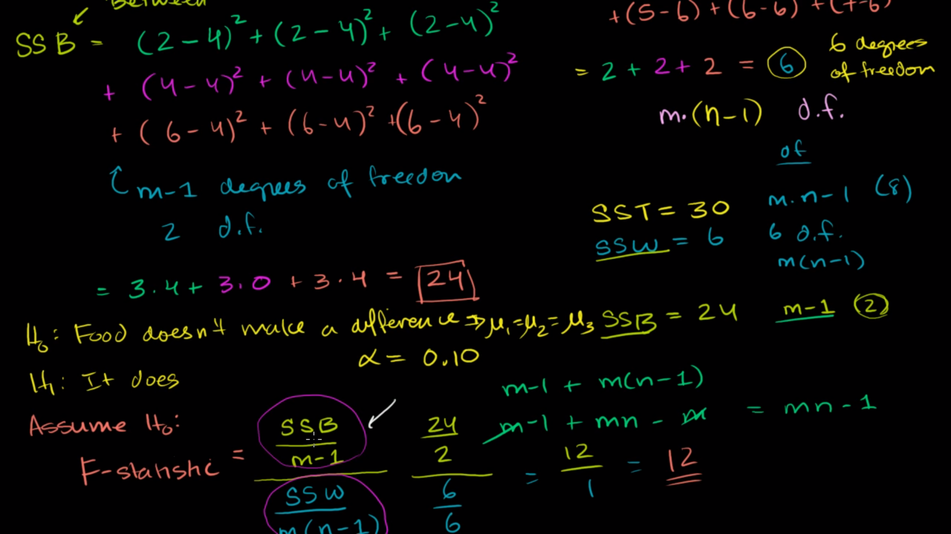

If numerator(SSB) is much larger than denominator (SSW), the variation is due mostly to the difference between the groups => there is difference between the groups => low probability that H0 is correct, reject the null; otherwise, if SSB is smaller than SSW, the difference within groups makes up more of the total variation => fail to reject the null

F- statistic = 12 > f-value = 3.46 => reject the null